**How to Download & Use CamScanner on Android**

**Step 1: Download & Install CamScanner**

First, unlock your Android phone and open the Google Play Store. Search for CamScanner and tap Install. Once installed, tap Open to launch the app and start scanning.

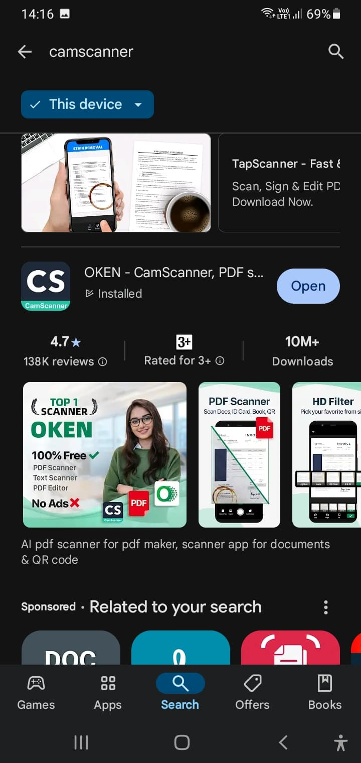

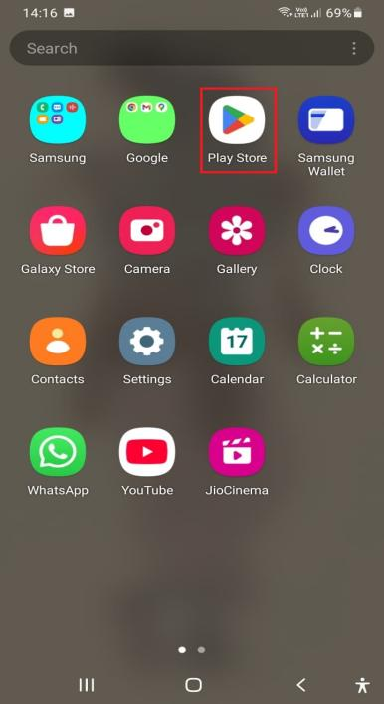

**Step 2: Set Up Permissions**

When you open CamScanner for the first time, it will ask for camera and storage access. Tap Allow to give the app permission to scan and save documents.

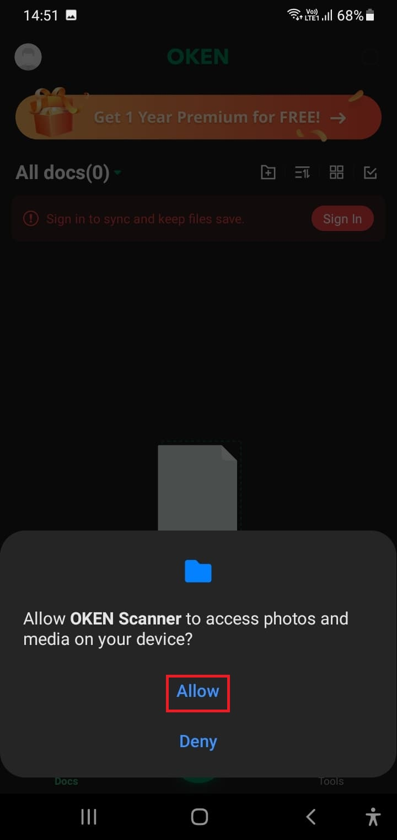

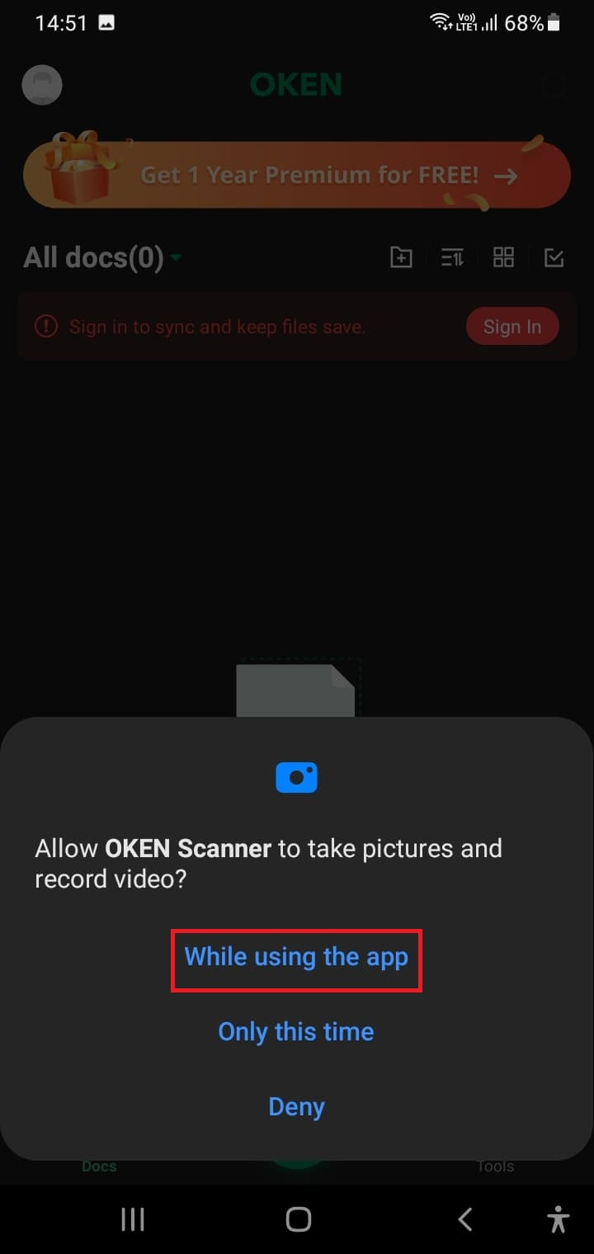

**Step 3: How to Scan a Document**

To scan a document, tap the camera icon. Place your document on a flat surface and capture the image. CamScanner will automatically detect the edges and enhance the quality. If the app doesn’t detect the edges automatically, you can manually adjust them. You can also crop, rotate, or fine-tune the scan as needed.

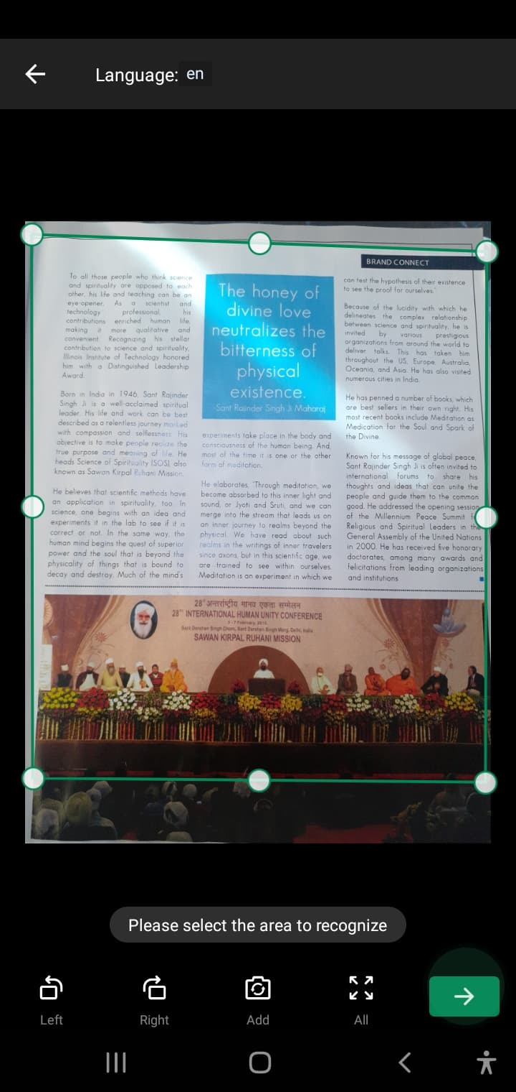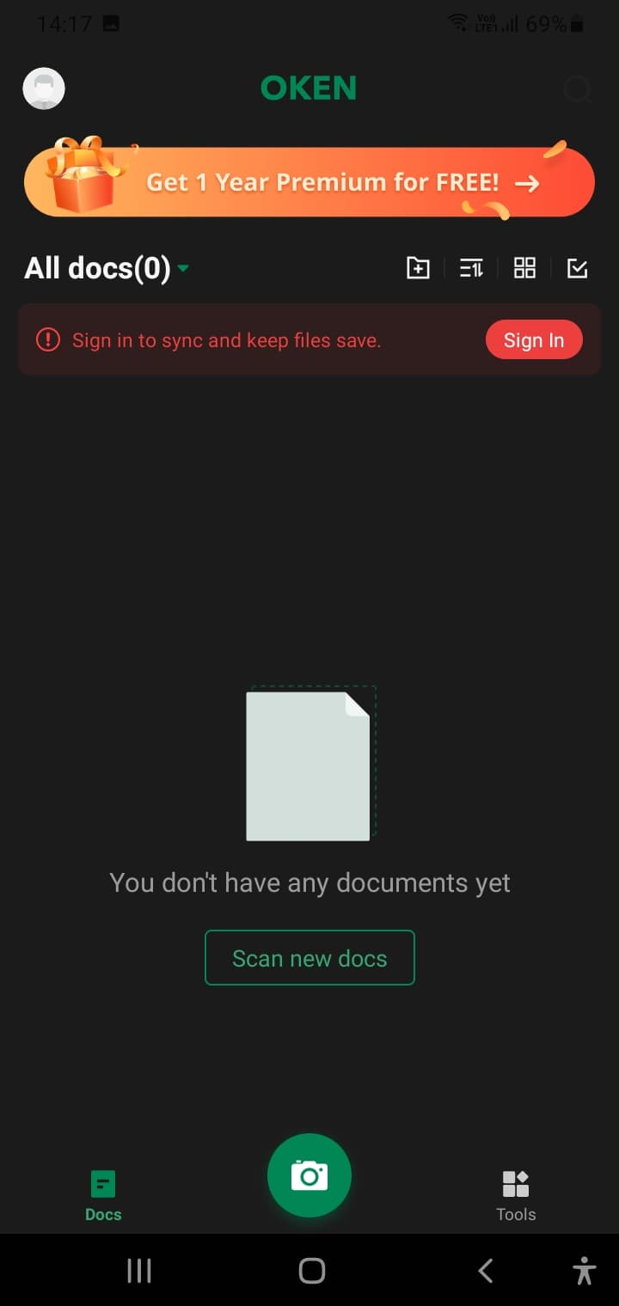

**Step 4: Editing & Enhancing the Scan**

After scanning, you can enhance the document by adjusting the brightness, applying filters, or improving clarity. These features help ensure your scanned documents look professional and are easy to read.



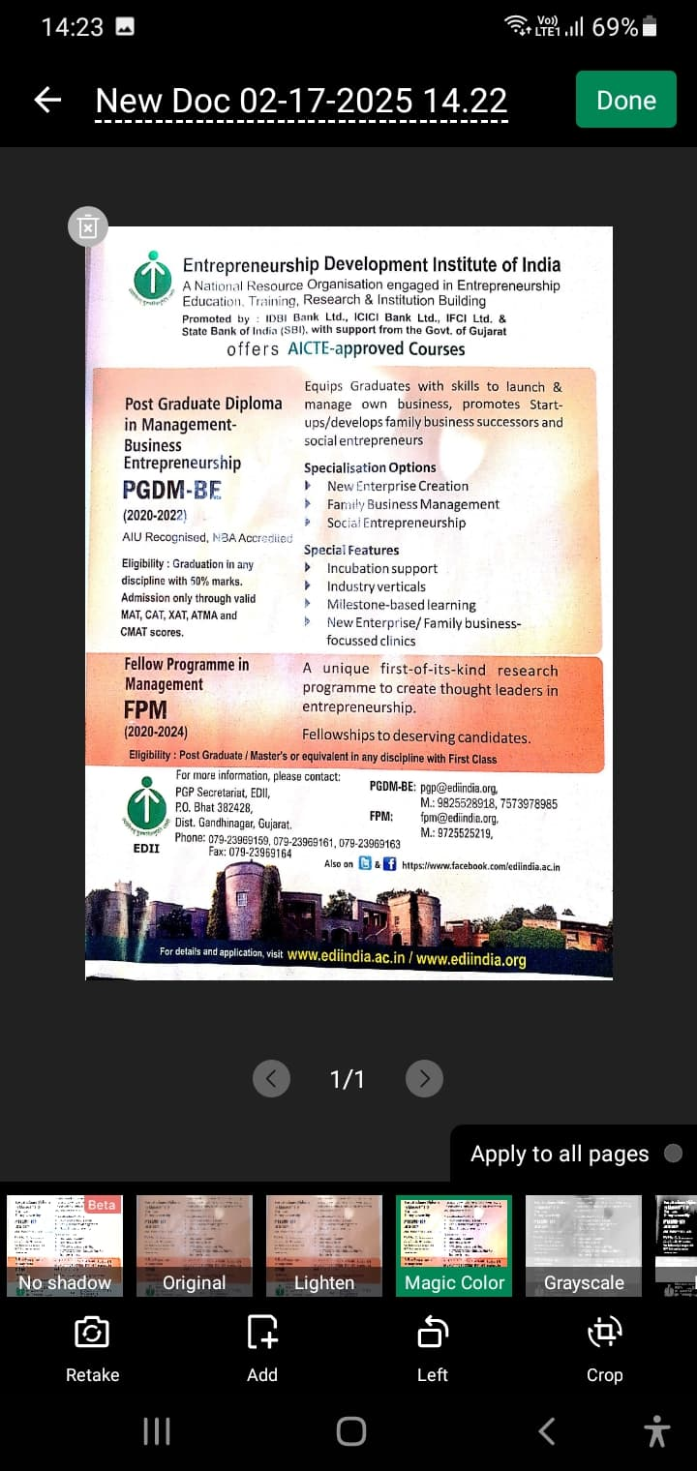

**Step 5: Saving & Sharing Scans**

Once you're happy with your scan, tap Save and choose the format you'd like: PDF or JPG. You can then share your scan via email, WhatsApp, Google Drive, or any other app you prefer.

