S.NO | Emails | Changed
1. | 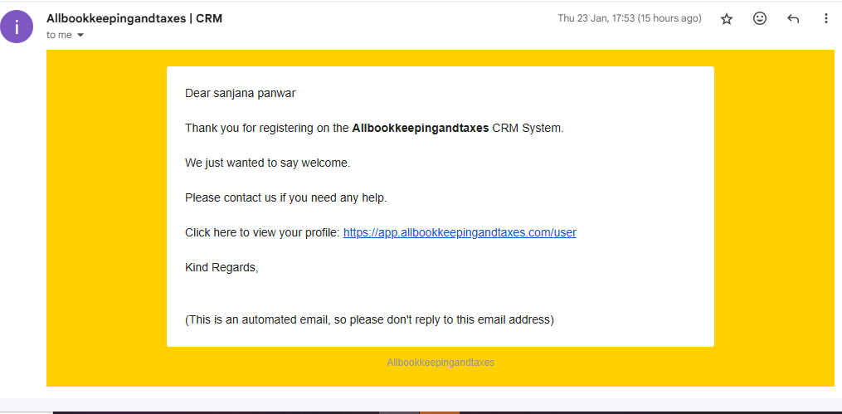
Welcome aboard
Allbookkeepingandtaxes | CRM <info@incubers.com> 23 January 2025 at 17:53
To: incuber.sanjana@gmail.com

Dear sanjana panwar

Thank you for registering on the Allbookkeepingandtaxes CRM System.

We just wanted to say welcome.

Please contact us if you need any help.

Click here to view your profile: https://app.allbookkeepingandtaxes.com/user

Kind Regards,

(This is an automated email, so please don't reply to this email address)
Allbookkeepingandtaxes

2. | 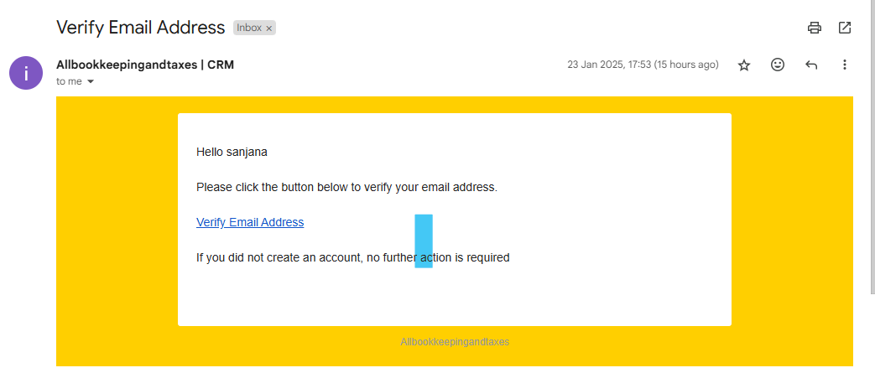
Verify Email Address
1 message
Allbookkeepingandtaxes | CRM <info@incubers.com> 23 January 2025 at 17:53
To: incuber.sanjana@gmail.com

Hello sanjana

Please click the button below to verify your email address.

Verify Email Address

If you did not create an account, no further action is required

Allbookkeepingandtaxes

3. | 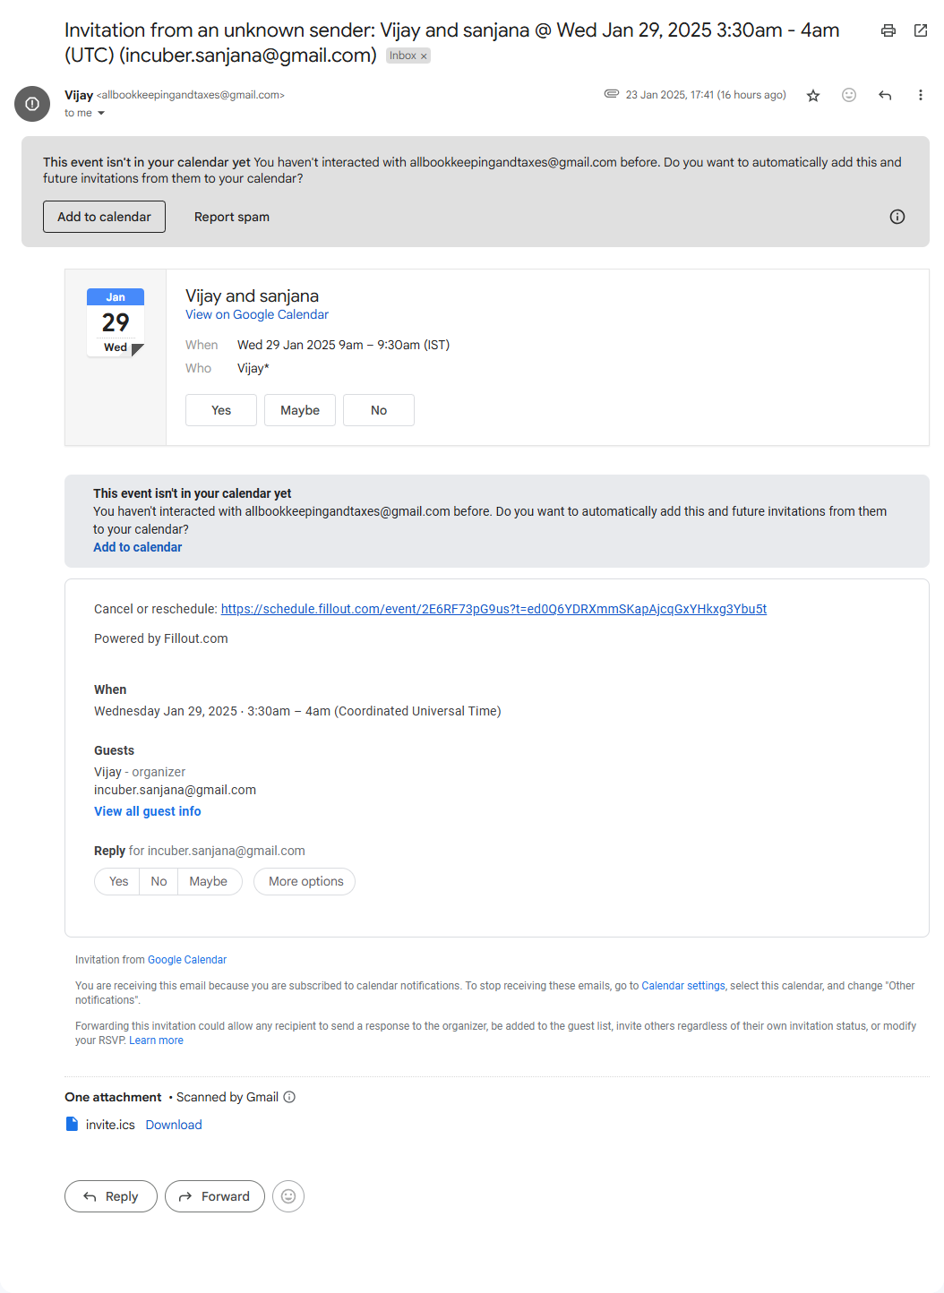
Invitation from an unknown sender: Vijay and sanjana @ Wed Jan 29, 2025 3:30am - 4am (UTC) (incuber.sanjana@gmail.com)
Vijay <allbookkeepingandtaxes@gmail.com> 23 January 2025 at 17:41
Reply-To: Vijay <allbookkeepingandtaxes@gmail.com>
To: incuber.sanjana@gmail.com

This event isn't in your calendar yet
You haven't interacted with allbookkeepingandtaxes@gmail.com before. Do you want to automatically add this and future invitations from them to your calendar?
Add to calendar

Cancel or reschedule: https://schedule.fillout.com/event/2E6RF73pG9us?t=ed0Q6YDRXmmSKapAjcqGxYHkxg3Ybu5t
Powered by Fillout.com

When
Wednesday Jan 29, 2025 ⋅ 3:30am – 4am (Coordinated Universal Time)
Guests
Vijay - organizer
incuber.sanjana@gmail.com
View all guest info
Reply for incuber.sanjana@gmail.com
Yes
No
Maybe
More options
Invitation from Google Calendar

You are receiving this email because you are subscribed to calendar notifications. To stop receiving these emails, go to Calendar settings, select this calendar, and change "Other notifications".

Forwarding this invitation could allow any recipient to send a response to the organizer, be added to the guest list, invite others regardless of their own invitation status, or modify your RSVP. Learn more

