S.No | Pages and links | Report
1. | Home page  https://allbookkeepingandtaxes.com/ | 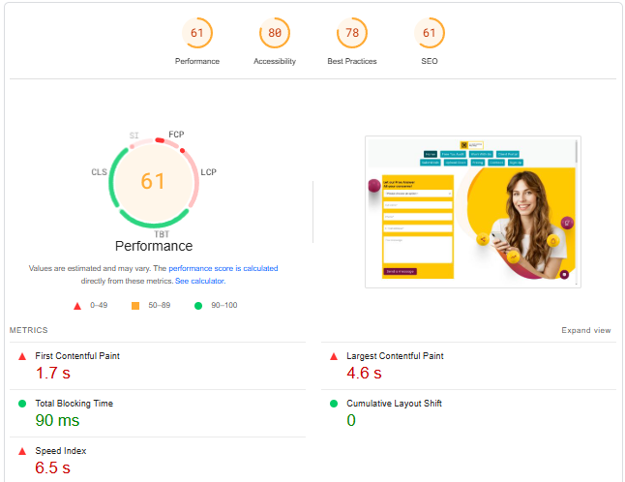
2. | Free Tax Audit  https://allbookkeepingandtaxes.com/our-free-audit-means-no-savings-no-fees/ | 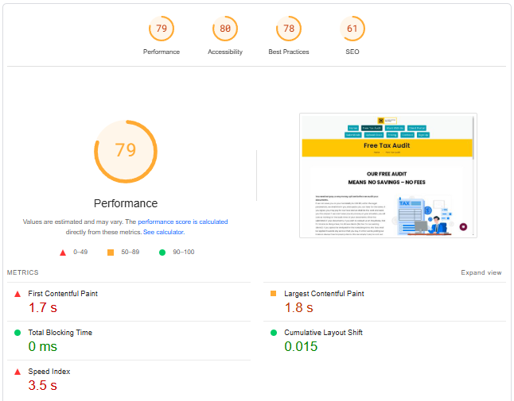
3. | Work With Us  https://allbookkeepingandtaxes.com/work-with-us/ | 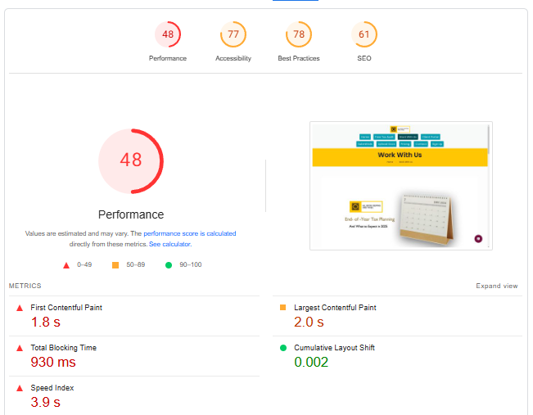
4. | Client Portal  https://allbookkeepingandtaxes.com/client-portal/ | 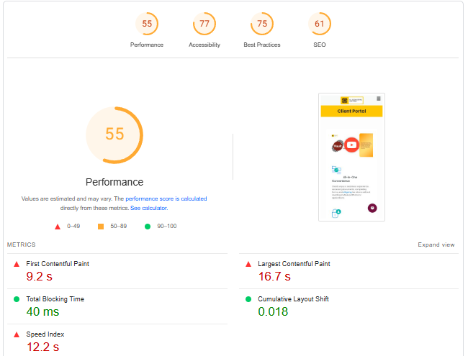
5. | Submittals  https://allbookkeepingandtaxes.com/submittals/ | 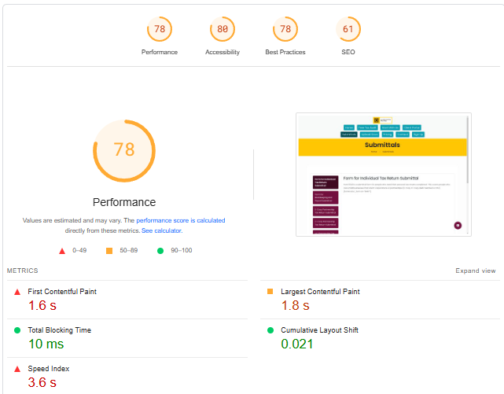
6. | Upload Docs  https://allbookkeepingandtaxes.com/upload-docs/ | 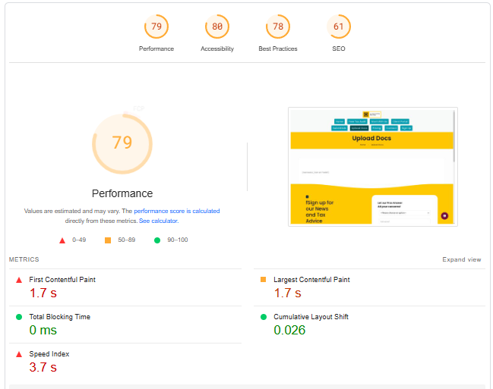
7. | Pricing  https://allbookkeepingandtaxes.com/pricing/ | 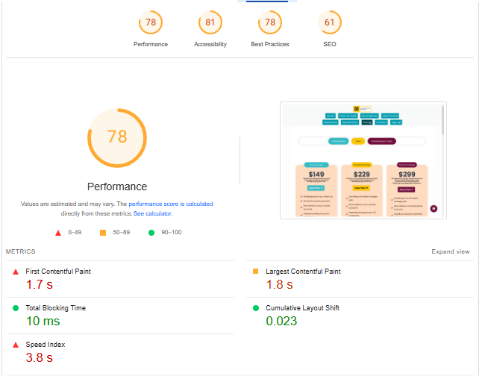
8. | Contact  https://allbookkeepingandtaxes.com/contact/ | 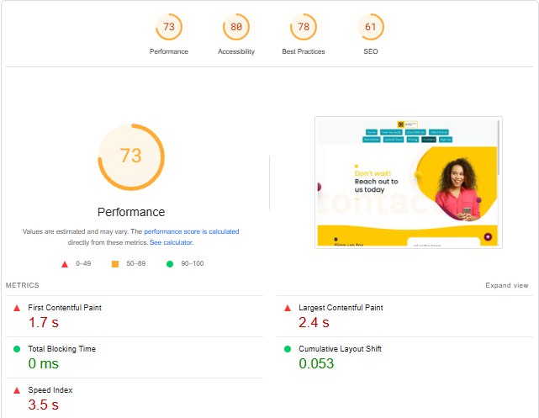
9. | Sign Up  https://app.allbookkeepingandtaxes.com/user/authentication/register | 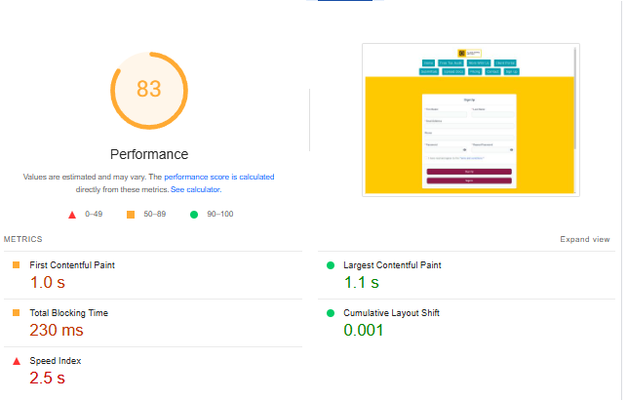
10. | Legal  https://allbookkeepingandtaxes.com/legal/ | 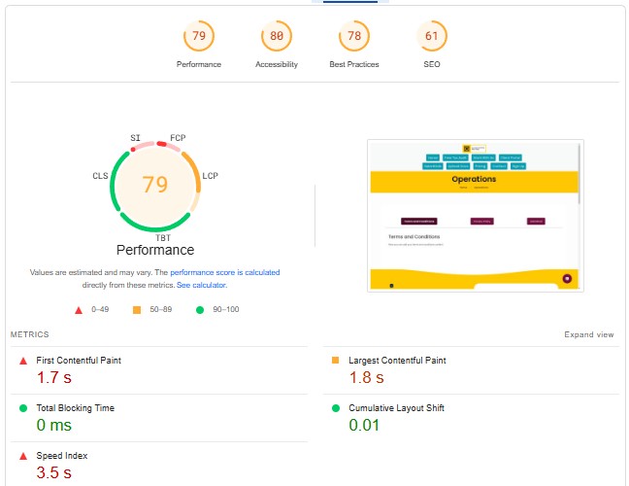
11. | Pro-portal  https://app.allbookkeepingandtaxes.com/user/pro_signup | 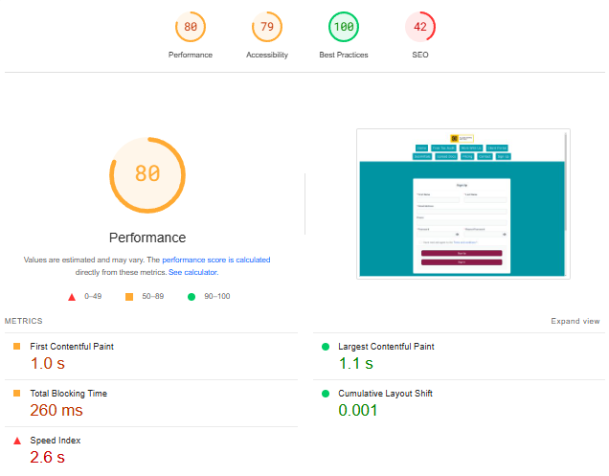
12. | Affilates  https://allbookkeepingandtaxes.com/affiliate-registration/ | 