Div | mytaxwebsite | Wp theme
1. | 
 | Home  Tax Information  Tax Tips  Tax Rates  Retention Guide  Tax Tools  IRS Forms  Due Dates  Financial Calculators  Contact Us  Appointment  Tax Tips & News  Tax Resolution  Payment |   Home  About us  Services  Pricing  Blog  Contact  Free Consultation
2. |  | 
 | Tax Experts At Your Service  Tax Preparation and Financial Services  Contact Us  How Can We Help?  First Name *  Last Name *  Email*  Phone  Message *  Submit | We will help your store to find customers!  Vesibulum egestas at, tellus.Cum socias natoque attirbustes et malesuda et, erat. Suspendisses sed leo valupate eget, auctor.  Try demo
3. |  | 
 | A Wide Range Of  Accounting Services | We provide  a wide range of services  Commodo eros varius taciti etiam tempor aptent sit justo nec quisque vulputate dolor dictumst class vestibulum porttitor massa condimentum est leo maecenas euismod tempus proin non odio aenean hac nunc quis dictumst conubia posuere nam.
4. | 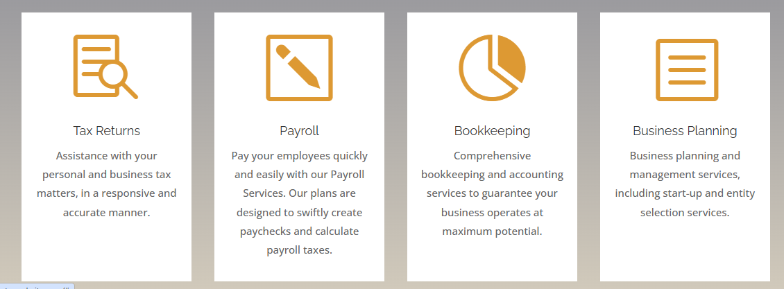 | 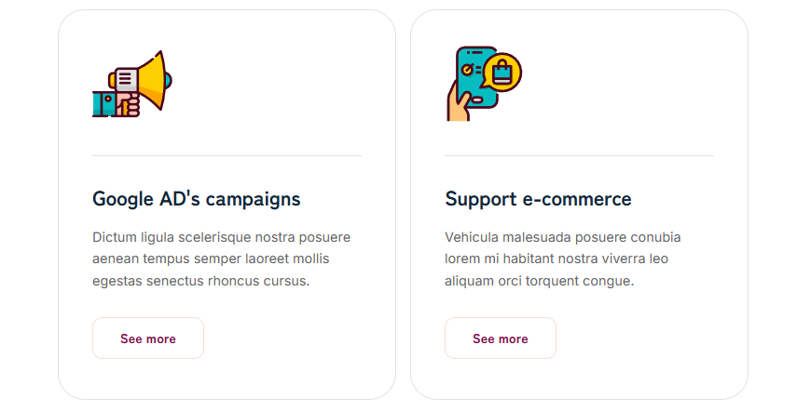
 | Tax Returns  Assistance with your personal and business tax matters, in a responsive and accurate manner.  Payroll  Pay your employees quickly and easily with our Payroll Services. Our plans are designed to swiftly create paychecks and calculate payroll taxes.  Bookkeeping  Comprehensive bookkeeping and accounting services to guarantee your business operates at maximum potential.  Business Planning  Business planning and management services, including start-up and entity selection services. | Google AD's campaigns  Dictum ligula scelerisque nostra posuere aenean tempus semper laoreet mollis egestas senectus rhoncus cursus.  See more  Support e-commerce  Vehicula malesuada posuere conubia lorem mi habitant nostra viverra leo aliquam orci torquent congue.  See more
5. |  | 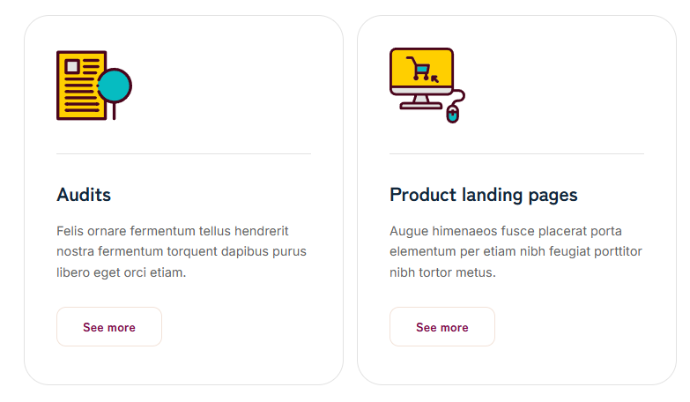
 | ABOUT My Company  We believe in the value of relationships. We view every client relationship like a partnership and truly believe that our success is a result of your success. We are committed to providing close, personal attention to our clients. We take pride in giving you the assurance that the personal assistance you receive comes from years of advanced training, technical experience, and financial acumen.  We provide a variety of services including Income Tax Preparation for all types of businesses and individuals, IRS and State Audit Representation, Payroll Reporting, QuickBooks® setup, support and training, Business startup services, Monthly bookkeeping, Financial statements – making sure your financial records are timely and accurate.  Our continual investment of time and resources in professional continuing education, state-of-the-art computer technology, and extensive business relationships is indicative of our commitment to excellence. | Audits  Felis ornare fermentum tellus hendrerit nostra fermentum torquent dapibus purus libero eget orci etiam.  See more  Product landing pages  Augue himenaeos fusce placerat porta elementum per etiam nibh feugiat porttitor nibh tortor metus.  See more
6. |  | 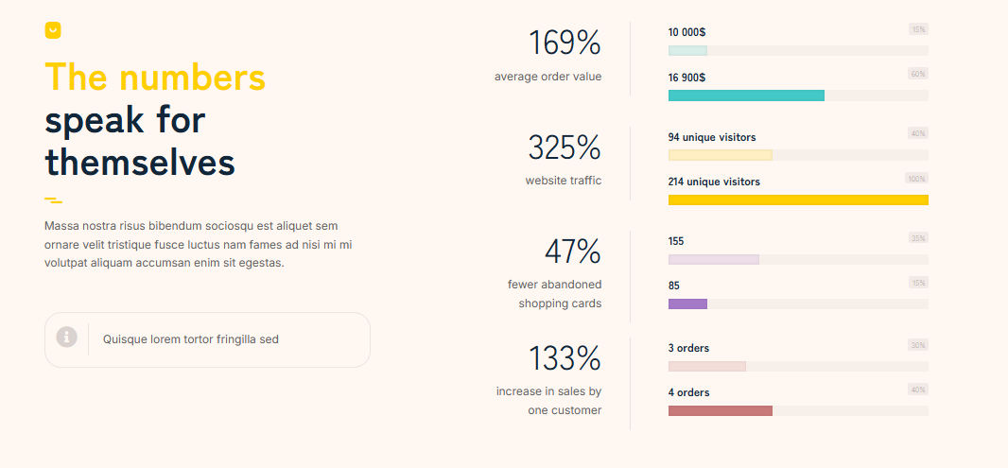
 | Professional Service  A full range of accounting services while giving you the individual attention that you need.  Years of Experience  Volumes of experience working through IRS audit strategies and financial issues. We guarantee that your business is in good hands at all times.  Serving Your Business  Support in all areas of business consulting. Let our team guide you with a financial strategy that leads to business growth and success. | The numbers  speak for themselves  Massa nostra risus bibendum sociosqu est aliquet sem ornare velit tristique fusce luctus nam fames ad nisi mi mi volutpat aliquam accumsan enim sit egestas.  Quisque lorem tortor fringilla sed  169%  average order value  325%  website traffic  47%  fewer abandoned shopping cards  133%  increase in sales by one customer
7. |  | 
 | OUR STAFF  Name Goes Here  Position  Short bio.  Name Goes Here  Position  Short bio.  Name Goes Here  Position  Short bio. | 100 +  shopassistant-sep2  satisfied customers  Awesome!  Lorem ligula sociosqu dapibus imperdiet ligula lorem amet egestas sit inceptos porta feugiat fames erat curabitur non dictumst morbi etiam netus nullam lectus molestie elementum ut pharetra sit dapibus hendrerit.  John Smith  shopassistant-home-pic1  Perfect!  Blandit ultrices ornare pulvinar convallis orci sagittis aliquam curabitur cras consequat vehicula eget malesuada enim justo lectus mauris cursus eu pretium senectus augue non sagittis diam vel tellus curabitur etiam.  John Smith
8. | 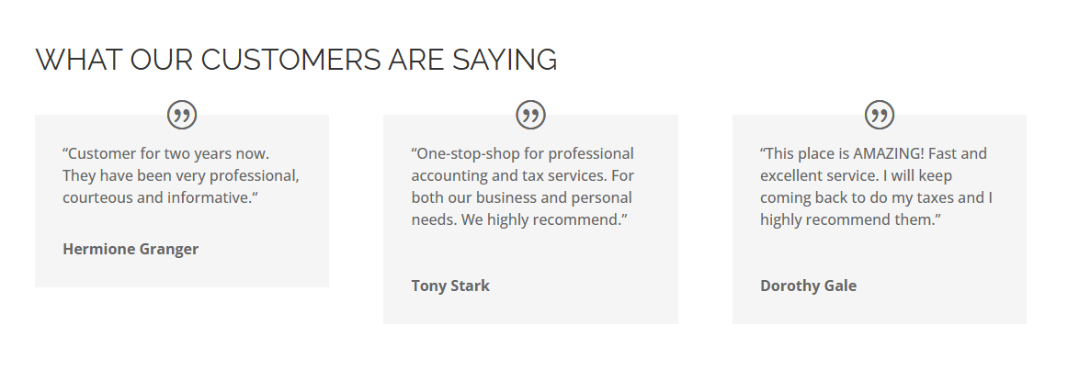 | 
 | WHAT OUR CUSTOMERS ARE SAYING  “Customer for two years now. They have been very professional, courteous and informative.“  Hermione Granger  “One-stop-shop for professional accounting and tax services. For both our business and personal needs. We highly recommend.”  Tony Stark  “This place is AMAZING! Fast and excellent service. I will keep coming back to do my taxes and I highly recommend them.DorothyGale | Our specialists are waiting to help you  Felis congue orci tellus lectus libero consectetur lorem magna eros nostra dapibus bibendum lorem fermentum dolor purus auctor venenatis nec.
9. |  | 
 | Superscribe to our Tax Tips and News Newsletter  Get all the latest news and information on paying your federal taxes, government tax news and local news to help you identify and work with the tax laws.  First Name  Last Name  Email  Subscribe | Jane Cooper  Art director  Joseph Master  CEO  Alexandra Levinski  CTO
10. |  | 
 | - Privacy Policy  HAVE A QUESTION? WE'RE HERE TO HELP  555-111-2222  info@mytaxwebsite.com  1212 Address  City, State ZIP  Copyright ©2024 | My Company | taxPRO Websites | They trust us
11. |  | 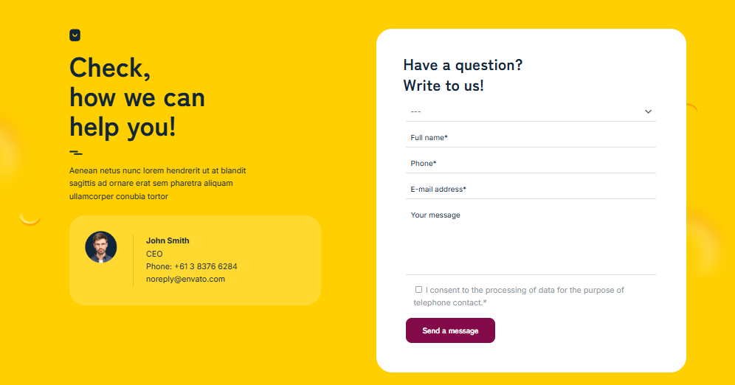
Check,
how we can help you!
Aenean netus nunc lorem hendrerit ut at blandit sagittis ad ornare erat sem pharetra aliquam ullamcorper conubia tortor

John Smith
CEO
Phone: +61 3 8376 6284
noreply@envato.com

Have a question?
Write to us!
Full name*
Phone*
E-mail address*
Your message
I consent to the processing of data for the purpose of telephone contact.*
12. |  | 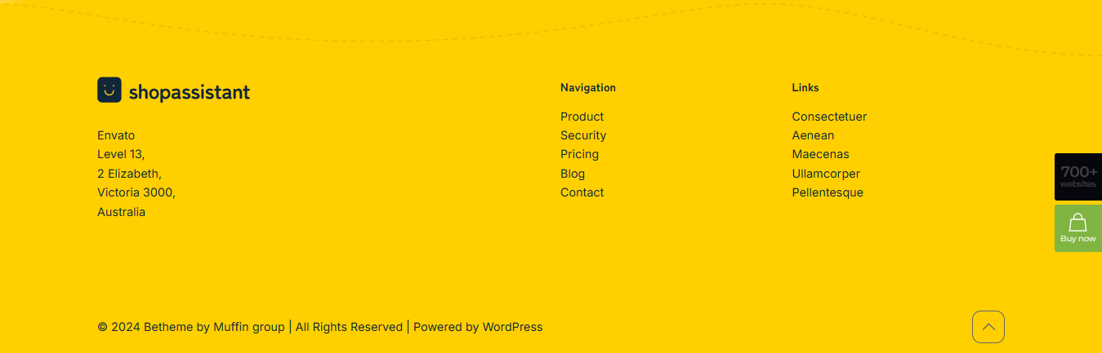
Envato
Level 13,
2 Elizabeth,
Victoria 3000,
Australia

Navigation
Product
Security
Pricing
Blog
Contact

Links
Consectetuer
Aenean
Maecenas
Ullamcorper
Pellentesque

