S.NO | Image | Content | Change Content
- Employee monitoring

https://old0.pnapna.com/en/page/monitoring

Div 1. | 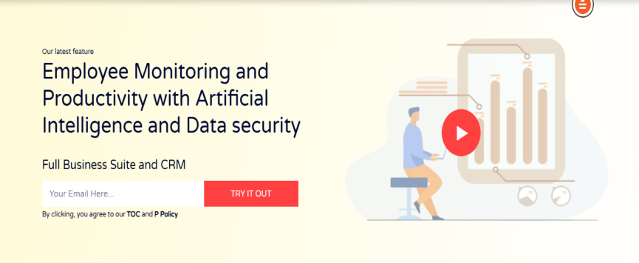 | Our latest feature  Employee Monitoring and Productivity with Artificial Intelligence and Data security  Full Business Suite and CRM  窗体顶端  Your Email Here Try It Out  窗体底端  By clicking, you agree to our TOC and P Policy
Div 2. | 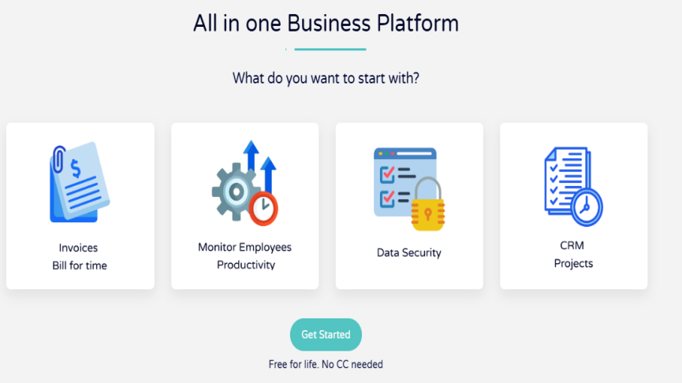 | All in one Business Platform  What do you want to start with?  Invoice bill for time  Monitoring Employees Productivity  Data security  Crm Projects  Get Started  Free for life. No CC needed
Div 3. | 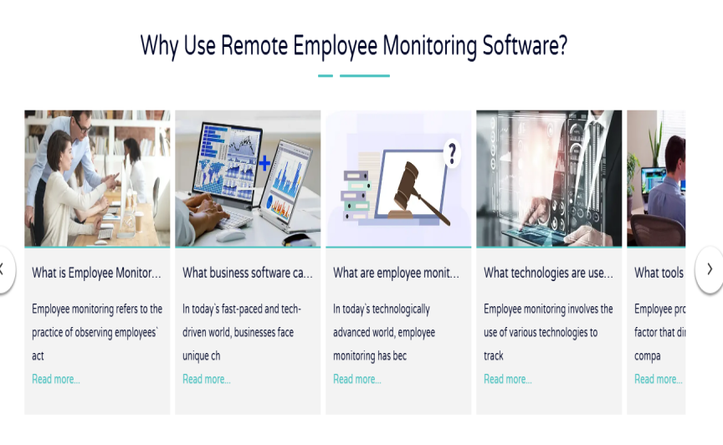 | Why Use Remote Employee Monitoring Software?  What is Employee Monitoring?  Employee monitoring refers to the practice of observing employees` act  Read more...  What business software can be combined with employee monitoring?  In today`s fast-paced and tech-driven world, businesses face unique ch  Read more...  What are employee monitoring laws in the USA?  In today`s technologically advanced world, employee monitoring has bec  Read more...  What technologies are used for employee monitoring?  Employee monitoring involves the use of various technologies to track  Read more.  What tools can be used to boost employee productivity?  Employee productivity is the main factor that directly impacts a compa  Read more.  What is Employee Monitoring?  Employee monitoring refers to the practice of observing employees` act  Read more...  What business software can be combined with employee monitoring?  In today`s fast-paced and tech-driven world, businesses face unique ch  Read more...  What are employee monitoring laws in the USA?  In today`s technologically advanced world, employee monitoring has bec  Read More..
Div 4. | 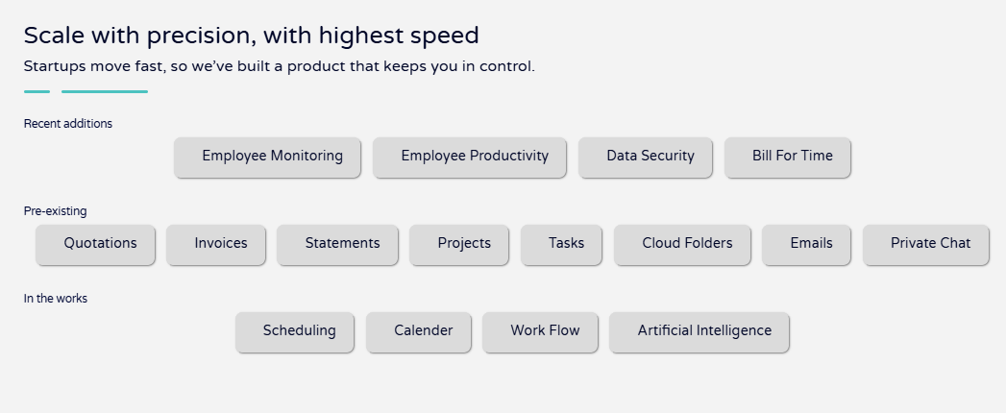 | Scale with precision, with highest speed  Startups move fast, so we’ve built a product that keeps you in control.  Recent additions  Employee Monitoring  Employee Productivity  Data Security  Bill For Time  Pre-existing  Quotations  Invoices  Statements  Projects  Tasks  Cloud Folders  Emails  Private Chat  In the works  Scheduling  Calender  Work Flow  Artificial Intelligence
Div 5. | 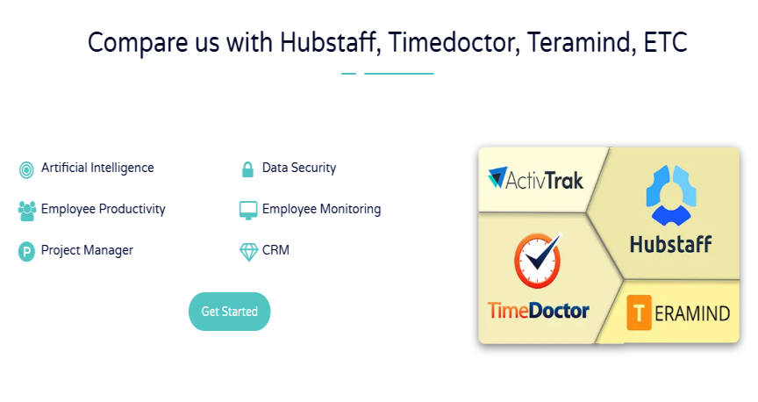 | Compare us with Hubstaff, Timedoctor, Teramind, ETC  Artificial Intelligence  Data Security  Employee Productivity  Employee Monitoring  Project Manager  CRM  Get Started
Div 6. | 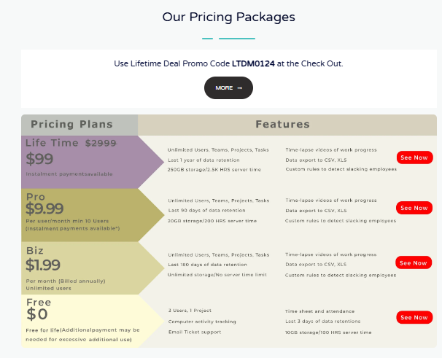 | Our Pricing Packages  Use Lifetime Deal Promo Code LTDM0124 at the Check Out.  More
Div 7. | 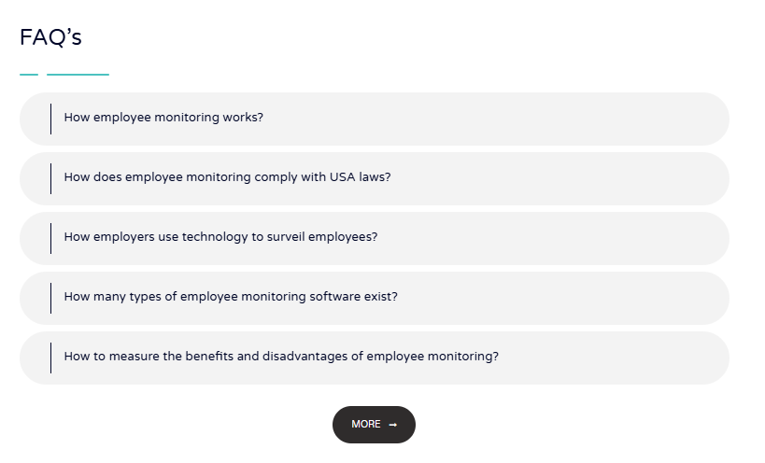 | How employee monitoring works?  The era of fast-paced and technology driven world, businesses are constantly seeking ways to optimize their operations and boost productivity. One of the methods gaining popularity is employee monitoring.Before knowing about how employee monitoring works, it is very important for us to fully know about what is employee monitoring  Read more...  How does employee monitoring comply with USA laws?  Employee monitoring is one of the latest technologies of this era. With employee monitoring many employers can control the activities of their employees. Employee monitoring made too much ease for the big industries, companies and organizations to grow rapidly  Read more...  How employers use technology to surveil employees?  Now, the world has totally changed and it is very important for the employers to surveil their employees. Businesses have access to a variety of tools and technologies that can track and monitor employees every move. This newfound capability has led to the widespread implementation of employee surveillance systems across various industries  Read more...  How many types of employee monitoring software exist?  Employee monitoring is a way in which employers can get access to their employees about their progress report, monitor their screens and track their locations etc.This monitoring can encompass various aspects, such as internet usage  Read more...  How to measure the benefits and disadvantages of employee monitoring?  As we know in the modern era of IT, employee monitoring is growing too fast. Every employer wants to monitor their employees so for this purpose we know that there will be some cons and pros of employee monitoring  Read more...  More
Div 8. | 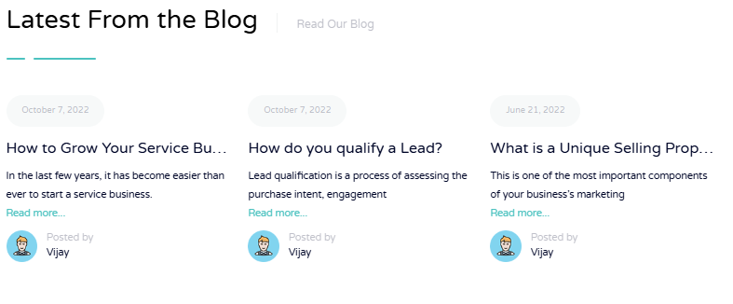 | Latest From the BlogRead Our Blog  October 7, 2022  How to Grow Your Service Business?  In the last few years, it has become easier than ever to start a service business.  Read more...  Posted by  Vijay  October 7, 2022  How do you qualify a Lead?  Lead qualification is a process of assessing the purchase intent, engagement  Read more...  Posted by  Vijay  June 21, 2022  What is a Unique Selling Proposition?  This is one of the most important components of your business’s marketing  Read more...  Posted by  Vijay

S.NO | Image | Content | Change Content
Div 1. | 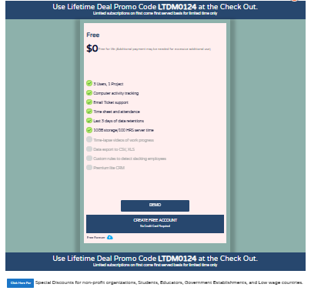 | Free  $0  Free for life (Additional payment may be needed for excessive additional use)  - 3 Users, 1 Project  - Computer activity tracking  - Email Ticket support  - Time sheet and attendance  - Last 3 days of data retentions  - 10GB storage/100 HRS server time  - Time-lapse videos of work progress  - Data export to CSV, XLS  - Custom rules to detect slacking employees  - Premium lite CRM  Free Forever  Use Lifetime Deal Promo Code LTDM0124 at the Check Out.  Limited subscriptions on first come first served basis for limited time only  Special Discounts for non-profit organizations, Students, Educators, Government Establishments, and Low wage countries
Div 2. | 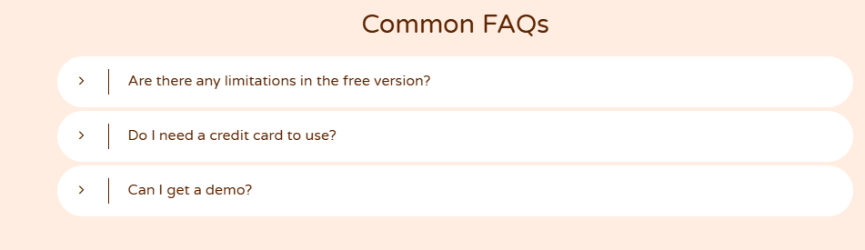 | Common FAQs  Are there any limitations in the free version?  All basic features are available in the free version. You can continue to use this tool for free forever. The difference is that you will not be able to access your older data of more than 3 days and the storage limit/bandwidth hours are 10GB. If you exceed your storage limit you have to pay $9.99/10GB.  Do I need a credit card to use?  No. You can try the free version without entering any credit card details. We need your credit card details to thawrt robots period. However we shall charge your credit card only after 14 days.  Can I get a demo?  Yes of course. Please communicate with us and we will arrange a demo at your convenience. Click here
- Employee monitoring Free Plan

https://old0.pnapna.com/en/page/emon-free-pricing-plans

S.NO | Image | Content | Change Content
Div 1. | 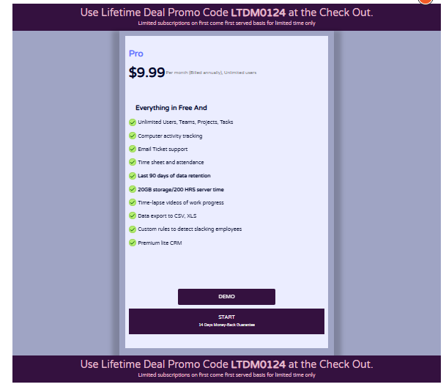 | Use Lifetime Deal Promo Code LTDM0124 at the Check Out.  Limited subscriptions on first come first served basis for limited time only  Pro  $9.99  Per month (Billed annually), Unlimited users  Everything in Free And  - Unlimited Users, Teams, Projects, Tasks  - Computer activity tracking  - Email Ticket support  - Time sheet and attendance  - Last 90 days of data retention  - 20GB storage/200 HRS server time  - Time-lapse videos of work progress  - Data export to CSV, XLS  - Custom rules to detect slacking employees  - Premium lite CRM  Use Lifetime Deal Promo Code LTDM0124 at the Check Out.  Limited subscriptions on first come first served basis for limited time only  Special Discounts for non-profit organizations, Students, Educators, Government Establishments, and Low wage countries
Div 2. | 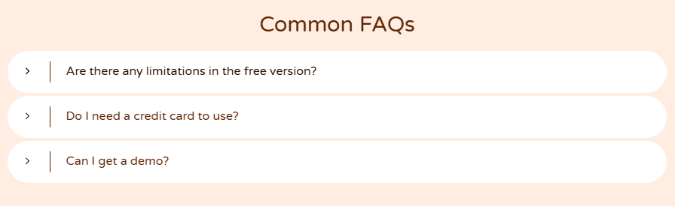 | Common FAQs  Are there any limitations in the free version?  All basic features are available in the free version. You can continue to use this tool for free forever. The difference is that you will not be able to access your older data of more than 3 days and the storage limit/bandwidth hours are 10GB. If you exceed your storage limit you have to pay $9.99/10GB.  Do I need a credit card to use?  No. You can try the free version without entering any credit card details. We need your credit card details to thawrt robots period. However we shall charge your credit card only after 14 days.  Can I get a demo?  Yes of course. Please communicate with us and we will arrange a demo at your convenience. Click here
- Employee monitoring Pro plan

https://old0.pnapna.com/en/page/emon-pro-pricing-plans

S.NO | Image | Content | Change Content
Div 1. | 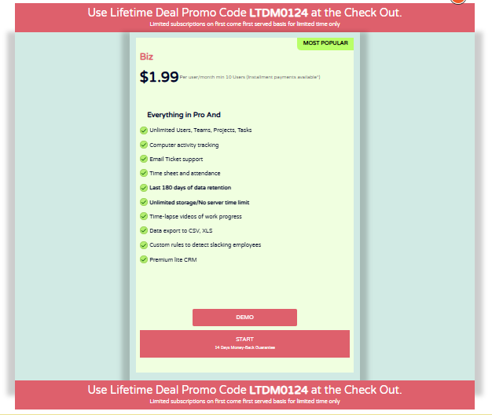 | Use Lifetime Deal Promo Code LTDM0124 at the Check Out.  Limited subscriptions on first come first served basis for limited time only  Most Popular  Biz  $1.99  Per user/month min 10 Users (Installment payments available*)  Everything in Pro And  Unlimited Users, Teams, Projects, Tasks  Computer activity tracking  Email Ticket support  Time sheet and attendance  Last 180 days of data retention  Unlimited storage/No server time limit  Time-lapse videos of work progress  Data export to CSV, XLS  Custom rules to detect slacking employees  Premium lite CRM  Use Lifetime Deal Promo Code LTDM0124 at the Check Out.  Limited subscriptions on first come first served basis for limited time only  Special Discounts for non-profit organizations, Students, Educators, Government Establishments, and Low wage countries.
Div 2. |  | Common FAQs  Are there any limitations in the free version?  All basic features are available in the free version. You can continue to use this tool for free forever. The difference is that you will not be able to access your older data of more than 3 days and the storage limit/bandwidth hours are 10GB. If you exceed your storage limit you have to pay $9.99/10GB.  Do I need a credit card to use?  No. You can try the free version without entering any credit card details. We need your credit card details to thawrt robots period. However we shall charge your credit card only after 14 days.  Can I get a demo?  Yes of course. Please communicate with us and we will arrange a demo at your convenience. Click here
- Employee monitoring Biz plan

https://old0.pnapna.com/en/page/emon-biz-pricing-plans

Div 1. | 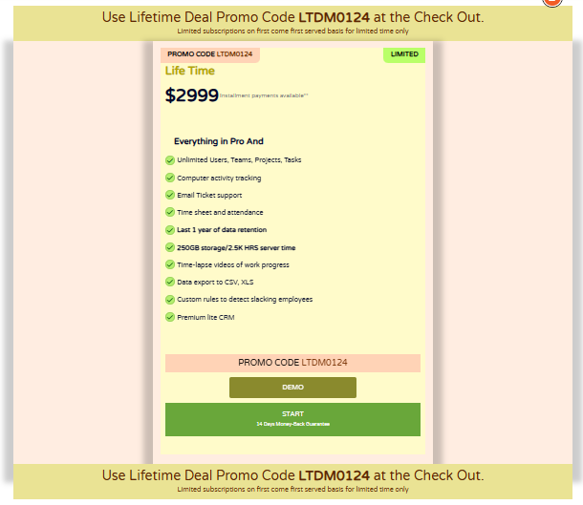 | Use Lifetime Deal Promo Code LTDM0124 at the Check Out.  Limited subscriptions on first come first served basis for limited time only  Promo Code LTDM0124Limited  Life Time  $2999  Installment payments available**  Everything in Pro And  Unlimited Users, Teams, Projects, Tasks  Computer activity tracking  Email Ticket support  Time sheet and attendance  Last 1 year of data retention  250GB storage/2.5K HRS server time  Time-lapse videos of work progress  Data export to CSV, XLS  Custom rules to detect slacking employees  Premium lite CRM  Promo Code LTDM0124  Use Lifetime Deal Promo Code LTDM0124 at the Check Out.  Limited subscriptions on first come first served basis for limited time only  Special Discounts for non-profit organizations, Students, Educators, Government Establishments, and Low wage countries.
Div 2. |  | Common FAQs  Are there any limitations in the free version?  All basic features are available in the free version. You can continue to use this tool for free forever. The difference is that you will not be able to access your older data of more than 3 days and the storage limit/bandwidth hours are 10GB. If you exceed your storage limit you have to pay $9.99/10GB.  Do I need a credit card to use?  No. You can try the free version without entering any credit card details. We need your credit card details to thawrt robots period. However we shall charge your credit card only after 14 days.  Can I get a demo?  Yes of course. Please communicate with us and we will arrange a demo at your convenience. Click here
- Employee monitoring Life time plan

https://old0.pnapna.com/en/page/emon-life-time-pricing-plans

- Employee monitoring

https://old0.pnapna.com/en/page/employee-monitoring
S.NO | Image | Content | Change Content
Div 1. | 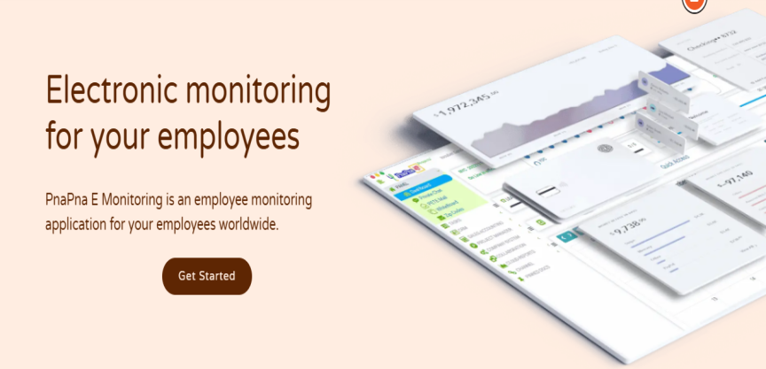 | Electronic monitoring  for your employees  PnaPna E Monitoring is an employee monitoring  application for your employees worldwide.  Get Started
Div 2. | 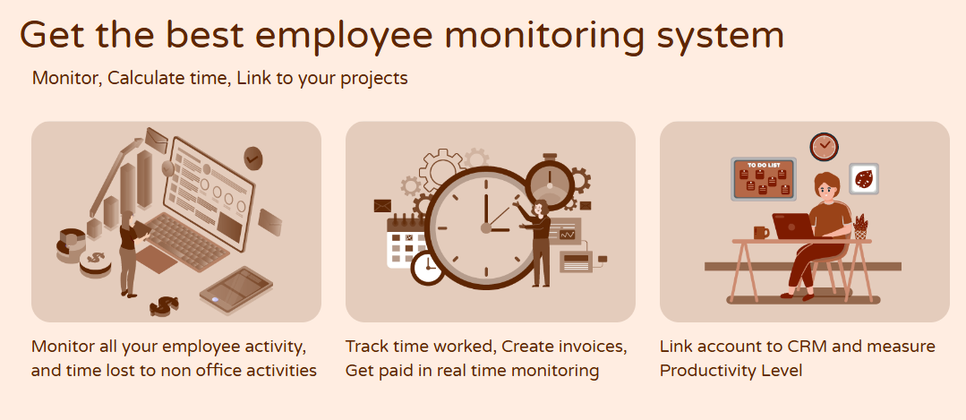 | Get the best employee monitoring system  Monitor, Calculate time, Link to your projects  Monitor all your employee activity, and time lost to non office activities  Track time worked, Create invoices, Get paid in real time monitoring  Link account to CRM and measure Productivity Level
Div 3. | 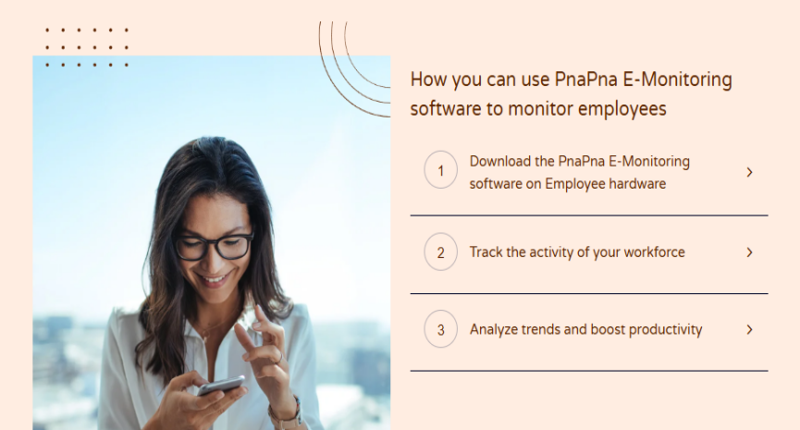 | How you can use PnaPna E-Monitoring software to monitor employees  - Download the PnaPna E-Monitoring software on Employee hardware  Empower your team with our employee location tracking system and monitor activity with our app for Windows, Linux, and Mac. Our software works seamlessly in the background, allowing you to monitor your employees and freelancers discreetly  - Track the activity of your workforce  Our cutting-edge software allows you to effortlessly track your employees' app usage and website activity. Additionally, you have the option to configure the software to automatically capture screenshots or videos of your employees' screens at regular intervals, providing you with comprehensive insights into their work activities.  3.Analyze trends and boost productivity  PnaPna's advanced employee monitoring solution offers a range of powerful features such as optional screenshots, activity levels to enhance productivity. Gain valuable insights from the AI.
Div 4. | 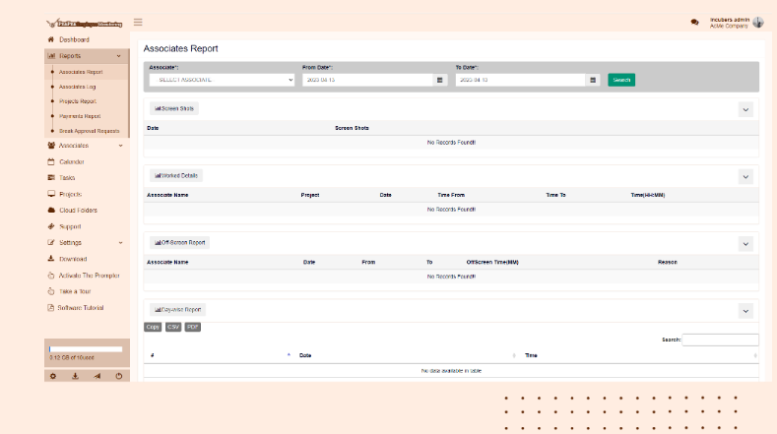
Div 5. | 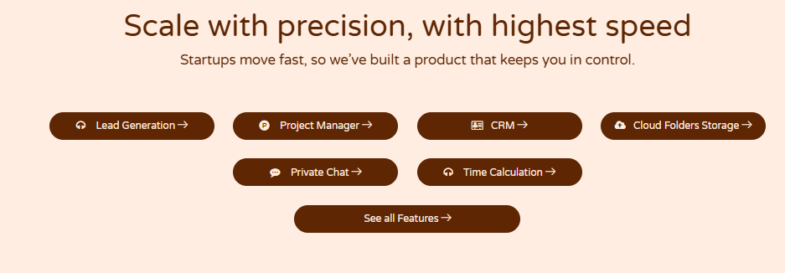 | Scale with precision, with highest speed  Startups move fast, so we’ve built a product that keeps you in control.  Lead Generation  Project Manager  CRM  Cloud Folders Storage  Private Chat  Time Calculation  See all Features
Div 6. | 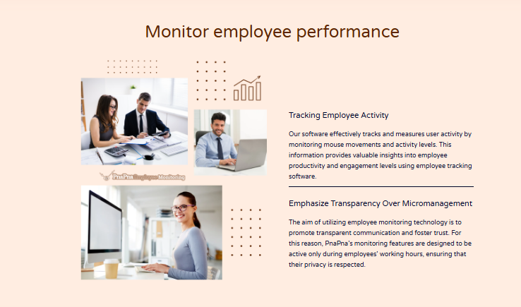 | Monitor employee performance  Tracking Employee Activity  Our software effectively tracks and measures user activity by monitoring mouse movements and activity levels. This information provides valuable insights into employee productivity and engagement levels using employee tracking software.  Emphasize Transparency Over Micromanagement  The aim of utilizing employee monitoring technology is to promote transparent communication and foster trust. For this reason, PnaPna's monitoring features are designed to be active only during employees' working hours, ensuring that their privacy is respected.
Div 7. | 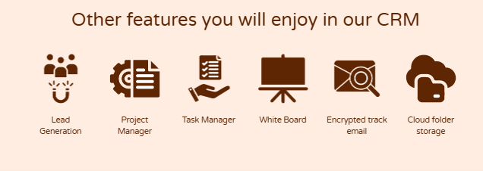 | Other features you will enjoy in our CRM  Lead Generation  Project Manager  Task Manager  White Board  Encrypted track email  Cloud folder storage
Div 8. |  | Pay $0 per month (Free Plan)  Get pro feature $9.99/month  Get Life time deal for $2,999.99 $99.99  Pricing and Plans
Div 9. | 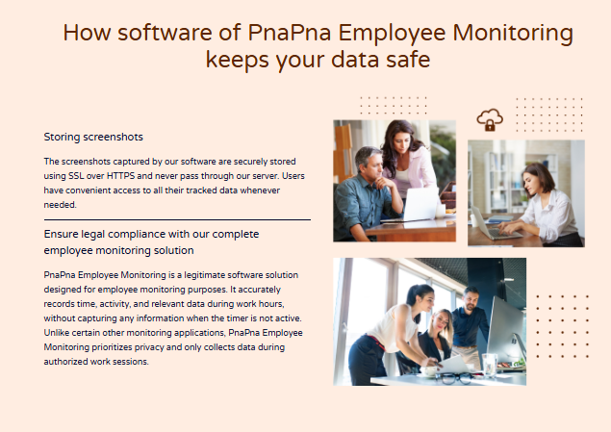 | How software of PnaPna Employee Monitoring keeps your data safe  Storing screenshots  The screenshots captured by our software are securely stored using SSL over HTTPS and never pass through our server. Users have convenient access to all their tracked data whenever needed.  Ensure legal compliance with our complete employee monitoring solution  PnaPna Employee Monitoring is a legitimate software solution designed for employee monitoring purposes. It accurately records time, activity, and relevant data during work hours, without capturing any information when the timer is not active. Unlike certain other monitoring applications, PnaPna Employee Monitoring prioritizes privacy and only collects data during authorized work sessions.
Div 10. |  | Get Started and reap the benefits  in 10 minutes or less  Scale smoothly with our application.  Sign Up

- Knowledge base

https://old0.pnapna.com/en/page/kb-tech
S.NO | Image | Content | Change Content
Div 1. | 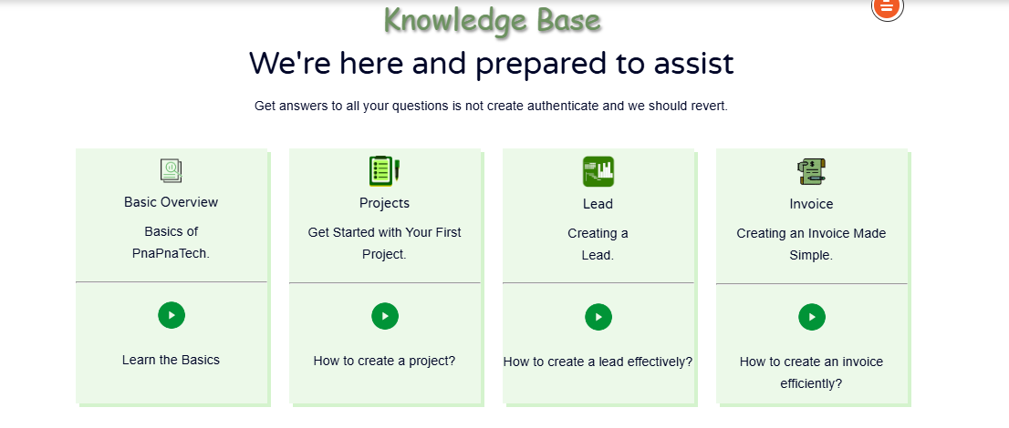 | Knowledge Base  We're here and prepared to assist  Get answers to all your questions is not create authenticate and we should revert.  Basic Overview  Basics of  PnaPnaTech.  Learn the Basics  Projects  Get Started with Your First Project.  How to create a project?  Lead  Creating a  Lead.  How to create a lead effectively?  Invoice  Creating an Invoice Made Simple.  How to create an invoice efficiently?
Div 2. | 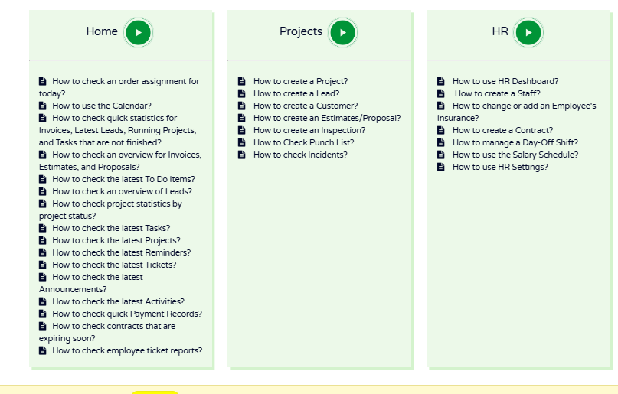 | Home  How to check an order assignment for today?  How to use the Calendar?  How to check quick statistics for Invoices, Latest Leads, Running Projects, and Tasks that are not finished?  How to check an overview for Invoices, Estimates, and Proposals?  How to check the latest To Do Items?  How to check an overview of Leads?  How to check project statistics by project status?  How to check the latest Tasks?  How to check the latest Projects?  How to check the latest Reminders?  How to check the latest Tickets?  How to check the latest Announcements?  How to check the latest Activities?  How to check quick Payment Records?  How to check contracts that are expiring soon?  How to check employee ticket reports?  Projects  How to create a Project?  How to create a Lead?  How to create a Customer?  How to create an Estimates/Proposal?  How to create an Inspection?  How to Check Punch List?  How to check Incidents?  HR  How to use HR Dashboard?  How to create a Staff?  How to change or add an Employee's Insurance?  How to create a Contract?  How to manage a Day-Off Shift?  How to use the Salary Schedule?  How to use HR Settings?
Div 3. | 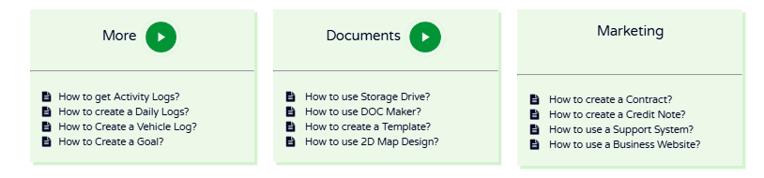 | More  How to get Activity Logs?  How to create a Daily Logs?  How to Create a Vehicle Log?  How to Create a Goal?  Documents  How to use Storage Drive?  How to use DOC Maker?  How to create a Template?  How to use 2D Map Design?  Marketing  How to create a Contract?  How to create a Credit Note?  How to use a Support System?  How to use a Business Website?
Div 4. | 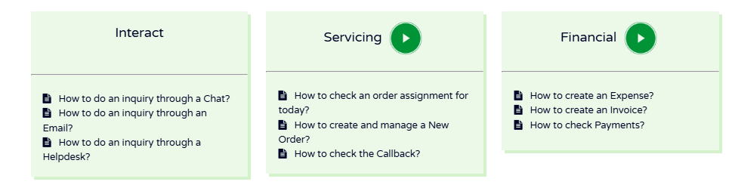 | Interact  How to do an inquiry through a Chat?  How to do an inquiry through an Email?  How to do an inquiry through a Helpdesk?  Servicing  How to check an order assignment for today?  How to create and manage a New Order?  How to check the Callback?  Financial  How to create an Expense?  How to create an Invoice?  How to check Payments?

