S.NO | Image | Content | Change Content

- Main Cleaning Webpage

https://old0.pnapna.com/en/page/maid-cleaning
Div 1. |  | Maid Cleaning  Powered by PnaPna  Strategy and growth solutions for cleaners  Get Started Free For Life  Give Me Free 100 Leads
Div 2. | 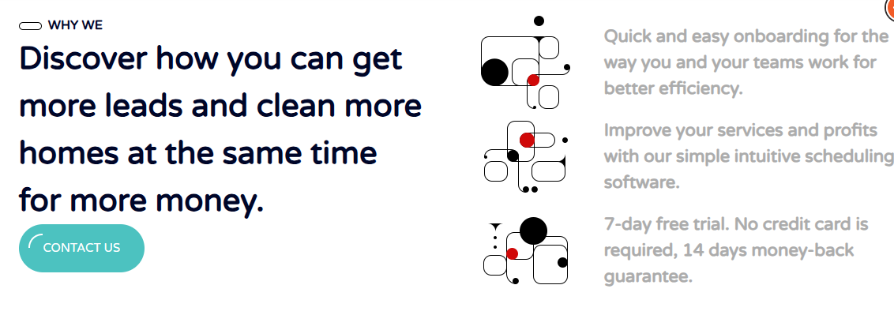 | WHY WE  Discover how you can get more leads and clean more homes at the same time for more money.  Contact us  Quick and easy onboarding for the way you and your teams work for better efficiency.  cleaning scheduling  Improve your services and profits with our simple intuitive scheduling software.  automatic scheduling  7-day free trial. No credit card is required, 14 days money-back guarantee.
Div 3. | 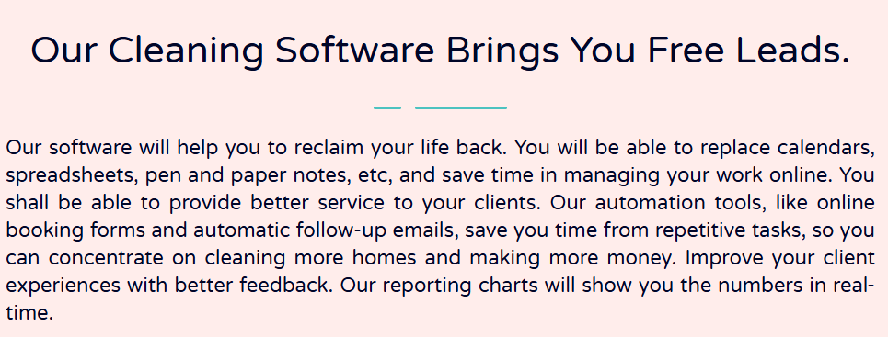 | Our Cleaning Software Brings You Free Leads.  Our software will help you to reclaim your life back. You will be able to replace calendars, spreadsheets, pen and paper notes, etc, and save time in managing your work online. You shall be able to provide better service to your clients. Our automation tools, like online booking forms and automatic follow-up emails, save you time from repetitive tasks, so you can concentrate on cleaning more homes and making more money. Improve your client experiences with better feedback. Our reporting charts will show you the numbers in real-time.
Div 4. | 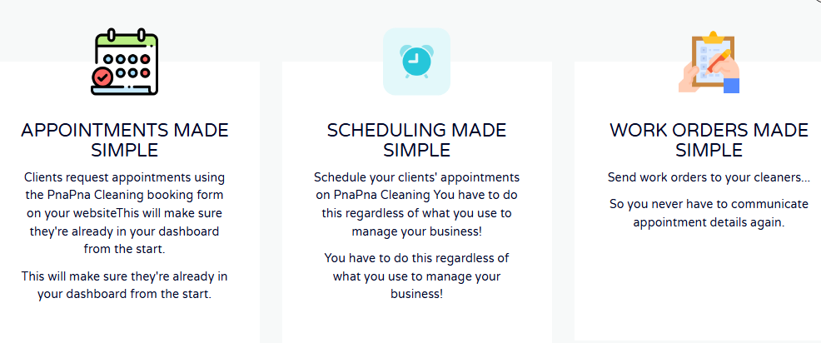  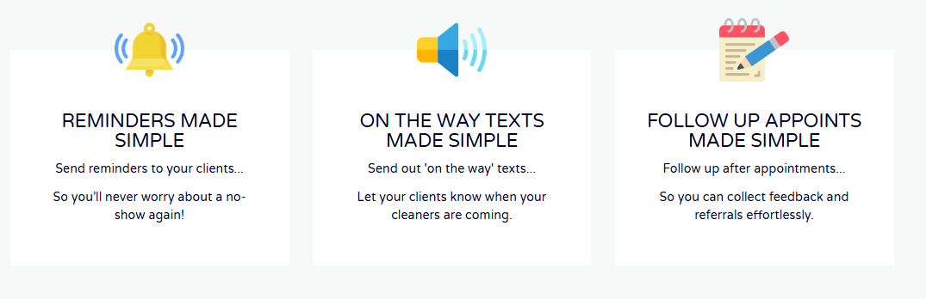 | Appointments Made Simple  Clients request appointments using the PnaPna Cleaning booking form on your websiteThis will make sure they're already in your dashboard from the start.  This will make sure they're already in your dashboard from the start.  Scheduling Made Simple  Schedule your clients' appointments on PnaPna Cleaning You have to do this regardless of what you use to manage your business!  You have to do this regardless of what you use to manage your business!  Work Orders Made Simple  Send work orders to your cleaners…  So you never have to communicate appointment details again.  Reminders Made Simple  Send reminders to your clients...  So you’ll never worry about a no-show again!  On the way texts Made Simple  Send out 'on the way' texts...  Let your clients know when your cleaners are coming.  Follow up Appoints Made Simple  Follow up after appointments...  So you can collect feedback and referrals effortlessly.
Div 5. | 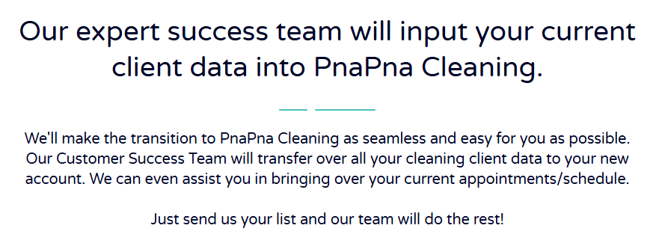 | Our expert success team will input your current client data into PnaPna Cleaning.  We'll make the transition to PnaPna Cleaning as seamless and easy for you as possible. Our Customer Success Team will transfer over all your cleaning client data to your new account. We can even assist you in bringing over your current appointments/schedule.  Just send us your list and our team will do the rest!
Div 6. | 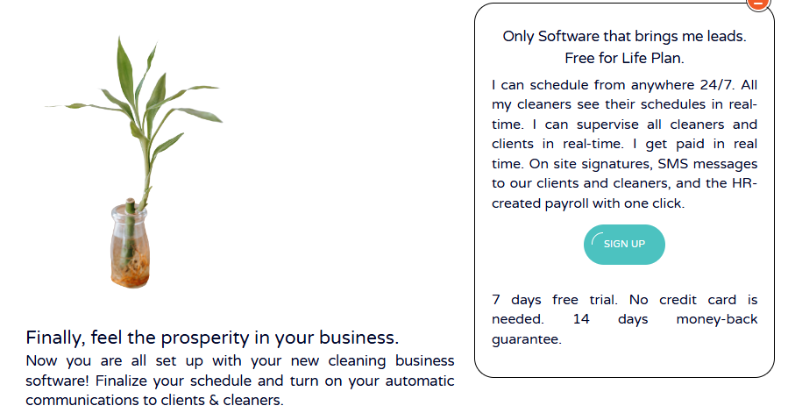 | Finally, feel the prosperity in your business.  Now you are all set up with your new cleaning business software! Finalize your schedule and turn on your automatic communications to clients & cleaners.  Only Software that brings me leads. Free for Life Plan.  I can schedule from anywhere 24/7. All my cleaners see their schedules in real-time. I can supervise all cleaners and clients in real-time. I get paid in real time. On site signatures, SMS messages to our clients and cleaners, and the HR-created payroll with one click.  Sign Up  7 days free trial. No credit card is needed. 14 days money-back guarantee.
Div 7. |  | Our User Zilda Torres States.  American Cleaners of Colorado increased  her business from one location to four  locations and $250K per year.  $250K  Per year reached  in 1 year  Easiest Scheduling  by anyone  4  Locations on  1 subscription  48  Employee payroll  handled automatically  99%  Uptime  guarantee
Div 8. | 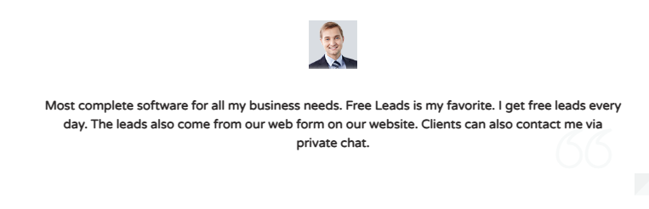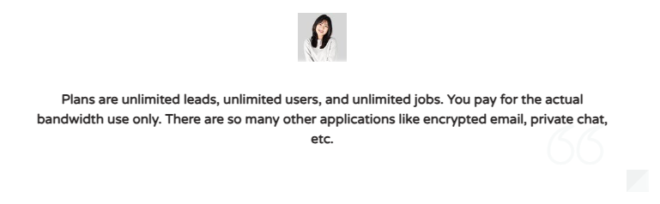 | Most complete software for all my business needs. Free Leads is my favorite. I get free leads every day. The leads also come from our web form on our website. Clients can also contact me via private chat.  Cheapest monthly subscriptions. Also, there is a lighter version  that is “Free for Lifetime”. 7 days free trial. No credit cards  are needed. 14 days money-back guarantee.  Plans are unlimited leads, unlimited users, and unlimited jobs.  You pay for the actual bandwidth use only. There are so many  other applications like encrypted email, private chat, etc.
Div 9 |  | Get new Leads  This is the only  software that brings  me new client leads.
Div 10. | 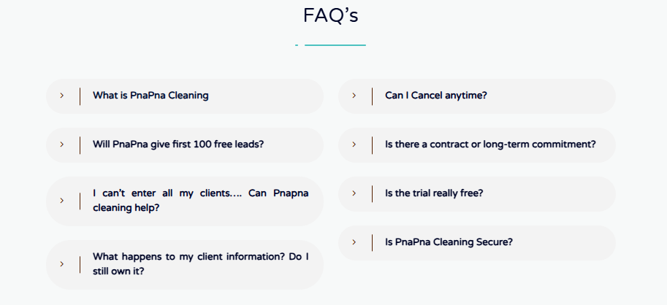 | 1. What is PnaPna Cleaning  PnaPna service software is software that caters specifically to residential home cleaning businesses. Your maid service should use software designed for maid services like yours by maid service owners like you. Your scheduling solution should improve your team's efficiency and help you provide your customer with an even better customer experience.  - Will PnaPna give first 100 free leads?  Yes, up to the first 100 leads are free from our market place.  - I can’t enter all my clients…. Can Pnapna cleaning help?  You bet we can! Just send us over your current client information however you have it, and the PnaPna team will format and upload it to your new account. FREE!  - What happens to my client information? Do I still own it?  Yes, PnaPna Cleaning's terms of service state that the only right we have to your clients information is to assist you with your account. You own any data you keep in PnaPna Cleaning.  - Can I Cancel anytime?  Yes.  - Is there a contract or long-term commitment?  No, you can try any of PnaPna Cleaning plans on a month-to-month agreement, with no signature necessary. If PnaPna Cleaning isn’t for you can cancel anytime.  - Is the trial really free?  Yes, when you sign up today, you’ll have days of free access to the best software on the market for PnaPna services. No hidden fees or surprise bills.  - Is PnaPna Cleaning Secure?  Yes, your payment information and customer information are safe with us.

Div 11. | 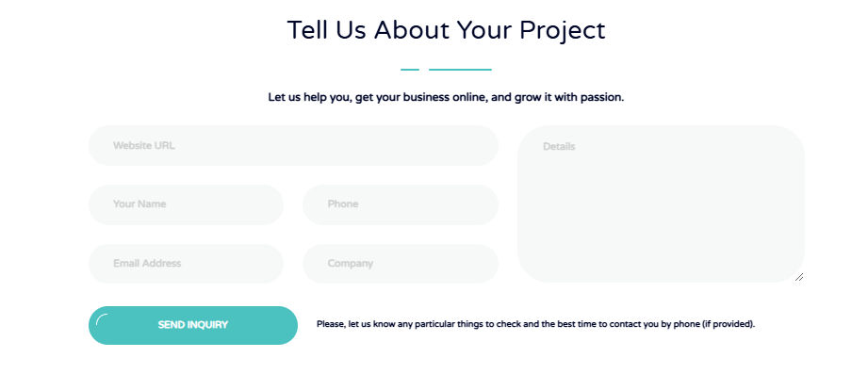 | Tell Us About Your Project  Let us help you, get your business online, and grow it with passion.  Website url :  Your name:  Phone:  Email Address:  Company:  Details:  Send inquery  Please, let us know any particular things to check and the best time to contact you by phone (if provided).

- Contractor-business-software

https://old0.pnapna.com/en/page/contractor-business-software

S.NO | Image | Content | Change Content
Div 1. | 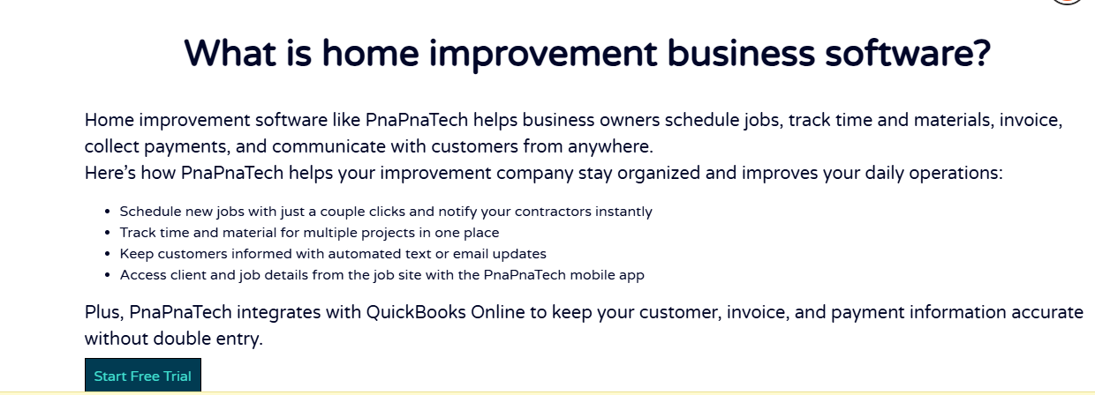 | What is home improvement business software?  Home improvement software like PnaPnaTech helps business owners schedule jobs, track time and materials, invoice, collect payments, and communicate with customers from anywhere.  Here’s how PnaPnaTech helps your improvement company stay organized and improves your daily operations:  - Schedule new jobs with just a couple clicks and notify your contractors instantly  - Track time and material for multiple projects in one place  - Keep customers informed with automated text or email updates  - Access client and job details from the job site with the PnaPnaTech mobile app  Plus, PnaPnaTech integrates with QuickBooks Online to keep your customer, invoice, and payment information accurate without double entry.  Start free trail
Div 2. | 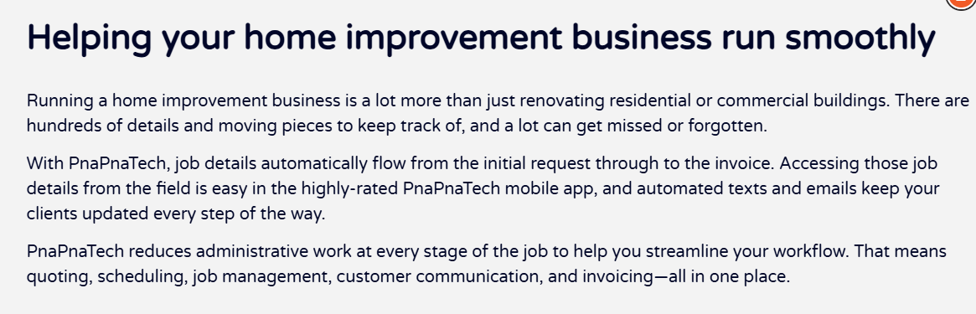 | Helping your home improvement business run smoothly  Running a home improvement business is a lot more than just renovating residential or commercial buildings. There are hundreds of details and moving pieces to keep track of, and a lot can get missed or forgotten.  With PnaPnaTech, job details automatically flow from the initial request through to the invoice. Accessing those job details from the field is easy in the highly-rated PnaPnaTech mobile app, and automated texts and emails keep your clients updated every step of the way.  PnaPnaTech reduces administrative work at every stage of the job to help you streamline your workflow. That means quoting, scheduling, job management, customer communication, and invoicing—all in one place.
Div 3. | 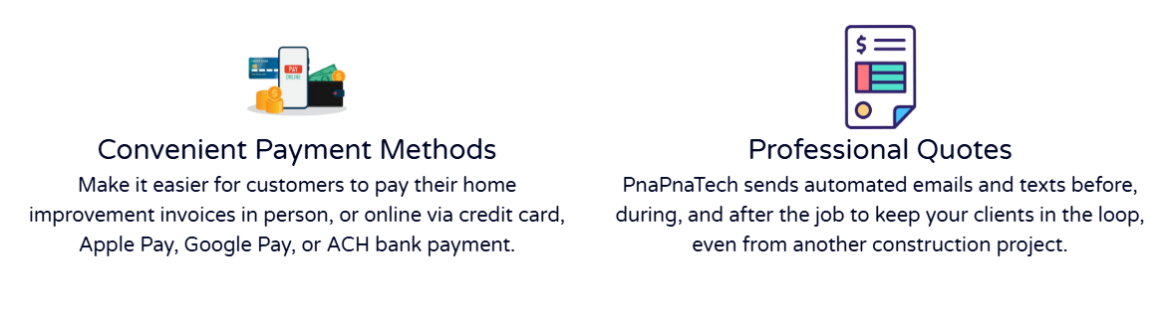  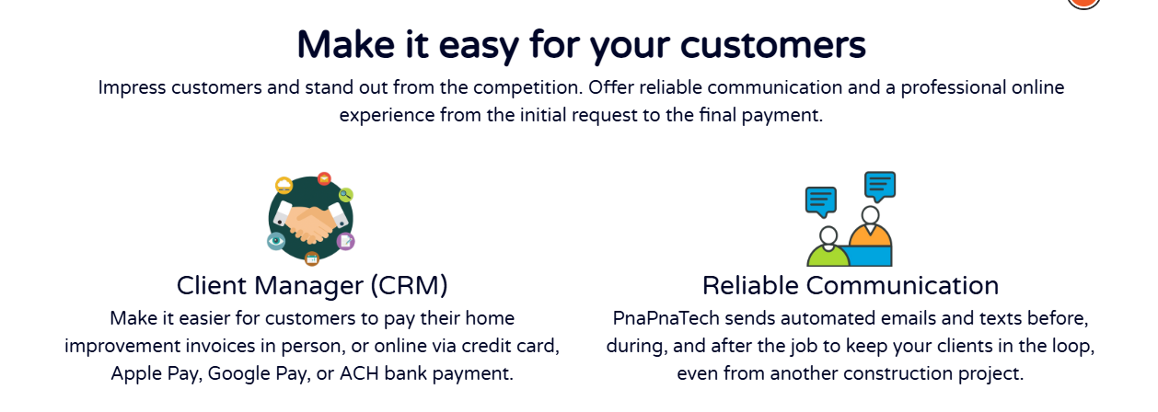 | Make it easy for your customers  Impress customers and stand out from the competition. Offer reliable communication and a professional online  experience from the initial request to the final payment.  Client Manager (CRM)  Make it easier for customers to pay their home improvement invoices in person, or online via credit card, Apple Pay, Google Pay, or ACH bank payment.  Reliable Communication  PnaPnaTech sends automated emails and texts before, during, and after the job to keep your clients in the loop, even from another construction project.  Convenient Payment Methods  Make it easier for customers to pay their home improvement invoices in person, or online via credit card, Apple Pay, Google Pay, or ACH bank payment.  Professional Quotes  PnaPnaTech sends automated emails and texts before, during, and after the job to keep your clients in the loop, even from another construction project.
Div 4. | 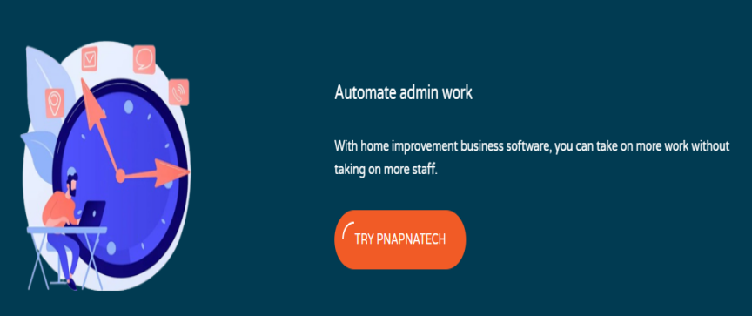 | Automate admin work  With home improvement business software, you can take on more work without taking on more staff.  TRY PNAPNATECH
Div 5. | 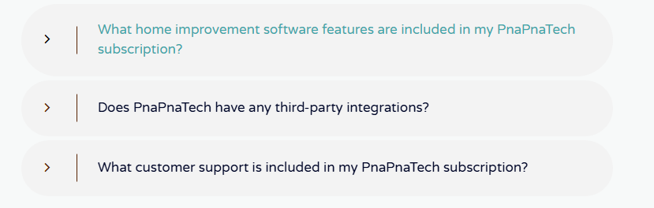  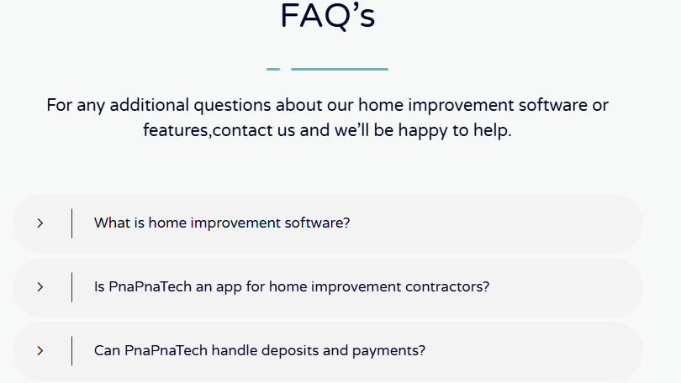 | FAQ’s  For any additional questions about our home improvement software or features,contact us and we’ll be happy to help.  What is home improvement software?  Home improvement software is used by business owners and their employees to organize and manage their daily operations. This means one platform to manage clients, quote jobs, schedule visits, dispatch and route crews, track time, invoice, and collect payments. Using software helps you run your home improvement and construction business more efficiently so you can improve customer service, win more jobs, and grow.  Is PnaPnaTech an app for home improvement contractors?  Yes. The PnaPnaTech mobile app is designed with home improvement businesses in mind. PnaPnaTech lets you manage your operations from anywhere, and gives your remodelers access to their schedules, work order information, and turn-by-turn directions to their next job. The PnaPnaTech mobile app is available on iOS and Android devices.  Can PnaPnaTech handle deposits and payments?  PnaPnaTech offers convenient credit card processing on the job site, or online through client hub. Securely save your client’s card information on file so you can accept deposits and instantly charge them when the work is done.  What home improvement software features are included in my PnaPnaTech subscription?  PnaPnaTech’s field service management software has different plans for all of your home improvement business’s needs. Each plan offers a different set of features designed to help you run a smoother home improvement business. All plans include a CRM, online customer portal, quoting, invoicing, and payments. Learn more about our plans and pricing.  Does PnaPnaTech have any third-party integrations?  Yes! PnaPnaTech integrates with your favorite apps like QuickBooks Online and Mailchimp to help you do more with your home improvement business.  What customer support is included in my PnaPnaTech subscription?  Whether you’re checking us out for the first time, or you’re one of our oldest customers, we’ve got your back when it comes to support. Phone support, email support, and online chat are available to you for free and included in all PnaPnaTech plans. Plus, PnaPnaTech offers free 1-on-1 product coaching to get you started. Learn more about PnaPnaTech’s award-winning customer service.
Div 6. | 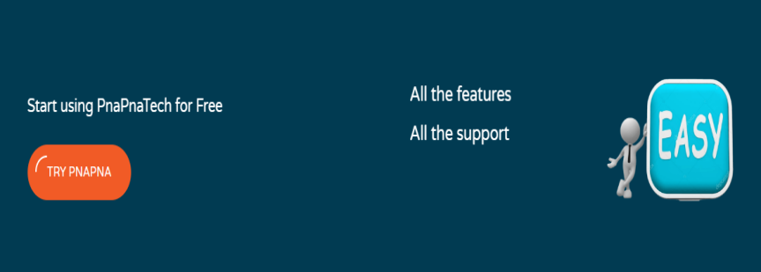 | Start using PnaPnaTech for Free  Try PnaPna  All the features  All the support
Div 7. | 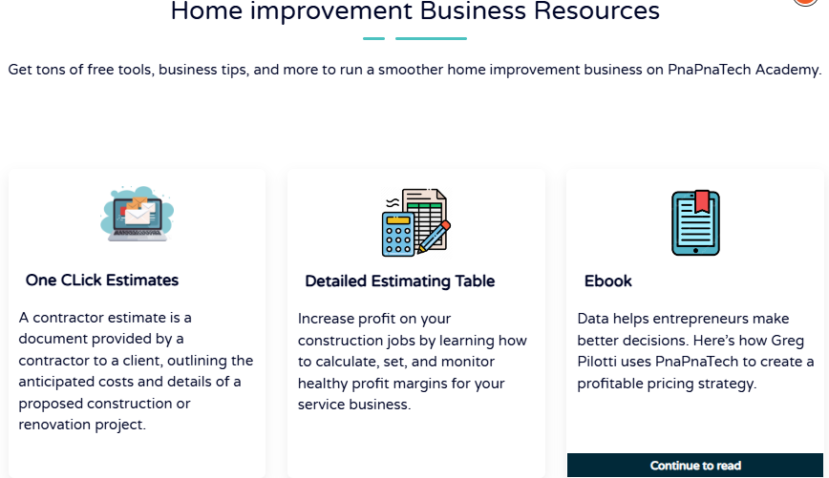 | Home improvement Business Resources  Get tons of free tools, business tips, and more to run a smoother home improvement business on PnaPnaTech Academy.  One Click Estimates  A contractor estimate is a document provided by a contractor to a client, outlining the anticipated costs and details of a proposed construction or renovation project.  Detailed Estimating Table  Increase profit on your construction jobs by learning how to calculate, set, and monitor healthy profit margins for your service business.  Ebook  Data helps entrepreneurs make better decisions. Here’s how Greg Pilotti uses PnaPnaTech to create a profitable pricing strategy.  Continue to read

- Image-sharing webpage

S.NO | Image | Content | Change Content
Div 1. | 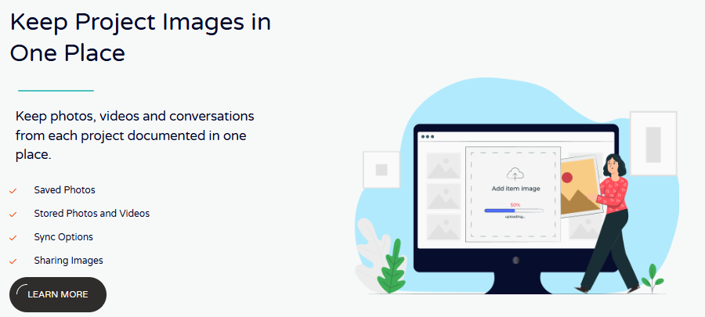 | Keep Project Images in One Place  Keep photos, videos and conversations from each project documented in one place.  Saved Photos  Stored Photos and Videos  Sync Options  Sharing Images  Learn More
Div 2. | 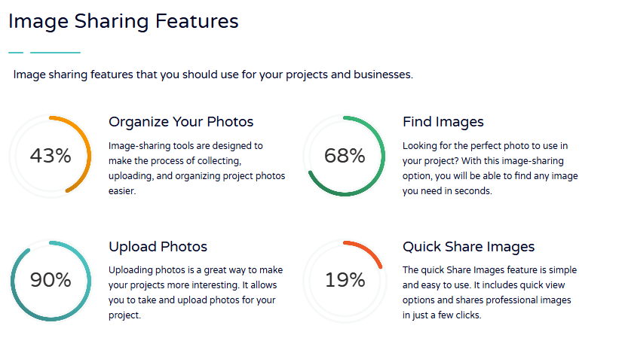 | Image Sharing Features  Image sharing features that you should use for your projects and businesses.  Organize Your Photos  Image-sharing tools are designed to make the process of collecting, uploading, and organizing project photos easier.  Find Images  Looking for the perfect photo to use in your project? With this image-sharing option, you will be able to find any image you need in seconds.  Upload Photos  Uploading photos is a great way to make your projects more interesting. It allows you to take and upload photos for your project.  Quick Share Images  The quick Share Images feature is simple and easy to use. It includes quick view options and shares professional images in just a few clicks.
Div 3. | 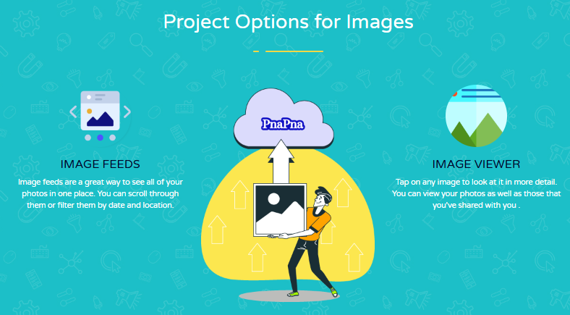 | Project Options for Images  Image Feeds  Image feeds are a great way to see all of your photos in one place. You can scroll through them or filter them by date and location.  Image Viewer  Tap on any image to look at it in more detail. You can view your photos as well as those that you've shared with you .
https://old0.pnapna.com/en/page/image-sharing

- Crm webpage

https://old0.pnapna.com/en/page/crm

S.NO | Content | Change Content
1. | Nurturing and getting your customer interactions is critical even for the smallest businesses. That’s exceptionally true now that both sales staff and consumers are likely being stayed home due to the pandemic. Tracking interactions means discovering ways to record or measure every consumer touch-point from their marketing and support history to what the discussion was about during the launch of a particular consumer with your regional sales. More than just a bucket for comments, this information requires to be stored in a safe place that can trace, examine, and surface the data when and where it’s needed. That’s where customer relationship management (CRM) software shines.  What Is CRM Software?  Customer relationship management (CRM) software is software that automates and guides the customer life cycle of an organization. It is usually used by the sales team, sales reps, and call center reps to have contact with customers and quickly respond to their needs. Customer Relationship Management (CRM) is more than accepting contact with potential points. It involves sustaining connections and building loyalty while maintaining a dynamic repository of contact information and client history. Making this information accessible for collaborative teams and piping it out to other business software solutions via smart integrations is the logical next step. User experience (UX) has become more important than ever, and being able to efficiently manage a business’s relationship with customers through the entire sales and the after-sales process is a key consideration. For small to midsize businesses (SMBs), trying to emulate CRM functionality on a large and heavy spreadsheet could lead to a lot of confusion and redundancy. CRM solutions are easier to use than spreadsheets, they also do more than receive user and contact information because they can dynamically generate calendar events and set reminders. CRM software often combines messaging and phone calling functionality, usually with reported conversations that can be used to track and document consumer opinion and better insights. A good CRM solution records your customers’ contact data and gets the details of your relationship and every interaction-whether by phone or email and now across other channels such as social media or even your client help desk.  This information is a great opportunity, letting you identify possibilities for up-sell or cross-sell, turn existing customers into new products or services, target new marketing, or even follow invoices. The software is also a fail-safe, checking salespeople from chasing the same view. Choosing the right CRM management software for your company can dramatically improve your team’s collaboration and productivity, increase sales, and increase client satisfaction. In its report, “CRM Software Market Research Report – Global Forecast to 2023,” Market research firm Market Research Future forecasts the CRM market to grow up to 35 billion by 2023. Also, the CRM market’s compound annual growth rate (CAGR) will be 6 percent between 2017 and 2023, according to the report. A key area for CRM growth in 2018 and 2019 will be the addition of artificial intelligence (AI) to leading CRM platforms. Businesses like Salesforce and Microsoft are either building their own AI engines to improve their CRM capabilities or partnering with the likes of IBM’s Watson and similar players to integrate AI’s benefits into their offerings.  Benefits of CRM software  CRM software provides your business with several real benefits, including:  1. Customer data management: Most products present a searchable database to put consumer information (e.g., contact information) and related documents (e.g, sales proposals, and contracts). While most CRMs offer this functionality, it can also be incorporated into other industry-specific systems. For example, contact management is a core component of salon management software.  2. Interaction tracking: A CRM solution reports consumer interactions, such as discussions held on the phone, in person, through live chat, email, or other channels. These interactions can be logged manually, or automated with phone and email system integrations. Some systems can also track interactions on social media platforms including Facebook, Twitter, and Google.  3. Workflow automation: This regulates business rules, usually through a combination of task lists, calendars, alerts, and templates. For example, once a task is marked as complete, the Customer relationship management system software might automatically create a task for the next step in the process.  4. Reporting: Management can use CRM tools to track performance and productivity based on activities logged in the CRM system-for instance, how many new contacts were added to the database that day, or how much revenue was generated. These tools can also be used for sales forecasting, such as for the next-quarter sales pipeline, lead management, scoring, and analyzing customer satisfaction.  Advantages of using CRM software  1-Scale your business: If you only have 100 contacts to deal with, then you strength be able to keep all of their information straight using a simple Excel spreadsheet, or even pen and paper. Larger businesses, however, deal with thousands or potentially millions of contacts and customers, which require customer relationship management software to keep that knowledge well-organized and accessible.  Operate more efficiently: When everyone in your company has access to your customer and contact data, you can deal with those clients more efficiently and avoid the dangers of over-or under-contacting them. You can also follow those customer interactions and analyze that data for more efficient support planning and optimizing the sales method.  3-Compete with superior customer satisfaction: Staying in the right amount of touch with your customers, and using the communication method they prefer, lets you stay on top of their needs and concerns in a way that stands out. Better customer service, focused on providing the best feasible customer experience, will allow you to seriously compete against other clients.  Which CRM Features Do You Need?  CRMs run the range from lightweight sets designed for quick and easy client connection and lead management to powerhouse systems with integrated e-commerce solutions and advanced analytics. While many small company owners worry that they’ll sign up for a product that doesn’t offer full functionality under the way, these concerns are often excessive. Higher tiers of service and add-on features are almost always available. Also, while more features and functionality may seem naturally better, too many options within a policy can be amazing, make the implementation method longer and more complex, and cost more than needed. If you previously know what you’re looking for and why you need it but want to narrow down your options, begin by asking yourself (and your team) these questions: Should we have workflows with built-in multilevel approvals?  Will we need to email customers directly from the top CRM software for small businesses? What sales tools do we need? Do we want something that can be used out of the box, or do we want to do lots of customization ourselves? If we do want to customize our system, how much API path do we want? Who will be the primary software admins, and what comfort level do they have in that role? How much are we willing to spend, either per user or on an annual basis? Whatever your needs are, list them out in interest to the answers to these questions. Also list any combinations you need (including proprietary legacy software, if applicable), and ask the CRM company how such integrations are performed before you choose a product.  In some CRM systems, for example, integration with an outside solution is as simple as clicking a few boxes; in others, you must use a third-party tool to click your way through the integration. Some even require hands-on coding to make integrations happen. It’s important to understand which key functions a CRM should offer so you can make sure you’re getting the most out of the program. These are some of the most important features:  1. Automation  You want to use a plan that automatically performs actions based on data in the business. For example, when a client fills out a form, your CRM should automatically forward the message to the relevant sales representative. After the message is accepted, the CRM should send a notification that the message was received. Workflow automation uses the tiny features and extra work off your base and allows your business’s tasks to run smoothly.  2. Reporting Tools  Reports help you know the state of your sales and marketing work. Information like the number of leads or sales you get within a certain time-frame or how many outbound calls your team makes can help you improve your processes. Moreover, it allows you to make more knowledgeable decisions about your company and also about the Best free CRM software.  3. Customer Data Management  Understanding your customer is a big part of your business’s success, and consumer data management features help you organize that information. Well-organized, easily available data on current and potential clients will help you build better connections, which ultimately has a positive effect on your company.  4. Customization  When a program is in customization, you can select the features you want in your package and arrange your dashboard, reports, extensions, and plugins to your liking. This creates a more flexible, comfortable user experience for you and your team.  5. Integrations  Third-party integrations connect your CRM software to other programs you use, which saves you the time of switching between apps and manually inputting data you’ve already stored in other software. The best way to determine the features you require in a CRM is to list what you want to be able to do with it. Technology should never be adopted simply because it’s current or common, but because it solves a specific problem. If you cannot outline in detail what you want to do with your future CRM system, and why you want to adopt one in the first place, you may not be ready to implement it.  By outlining your requirements ahead of time, you stand a much better chance of getting a product that does what you need without overpaying for features you’ll never use. You can always upgrade – a company will never refuse to sell you more characteristics in the future, so approach your most pressing needs first and go from there. Keep in mind that when you’re not a client yet, nearly everyone you talk to is a sales rep, so treat their advice respectively.  What to Look for in Your CRM Software?  Since there are so many various CRM software businesses out there, it becomes quite hard for small firms to decide which one is the best RM for their requirements.  Here are some quick tips on picking the best CRM software for your business:  1. Ease of Use – A recent survey showed that 67% of businesses put ease of use as the most important feature of their CRM software. You and your team will be using it for several hours every day. If the CRM is not easy to use, then it will not you help achieve your business goals.  2. Cloud and Mobile – In 2008, less than 12% of CRM software appeared on the cloud. Today, 87% of CRMs are cloud-based software. It is more secure, faster, and easy to combine with other apps and services. Another study by Nucleus Research revealed that 65% of companies using a mobile-friendly CRM, passed their sales targets. This means you need to look for CRM software that is mobile-friendly. This makes it suitable for your teams to meet their targets. Your customers get quicker responses and don’t have to wait for hours just to get quick answers.  3. Make a Features List – You need to make a list of features that you need in your CRM software. Don’t worry if you can’t think of all the features right away. This exercise will give you an idea of what would be a good fit for your business. CRM software is not just an address book of your customers’ contact information. They are useful because they integrate into your marketing, sales, and lead generation. They help you manage every aspect of a customer’s journey with your business with great detail. You would need to see how you can combine the specific CRM software with your existing business method and sales activities.  4. Integrations – Many modern CRM software include a ton of features. However, you would still need to get them to work with other apps, like your WordPress site, lead generation software, email marketing service, business email service, social media platforms, and more. Make sure that your CRM software supports those integrations.  For example, if you are running a website or online store, then you should need your CRM to combine with your membership plugin or e-Commerce platform. These are just some very basic requirements that you would want to check. You may also want to estimate pricing, the ability to add users and departments, security, GDPR compliance, and more.  What does CRM do?  Today, CRM aims not only to track and store client contact information but also to help guide current marketing purposes as well as to inform future efforts. In other words, CRM tries to be a one-stop-shop: a database of current and future clients as well as a program that helps to promote current marketing and sales efforts. Best Customer Relationship Management software packages track client communications, sales, and invoices, among other options. They allow the company owner to see, at a glance, the status of the company’s relationship with a particular client. CRM software is just one part of a broader CRM approach. Those programs highlight the need for a strong relationship between business and client, and CRM software makes maintaining that relationship easier.  At the most basic level, CRM software allows marketers and salespeople to handle and examine relationships with the company’s actual and potential clients. It enables tracking of every communication with the company and receives information about the customer. This way, when speaking to a customer, the marketer always knows who they are and sees their history with the company. This makes the interaction more personalized, increases the chances of conversion, and encourages customer trust and loyalty.  CRMs include functionalities that allow you to track customer interactions through various available touch-points, including those from:  - Contact forms  - Search engines  - Emails  - Phone calls  - Social media  The software takes care of certain processes-it and can offer automation of the marketer’s repetitive tasks, sets reminders for major events, and displays alerts if things need attention. Some CRMs also offer analytics abilities, allowing you to track the efficiency of various marketing efforts to create leads and conversions. CRM software, in combination with marketing automation, provides sales and marketing teams with a set of tools to manage the entire sales and marketing funnels, from lead qualification to opportunity management, forecasting, and deal closure.  Who Uses CRM Software for business?  Businesses that need to build a strong relationship with their target audience need high-quality and Best customer relationship management. Suppose a salesman obtains some valuable information about their customers. They record some of this data in their books and spreadsheets. They also create notes with customer’s phone numbers and personal details scribbled on them.  That’s when the CRM software for small business comes into the picture. The sales manager and sales representatives need CRM software to access information about their clients. They use this solution to collect insights into their prospects. In addition to tracking information about customers, CRM solutions are designed to generate sales reports and financial statements. So, all departments in your business will use CRM software to automate multiple tasks.  CRM software in India allows businesses to put all this information into a single unit. This makes it more comfortable for you to access real-time customers’ information at any time. The software accommodates all your customer’s history, products they have purchased from your store, previous deals, and other such records. You need to type the name of the customer to access all their records. Additionally, you will get a notification every time a new customer subscribes to your email newsletter and visit your pricing section or landing page. In simple terms, it allows you to track your customer’s shopping and experience with your brand.  That being said, the Best CRM system is the one-stop platform for small, middle-scale, and large companies. It allows you to boost your progress and sales. Moreover, it forms better and smoother coordination between different departments in your firm. Even start-ups need effective and advanced CRM software for small businesses to streamline their regular management and marketing operations. After all, who wouldn’t want to enhance their connection with customers and boost their sales productivity? Every business needs an automated solution that can help seamless interaction with customers and better contact with the team.  Don’t get distracted by CRM capabilities you won’t use. Make sure the software you finally select captures the information that’s essential for your business, allows effective follow-up, and is easy enough to use that your team will work with it, not around it. Remember that new technologies, while slick, aren’t automatically pervasive. For example, social media is a game-changing technology for mixing with customers. But as much as social and collaboration applications such as Slack are catching on, that doesn’t mean email is dead. Most customers still expect to communicate with you via email, and an email can still capture much more data than a Facebook post or a tweet can. Understand how your company associates with customers over email and make sure your CRM software acts as a supplement to that connection, not as an obstacle. Best Customer Relationship Management system should automatically take data from email interactions, not force your employees to manually enter email data.  Take the time to also properly evaluate the mobile app; this should be considered a separate app, not just as a mobile “capability” and you also shouldn’t be asked to pay anything extra for it. Mobile devices are an entirely different breed from desktops or notebooks. Employees use them differently and software renders them differently, which means that business processes that involve them will behave differently. Make sure your CRM software of choice can support the mobile device platform your team uses and carefully evaluate what the app can do. Some apps offer a read-only view of your sales pipeline or contacts so that you can look up the relevant information while out and about.  Those apps won’t let you make updates until you get back to a computer. Others offer a seamless and responsive experience, letting you do everything you would do on a mobile device that you would on a computer (but usually presenting tools and features differently, which can be difficult for some users to get used to). Don’t commit to CRM software until you’ve used the mobile app in a way you and your team would on a day-to-day basis. For many SMBs and their agents, the mobile component of a CRM app might even be more critical than the desktop version.  Companies, including Sugar CRM and Zoho, cater to the mobile workforce, with full-featured, responsive apps, and mobile layouts. If you have a field sales team that leaves their laptops behind and instead works on their tablets and smartphones, then you need to give them the tools they need.  Here’s a list of functionalities typically offered by a CRM platform:  - Lead management: A CRM tracks the company’s lead, allowing marketing teams to enter new leads into the system (automatically or manually) and to track and analyze data about them.  - Marketing automation: Some CRMs like Hub-Spot and Salesforce offer marketing-automation functionalities to automate some slow tasks in the funnel. For example, the system can automatically send customers marketing emails at times set by the marketer, or publish social media posts according to a schedule. The goal of marketing automation is to keep sales leads engaged and to help turn them into paying customers.  - Sales automation: CRMs can track client interactions and automate selected business purposes of the sales cycle that is necessary to follow leads and attract and obtain new customers.  - Workflow automation: CRM systems help businesses optimize methods by streamlining ordinary workloads, which enables employees to focus on creative and more high-level tasks.  - Analytics: CRM solutions can offer built-in analytics tools that offer insights and help boost customer pleasure rates. A marketer can analyze the data and create targeted campaigns accordingly. CRM analytics help to track attribution and provide insights into the quality of the customer experience.  - Artificial intelligence: CRM solutions like Salesforce offer AI capabilities built into their systems to help automatically recognize patterns leading to successful sales, which can help you build more accurate strategies for future marketing efforts.  - Individualized customer experiences: You can also use a CRM to create personalized and consistent experiences for your potential customers across various marketing channels, which may help increase conversions and boost brand awareness.  Future Of CRM  The future of CRM is not 100% clear-the needs of company owners vary over time, and top performers are constantly raising expectations by making discoveries in the product marketplace. However, those who know how a customer relationship management system is growing will have a better idea of where it could be headed. Organizations that are accommodated to the current CRM climate have the opportunity to take advantage of the best options available today.  In this part, we outline five important aims for the future of customer relationship management systems that are:  - Better customer insight  - Mobile-first technology  - Growing beyond cloud-based CRM  - Customer and employee retention  Best CRM for Small Businesses  Even one-person companies can benefit from CRM software. Since a CRM suite performs the work of several individuals, from secretaries to sales managers, small and one-man businesses gain the advantage of several additional workers in one suite of software. With that said, what’s the best CRM for the smallest businesses out there? If you’re a freelancer or entrepreneur, consider these choices. Most of them offer some project management features as well as customer relationship management.  Vwork247  It is the Best CRM for Small businesses, our tools are well-integrated with the websites for your clients and the back-end boards that you operate. All characteristics are available with minimal redundancies and flexibility. Most features are very meaningful and reflect the current business climates and needs. Private Chat and Emails stay on your drives. Full cycle CRM that starts with fresh leads from all sources and ends with the final payments on the invoices. We offer various tools from Marketing, to CRM, Communications, Project management, Human resource management, Tasks management, Notes, To-dos, Calendar, Cloud, Payment, etc.!  Zoho CRM  Automation and analytics – that’s ZOHO in a nutshell. The automation features for marketing outreach and communications alone make the software worth it, but ZOHO adds an entire suite of analytics tools. ZOHO offers over 40 built-in reports that can be generated allowing you to see the effectiveness of each step of your process. ZOHO has features enough for a larger company but can be especially useful for businesses of any size.  Close  A CRM tried to help you streamline your leads and sales methods. Close lets you automate information and marketing operations, integrating multiple ways – emails, calls, video conferencing, the entire works.  HubSpot  An incredibly popular CRM solution that warrants further attention, Hub-Spot has got a huge following for at least one major reason – its most basic design is free. Hub-Spot gives premium subscriptions, of course, but is filled with many features – such as custom deals for your customers and contact administration – that are free without a paid subscription.  Conclusion  Customer relationship management insists on the building block for winning new customers. It supports proactively knowing sales opportunities, forecast potential deals, and visualizing all sales stages to increase your revenues. CRM supercharges your company wisely to reduce customers’ pain points and achieve exceptional results. Businesses rely on the best CRM software to efficiently cooperate and close deals .  Don’t be in a rush to make choices. Take time but choose a cost-effective solution that still provides all the functionalities that your company needs to improve its performance. Go through the opinions of this CRM software and pick the top four that meet your terms. Read reports about them and ask for a demo or explore the system through a free trial. After pondering over different factors like price, features, system performance, etc, choose the best fit for your organization.  Finding the best CRM system for your business is not easy but you must look at it as a reputed business investment. In other words, you must pay due to care and consider multiple aspects to make the right decision. I hope that all the tips I provided in this post will help you choose the right CRM software because only a great one will fully cater to all the unique needs of your company.
 | 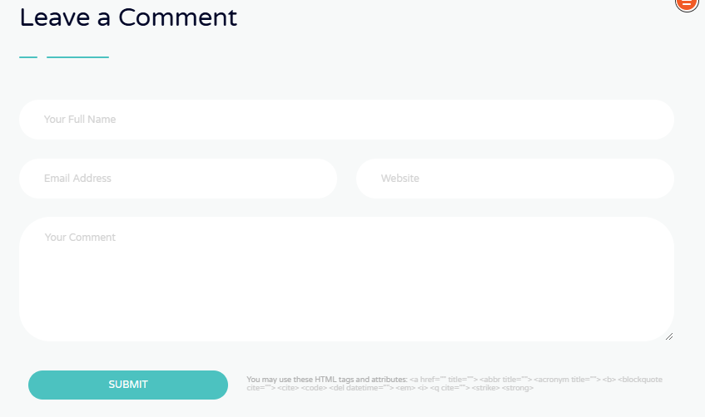
Post Category

168
SEO
52
Local SEO
40
Social Media Marketing
33
Email Marketing
21
PPC Management
18
Technology
5
Business
About Us and This Blog

Request a Free Quote
Gothica, quam nunc putamus parum claram, anteposuerit litterarum formas humanitatis.
Contact Now

Latest News

April 23, 2016
Eodem modo typi, qui nunc nobis videntur
April 8, 2016
Investigationes demonstraverunt lectores legere
March 25, 2016
Qemonstraverunt legere
March 12, 2016
Ut wisi enim ad minim veniam, quis nostrud exercice

All News

- cloud-folder-storage

https://old0.pnapna.com/en/page/cloud-folder-storage

S.NO | Content | Change Content

1. | 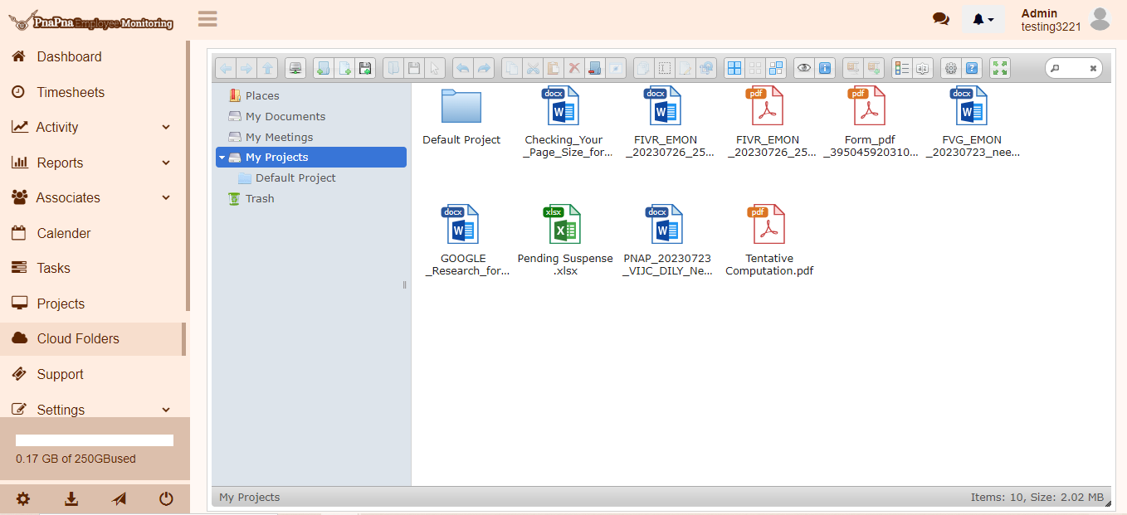  How cloud folder storage work?  Cloud folder storage is one of the most popular services in the world. It has a lot of benefits, such as accessibility from anywhere, anytime, and data safety. The data must be stored in a place and the ability to share or sync files with other people.  Cloud storage is a very popular solution for storing data and files securely. Users can store files, folders, photos, and videos using cloud storage solutions. It provides easy access to all your files, no matter where you are, as long as you have an internet connection.

- Private-chat

https://old0.pnapna.com/en/page/private-chat

S.NO | Image | Content | Change Content
Div 1. | 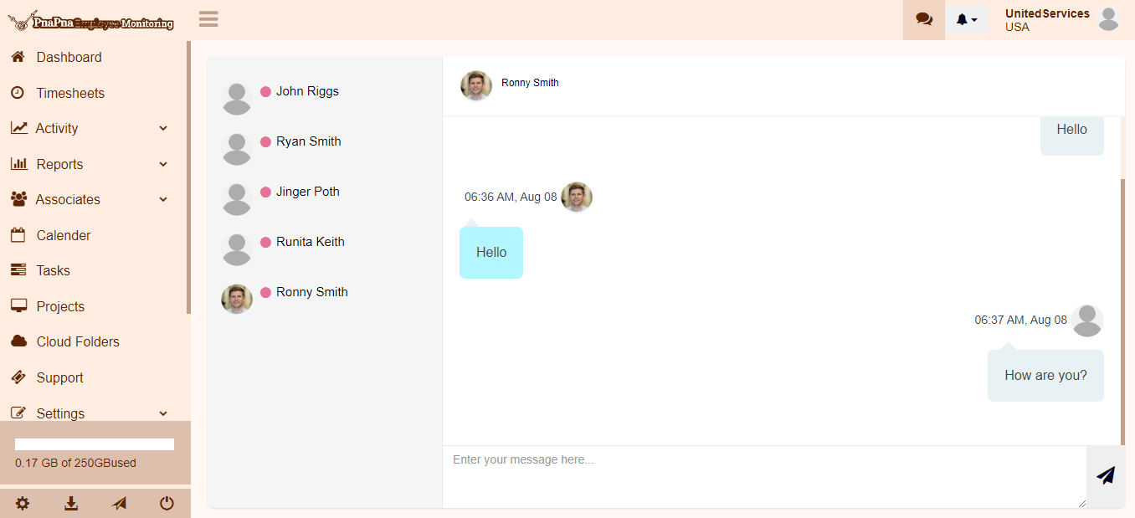  Private Communication Tool For Teams  Quickly reach each employee to keep your team connected and up-to-date with private communication tools. It features total managerial control and administration.  Keep your employees informed with real-time business updates. Employees want to be kept informed of all changes on time so they can adjust their work accordingly.  With the use of a private chat, you can have an instant messaging conversation with your team and provide them with the information they need.
Div 2. |   Monitor the Information  Monitoring the information available to employees on the company chat can be done and monitoring all conversations in real time and sending notifications also.    Chat Access  Chat Access is only available for those currently employed with the company. The purpose of this chat is to make communication more efficient and reduce email clutter.    Secure Media  Secure media is important for many reasons. It is important for the security of the employees who work in the company because they need their privacy as well.    No Need to Save  Many people are used to saving their contacts on their phone directory. But now, there is no need to save your work contacts in your phone directory.
Div 3. | - Checklists  - Scheduling  - Real Time Clock  - Communication

- Local seo

https://old0.pnapna.com/en/page/seo

S.NO | Content | Change Content
Div 1. | Professional SEO Tool for your Business  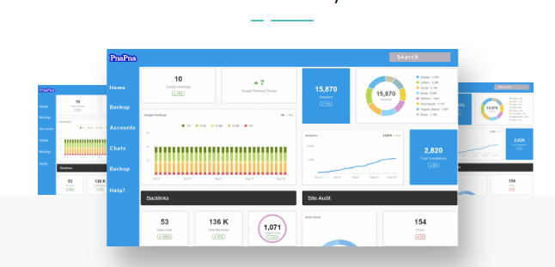  PnaPna SEO tool is an amazing tool to dominate your competition. PnaPna provides many features of SEO that will give you many advantages over your competition. PnaPna reveals your search marketing secret formula of your most successful competitors. This tool is for in-depth technical SEO analysis and SEO on-page testing tool for website optimization.  Tell Us About Your Company
Div 2. | 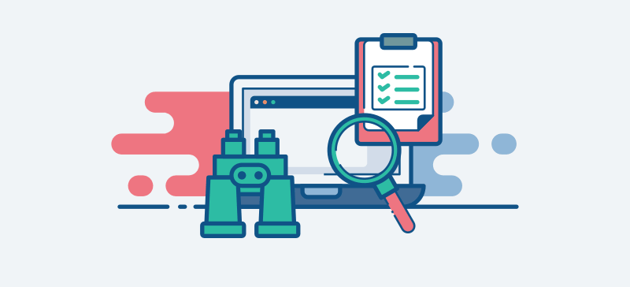  Real-Time SEO Auditing Solution  PnaPna provides you with the only SEO tool that delivers a complete and real-time overview of your SEO performance. PnaPna SEO tool audits your pages 24/7, providing you with actionable data from now. There is no need to wait for a crawl to finish before finding out about issues or changes.  Request a Free Quote
Div 3. | SEO Tool  Use the PnaPna SEO tool as a smart and easy-to-use tool to get an online SEO audit. This tool crawls your complete website and gives a full and detailed report based on your website’s SEO, heading tags, internal links, backlinks, page speed, social media, and so on.  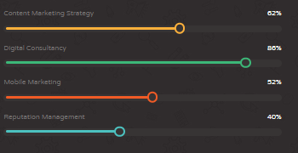  Free Consultation
Div 4. | A Professional SEO Tool for your Digital Marketing Campaigns  A tool that must have for professional SEOs.    Keyword Research  Keyword research is very important for any successful SEO campaign. It is what will determine your SEO campaign's success or failure. Keyword research is a process that can be done manually by using a keyword tool, or it can be automated with the help of an SEO software suite. Be smart with your content and keyword research.    Keyword Tracking  The SEO tool of PnaPna allows you to track thousands of keywords across multiple websites, giving you valuable insights to help you optimize your content. This tool allows you to see the search volume and rank for each keyword, as well as the number of competing pages and domains for each keyword.
Div 5. | 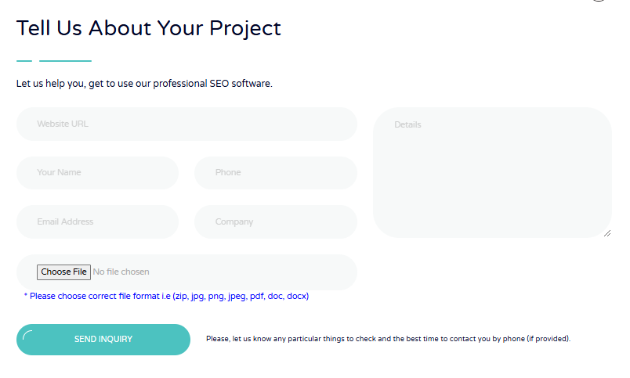

- Project Manager
https://old0.pnapna.com/en/page/project-manager
S.NO | Content | Change Content
Div 1. | 
Div 2. | What Is Project Management  Posted by  Admin March 20, 2016 Business, Seo 6  Project management is the regulation of planning and executing projects. Project management is the application of processes, methods, skills, knowledge, and experience altogether to achieve specific project objectives. Project management has a final output that is mannered to a finite timescale and budget. It seeks to achieve defined goals by using plans, schedules, and resources to implement project activities within a set timeframe. The discipline of project management consists of.  - Project management processes  - Project management phases  - Project management roles  - Project management tools  - Project management methodologies  Project goals and objectives are interpreted by the client or stakeholders, and a project manager applies project management methodologies to create a plan that set up the resources, tasks, milestones, and deliverables which are necessary to meet stakeholder requirements. This plan must also report for the triple restriction, which refers to the limitations of time, cost, and scope that apply to every project. Project management is often associated with fields in engineering, construction, healthcare, and information technology (IT), which typically have a complex set of elements that have to be completed and organized in a set to create a functioning product.  What is a Project?  A project is temporary and has a particular time of beginning and end, and therefore defined scope and resources. And a project is unique, which means it is not a routine operation but a specific group of operations designed to achieve a single goal. So a project team includes people who don’t usually work together, sometimes from different organizations and across multiple locations. The development of software for an improved business process, the construction of a building or bridge, the relief effort after a natural disaster, and the expansion of sales into a new geographic market, all are projects. And all must be perfectly managed to deliver on-time, on-budget results, learning , and combination that organizations need.  What Is a Project Manager?  A project manager is an individual tasked with planning and executing the project. This is the person responsible for leading the team and organizing the work. In more formal, structured organizations and on more complex projects, the project manager is usually a certified project management professional (PMP) by the Project Management Institute (PMI). In more informal organizations, such as small businesses, the project manager does not require certification. Project managers are responsible for all the different project management processes taking place throughout the project life cycle, such as risk management, task management, and resource management. In simple terms, they supervise the planning, execution, monitoring, and closure of the project. However, most project managers share common roles and responsibilities. Some of the more traditional duties of a project manager include the following:  - Scope Management: Defining the work needed to complete the project activities.  - Task Management: Planning tasks and defining their deliverables.  - Resource Management: Using people, capital, materials, and all other resources efficiently.  - Team Management: Assembling and leading a team.  - Schedule Management: Analyzing the duration of activities to create a project schedule. Once the execution phase begins, the project status must be monitored to update the schedule baseline.  - Quality Management: Establishing a quality policy for the project’s deliverables and implementing quality assurance and quality control procedures.  - Cost Management: Estimating costs and creating a budget.  - Stakeholder Management: Satisfying stakeholders' expectations and communicating with them throughout the project life cycle.  - Risk management: Identifying, monitoring, and minimizing project risk.  - Status Reporting: Monitoring and tracking progress and performance by generating reports and other documentation.  Project managers learn and receive certification from the Project Management Institute (PMI), which has certified standards in the Project Management Book of Knowledge (PMBOK). The Project Management Professional certification (PMP) is standard for project managers, but the PMI offers more specialized training choices such as the program management professional (PgMP) and Portfolio Management Professional (PfMP). Armed with their knowledge and skills, project managers rely on project management software to execute all of the tasks necessary for a successful project..  How to Become a Project Manager?  Project managers are leaders. They need to motivate their teams as well as plan, monitor, and report on their progress. It’s a job requiring multitasking. They must have strong communication skills and be able to connect with both stakeholders and the project team.  Formal project managers are typically certified through agencies like the Project Management Institute (PMI) in the U.S. or PRINCE2 in the U.K. After certification, they are required to maintain their certifications by acquiring additional project management training to gather a targeted number of Professional Development Units (PDU).  The standard of qualification for certified project managers has recently broadened to include more leadership and business skills. PMI’s certification and PDU standards can be found in A Guide to the Project Management Body of Knowledge (PMBOK Guide). But it can be difficult to get to grips with the technical feature of project management without formal certification training.  But certification is not always a requirement; it can be something needed later in one’s career. Most project managers usually start with a business administration degree, but not always. Often experience speaks louder than degrees. For example, if you’re leading a creative project then an arts-related degree would likely be more appropriate.  Elements of Project Management  These are the following elements of project management:  Initiating: The first stage of PM, where finalize of the project plan, charter, and scope are defined to determine the cost, resources, timeline, and budgeting for the project.  Planning: The most crucial stage of all, this stage includes the strategist scope of a project, identifying risks if any, and developing easing plans by creating a set of tasks to administer the project.  Executing: This is a stage where the project team is ready to launch the project. The tasks are assigned and resumed to keep track of the project and efficiently manage the same.  Monitoring/Controlling: At this stage, evaluation of project performance is undertaken by comparing the real-time results to the defined target, to ensure all the goals and deliverables are met.  Closing: The last stage of a project where deliverables are given to the customers, the forwarding of documents to the business, the release of resources, and notifying the closure of the project to the stakeholders is carried out.  Types of Project Management  - Waterfall Project Management: This is similar to traditional project management but includes the caution that each task needs to be completed before the next one starts. Steps are linear and progress flows in one direction, like a waterfall. Because of this, attention to tasks and timelines is very important in this type of project management. Often, the size of the team working on the project will grow as smaller tasks are completed and larger tasks begin.  - Agile Project Management: The computer software industry was the first one to use this methodology. With the basis originating in the 12 core principles of the Agile Platform, agile project management is a constant process focused on the continuous monitoring and improvement of products. At its core, the high-quality output is a result of providing customer value, team interactions, and acceptance of current business circumstances. Agile project management does not follow a sequential stage-by-stage approach. Instead, the project is completed in parallel to each other by various team members in an organization. This approach can find and correct errors without having to restart the entire procedure.  - Lean Project Management: This methodology is all about avoiding waste, both time and resources. The principles of this methodology were extracted from Japanese manufacturing practices. The main idea behind them is to create more value for customers with fewer resources.  - Scrum Project Management: Scrum is the abstract of agile. It's fast, very small in scope, and able to turn on a quarter. Scrum is all about a rush to accomplish projects in small pieces, often based on a one-month timeline. Scrum is great for smaller teams that are looking to repeat quickly.  - Kanban Project Management: Kanban is another variant of agile project management. Unlike Scrum, which is focused on time-based pieces, Kanban is all about organization. To accomplish this, Kanban looks primarily at the number of tasks that go into any process and how they can be smooth, reduced, and effective. This is an especially great model for those with a factory-like output that doesn't vary.  - Six Sigma Project Management: The Six Sigma method focuses on improving the quality of a project's output. This is especially helpful if you've undergone a lean management style and found the result less than satisfactory, as Six Sigma highlights creating a better result for the customer. This method can be secure onto other management styles and is a great way to refine it.  - PRINCE2 Project Management: The PRINCE2 method is often used by private sectors in the government, and is focused on efficiency and minimizing risks and errors. This detail-focused method is all about aiming projects up into product-based steps that can be handled one at a time, ensuring no mistake anywhere in the process.  Types of Project Management Software  Project Management Software for Gantt chart  A Gantt chart can help manage projects by breaking a large project into a series of smaller tasks in an organized way. Each task has a particular time duration, presented by a horizontal bar whose left end indicates the beginning date of the task and whose right end indicates the completion date of the task. Tasks may run sequentially, in parallel, or overlapping. During the process, significant events can be highlighted as "Milestones," marked by small diamond shapes.You can check what the sub-tasks are and when each task begins and ends from a Gantt chart. Presenting a visual overview of the project, you can easily track the progress by seeing what should be happening at any stage in the project.  You can check what the sub-tasks are and when each task begins and ends from a Gantt chart. Presenting a visual overview of the project, you can easily track the progress by seeing what should be happening at any stage in the project.  Project Management Software for PERT Chart  The PERT stands for "project evaluation and review technique"; it’s a primary project management tool for planning and scheduling entire projects and tracking the implementation phase. PERT charts can also show task division, time allocation, and starting and ending dates. Unlike the Gantt chart, which uses bars to represent tasks, the PERT chart displays information as a network model that uses boxes to represent tasks and arrows to present dependencies between tasks. The layout of a PERT chart makes the relationships between activities easier to see than with Gantt charts. But the disadvantage is it can be challenging when there are many complex dependencies and tasks.  Project Management Software for Calendar  The Calendar is the date or time-based project management tool, which is the easiest to understand. It is more suitable for personal time management and better to manage your daily, weekly, or monthly schedules. The outstanding part of this tool is that it has more space for adding to-do lists. It will remind you what to do every day and make sure things can be finished before the deadline.  Project Management Software for Timeline  The Timeline is also a visual project management tool to help track project progress. With a timeline, you can visualize by what time a task needs to be done. It is a more sequential way of looking at tasks over time. However, the timeline is not as popular as the Gantt chart since it has limitations in showing task dependencies and the completion state.  Project Management Software for WBS Diagram  The WBS, also known as Work Breakdown Structure, is a common project management tool that helps visualize the scope of work by breaking a project into individual components that can be effectively scheduled. The WBS is a tree-style structure with the overall task on the top, followed by project sections and further into individual tasks. WBS examples are similar to a flowchart that has its components linked logically. The components may be explained in the text or the boxes.  Project Management Software for Mind Map  The mind map is also a powerful tool to manage your projects. Unlike other project management tools, the mind map is less formal, yet more flexible. You can use it to break the whole complex project into smaller tasks that are easy to manage to-do lists and analyze problems. With a mind map, you can insert pictures, link files, and drill down to focus on a specific part, which other tools couldn't do.  Project Management Software for Status Table  The Status table is an effective tool that is used to track project progress. It doesn't contain too much detail about the project duration and task relations, but with more focus on the status and complete progress. A great function of the status table is that it can include people who take charge of the task, so that project leaders can better evaluate employee performance and know who to reach when there is a problem.  Project Management Software for Mind Map  HOQ, representing the house of quality, is a quality management tool used to define the relationship between customer desires and product capabilities. It's a tool used in QFD (Quality function deployment) to facilitate group decision-making. Though it looks complicated, it's easy to create through Edraw. All the components in the HOQ, like the roof, matrix, legend box, and markers, are already included in Edraw Max. You can create a high-quality HOQ diagram without much effort.  Project Management Software features which are required  Task management:  Task management software features let project team members create, update, and manage the progress of tasks throughout a project’s lifetime. This feature allows team members to:  - Set dependencies on a task  - Import a list of tasks from an external file  - Create and manage subtasks from larger tasks  - Set a task to repeat or recur at a specified time or date  - Assign the task to more than one user  Task management is essential in project management software. The best project management tools offer visual task management in Kanban boards, Gantt charts, waterfall dependencies, and burn-down charts.  Support documentation:  Software support documentation helps new and existing team members troubleshoot issues within the software and learn to use the tools quickly. Documentation and support tools that shorten the learning curve include:  - Help desk articles  - In-software tooltips  - Support videos  - Periodic educational webinars  - Chatbots  - Email or phone support  Email integration:  Email features within a project management tool will:  - Send notifications to individual team members regarding the status of their projects.  - Send alerts regarding due dates, keywords, or status changes  - Add comments, files, or custom labels to an existing task  - Make new or update existing tasks via email  This feature significantly increases productivity as the user can manage tasks and updates from their inbox without logging in to the tool. Individual members should also be able to set limits on the frequency and types of email notifications they receive.  Document management:  A good project management app provides a space for teams to store and manage files directly in the tool or by using an integrated third-party solution. Document management features that are indispensable in PM software are:  - A centralized document storage  - Multiple document uploads using drag-and-drop functionality  - The ability to attach documents to tasks  - The ability to attach notes and comments to uploaded documents  - Document organization within folders, projects, or custom settings  - Version control  An online PM app also provides cloud storage space or integrates with a third-party service that provides it.  Mobile app:  PM vendors offer mobile app solutions on various platforms and technology such as I-OS, Android, and HTML5. Today’s work has moved from the office desk to the field. Mobile access via domestic project management apps helps all types of teams. It provides a familiar interface and functionality so users can catch up on work and their teammates easily:  Third-party integrations or API:  A flexible solution can readily integrate with many popular apps and services in use by companies today such as G Suite, Microsoft 365, Salesforce, or Dropbox. The best project management tools have a solid core of PM features that allow users to manage projects effectively. It also has multiple integrations directly or via APIs for anything other than project management:  White label, branding, and custom settings:  These features often appeal to sales and marketing agencies and global or multinational corporations who want to adapt their tool to meet language and cultural requirements. When used for external clients, project management software will help teams with additional features such as white labeling, custom branding, or customization settings:  Reporting:  Project management software has reporting functionality included but to varying degrees. Consider the depth of your reporting needs and whether the software you’re considering meets those needs. Another feature to consider is the ability to export project data to a third-party business intelligence tool if your company has one or is planning to have one:  Scheduling:  PM software with scheduling functionality promotes organization in large or multiple teams. It allows the user to set schedules for tasks, create timelines and milestones, and determine dependencies and resources. For some, this is an essential project management function. However, for organizations with simple projects, short-duration projects, recurring tasks, or small teams, this may not be as important:  Time management:  Time management features in a project management app let team members track how much time they spend on independent tasks, let project managers set ideal time goals for the project, and integrate with a timesheet or payroll app. Teams with long-term projects or that regularly employ contractors may find these tools especially useful:  What Should You Look For In Project Management Software?  Team collaboration:  Team collaboration essentially determines whether your projects meet deadlines or not. Effective teamwork is the core of every project management process: Agile or otherwise. You just need to know how well your team works together.  Good project management software lets your team communicate easily and effectively. They need to easily share ideas, opinions, and resources or even attach files to get work done quickly.  Innovative Features:  Project management is a dynamic process. New process innovations and breakthroughs happen all the time. But is your project management system keeping up with the times, or is it way past its prime? You should choose a project management app that regularly keeps rolling out cool features. These could be things like a built-in wiki feature, a notes app, a built-in Gantt chart, and the list goes on. If not, you’ll be stuck with a simple tool while everyone else would be equipped with advanced technology.  User-Friendliness:  If your tool isn’t easy to use, it just isn’t worth it. It could have a million different features, but if they’re not user-friendly, then it’s of no use Your team will waste precious work hours figuring out how to use it. Imagine that wasting time on a productivity tool is not a good beginning. You might as well stick with Microsoft Word for project management.  Customer-Focused Product Roadmap:  Great project management software always lets you know what’s in store for its future. There has to be a set of ideas and objectives that it’s planned to release in the upcoming months. If there’s no project roadmap, there are two possibilities: These PM tools aren’t looking to achieve much or the software development team has given up on it.  Pros and Cons of Project Management  Pros of Project Management:  - The first and foremost advantage is the fact that a particular project is handled by a separate project manager as he or she will concentrate only on that particular project which makes it more likely to achieve success.  - Other pros of project management are that it helps the company in achieving efficiency when it comes to capital, labor, and other operational-related expenses as it keeps a close watch on all the activities of the project which in turn helps the management in identifying the areas which need more attention and help the company in saving a lot of capital.  - Project management creates a system where workflow is measured and accounted for, ensuring that resources are used sensibly in fulfilling the goals of the project. This type of planning develops expectations for staffers, provides clear command, and builds procedures for quickly addressing unexpected outcomes.  - It helps the company in developing managerial qualities in talented people by assigning them first small projects and then big projects which in turn create a favorable atmosphere in the company where people know that there is a lot of scope for growth.  - Effective project managers make determinations about appropriate staffing and team formation in the early stages of project planning. This can help ensure the right people with the most appropriate skill sets are assigned to tasks within the project, allowing the company to use its human resources cautiously and effectively.  - Managing projects from start to finish can help control project costs and help a project manager retain control over his budget, identifying problems or issues before they turn into barriers. This can also help a business ensure on-time delivery, retain satisfied customers and project an image of competence and professionalism.  Cons of Project Management:  - The biggest disadvantage of project management is that sometimes it leads to overlapping of authority and responsibility between the top management and project management where the top management has different plans in mind and the project manager has different plans in mind which leads to confusion among the team members of the project which ultimately leads to project under consideration suffering.  - Another limitation of project management is that suppose the company is working on 10 projects simultaneously then it will require 10 project managers to handle those projects which are not possible if the company is small and ultimately all projects are handled by either a single project manager or top management itself which results in limiting the use of project management.  - Another con of project management is that it may be possible that there is no capable staff to carry the responsibility of the project manager and if management selects inefficient staff then the project will be a failure leading to losses for the company. Hence the selection of the right project manager is important because no matter how much planning and resources are put into a project if the project manager is inefficient then the project is bound to fail.  Conclusion  Project management helps to detail what tasks will be accomplished, who will be involved in completing the tasks, and when tasks should start and finish. Typically, projects progress in steps or gradual stages; however, other approaches for rapid, interactive project management are also widely used.
Div 3. | 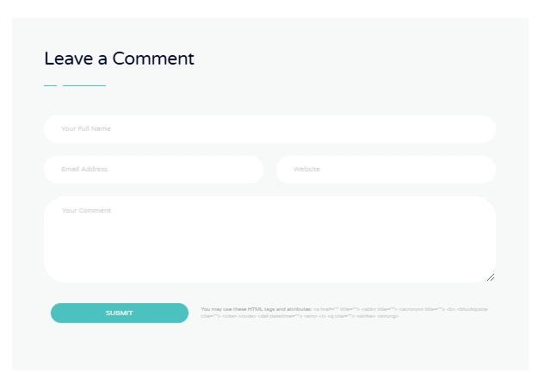
Div 4. | Post Category  168  SEO  52  Local SEO  40  Social Media Marketing  33  Email Marketing  21  PPC Management  18  Technology  5  Business  About Us and This Blog  Mirum est notare quam littera gothica, quam nunc putamus parum claram, anteposuerit litterarum formas humanitatis per seacula quarta decima quinta.  Request a Free Quote  Gothica, quam nunc putamus parum claram, anteposuerit litterarum formas humanitatis.  Contact Now  Latest News  April 23, 2016  Eodem modo typi, qui nunc nobis videntur  April 8, 2016  Investigationes demonstraverunt lectores legere  March 25, 2016  Qemonstraverunt legere  March 12, 2016  Ut wisi enim ad minim veniam, quis nostrud exerci  All News  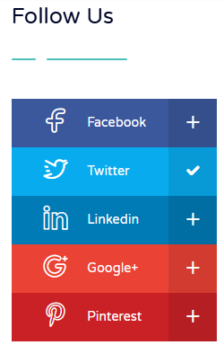  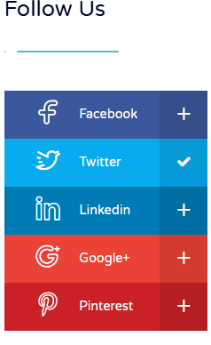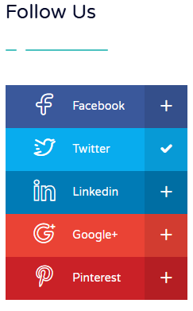  Popular Tags  SEO  Advertising  Business  Optimization  Digital Marketing  Socia  lKeyword  Strategy  Audience

- About

https://old0.pnapna.com/en/page/abouts

S.NO | Content | Change Content
Div 1. | Short Story About Our Company  We are a USA International Engineering company. We got started by creating software for ourselves. Now we use it and sell the Software as a service too.  We have expanded from business process management software to accounting, HR, private messaging, Communications like Encrypted tracked email, employee monitoring, etc.  We also provide Free leads procurement from our marketplace, a website builder with an image editor, and many other services.
Div 2. | 
Div 3. |   Foundation of the company  Dec, 2007  We launched our previous CRM with many features such as the field service module period. We also launched the full native application in flutter for iOS and android.
Div 4. |   We Work For Your Prosperity  All our applications are geared towards normal small to medium-sized businesses seeking to improve their operations. We take away the workload of one full-time employee.  We excel in Field Business Service  We have segregated the field service business like maintenance, managing, booking online, appointment remainders, etc. Our variants are useful for businesses. Lite Biz for office business and Core for freelancers.  We Serve the Current Needs of the Users  We have created several field service applications like field service magic that allow users in the field to send and receive images before and after the projects send their Geo-location, we can create maps for optimal routing.  We Have Tools for Virtual Work  We have created new applications for employee monitoring, document collaboration, and virtual signatures on mobiles and desktops and working towards many new features.
Div 5. |   Excellent Support  Although we are a small team, we are dedicated to attending to your queries. Someone will revert.    Awesome Team  We believe in making a new life, a better life, and making a bigger difference in this world.    Faster Performance  We aim to maintain agile code while focusing on accuracy and tech performance in speed.
Div 6. | Our Vision  To provide superior, essential business productivity software, and services at the most competitive price point to SMEs, worldwide for optimum PnaPna.

- Customers-leads

https://old0.pnapna.com/en/page/customer-leads

S.NO | Content | Change Content
Div 1. | 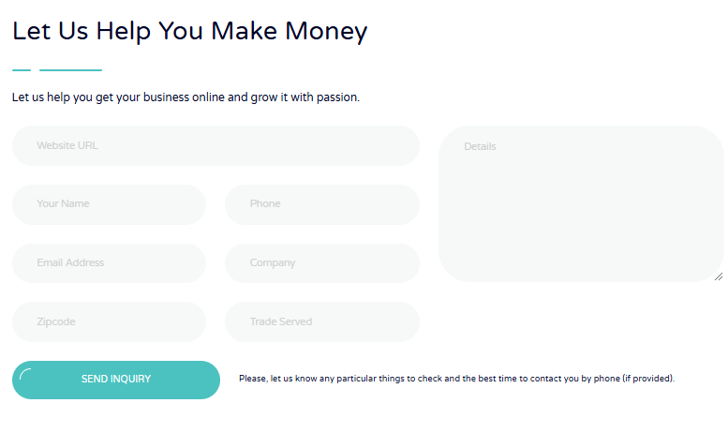Let Us Help You Make Money  Let us help you get your business online and grow it with passion.

- Contacts
https://old0.pnapna.com/en/page/contacts

S.NO | Content | Change Content
Div 1. |   3 Leona St., Somerset,  NJ 08873 USA  P.O. Box 11374, New Brunswick, NJ 08906 USA  Sales Agent Address    info@pnapna.online  Web Master Email    +1 212 292 5676  M to F 9 AM to 5 PM New York Time
Div 2. | 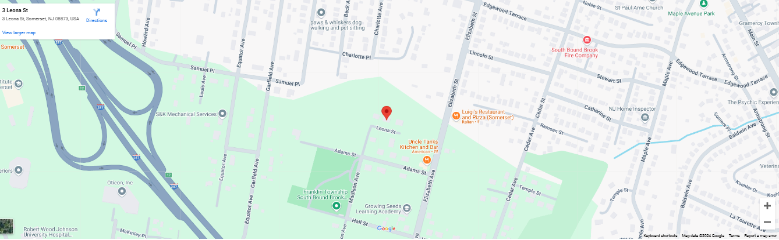
Div 3. | 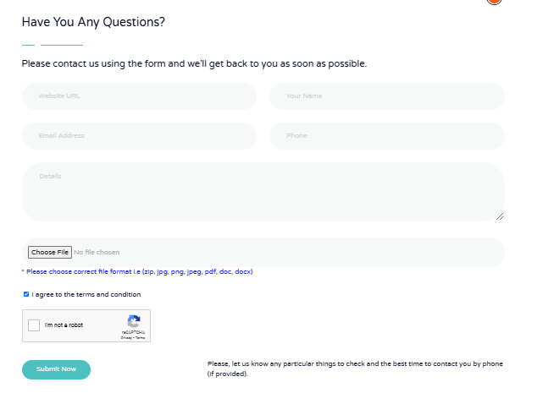

- Faq

https://old0.pnapna.com/en/page/faq

S.NO | Content | Change Content
Div 1. | How can we help you?  How employee monitoring works?  The era of fast-paced and technology driven world, businesses are constantly seeking ways to optimize their operations and boost productivity. One of the methods gaining popularity is employee monitoring.Before knowing about how employee monitoring works, it is very important for us to fully know about what is employee monitoring  Read more...  How does employee monitoring comply with USA laws?  Employee monitoring is one of the latest technologies of this era. With employee monitoring many employers can control the activities of their employees. Employee monitoring made too much ease for the big industries, companies and organizations to grow rapidly  Read more...  How employers use technology to surveil employees?  Now, the world has totally changed and it is very important for the employers to surveil their employees. Businesses have access to a variety of tools and technologies that can track and monitor employees every move. This newfound capability has led to the widespread implementation of employee surveillance systems across various industries  Read more...  How many types of employee monitoring software exist?  Employee monitoring is a way in which employers can get access to their employees about their progress report, monitor their screens and track their locations etc.This monitoring can encompass various aspects, such as internet usage  Read more...  How to measure the benefits and disadvantages of employee monitoring?  As we know in the modern era of IT, employee monitoring is growing too fast. Every employer wants to monitor their employees so for this purpose we know that there will be some cons and pros of employee monitoring  Read more...  Didn't find your answer? Contact Us

- help-desk

https://old0.pnapna.com/en/page/help-desk

S.NO | Content | Change Content
Div 1. | Tell Us About Your Project  Let us help you get use our professional Help Desk.  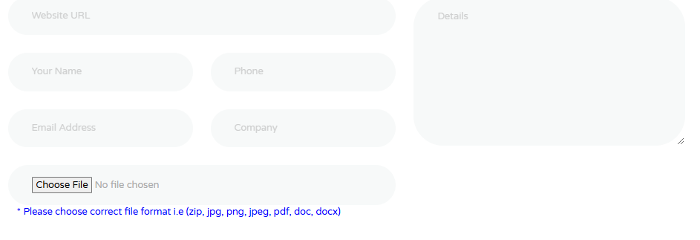  Send Inquiry  Please, let us know any particular things to check and the best time to contact you by phone (if provided).

- Industries-served

https://old0.pnapna.com/en/page/industries-served

Div 1. | We Serve Following Industries and More  PnaPna is the best way to manage your team and customers. To learn more, select a industry from the below.    Home Cleaning  Manage your appointment, employees, and jobs using one software  Read More  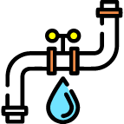  Plumbing  Access Plumbing's features and automate your daily plumbing tasks  Read More  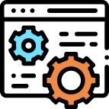  Maintenance  We provide the softwares you need to run your business and maintain business performance.  Read More    General Contracting  Organize business projects and grow your general contracting business using PnaPna.  Read More    Window Cleaning  We provide window cleaning features like scheduling, billing and customer service.  Read More    Pressure Washing  Manage your pressure washing business and impress your clients using PnaPna.  Read More  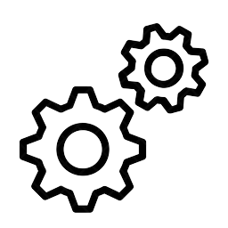  Other Industries  We have all the industries you need to run your business like a professional.  See all industries  Industry Served Options  We’ve got all sorts of tools to help you with your industry and we’re always up for a challenge.  We know that you need a software who manages your industry and can provide you with the tools and expertise to get the job done.  Free Consultation Request a Free Quote

- Sitemap

https://old0.pnapna.com/en/page/sitemap

S.NO | Content | Change Content
Div 1. | Home-page  Products  Variants  - Maid Cleaning  Applications  - Employee Monitoring  - SEO Tools  Others  - Image Sharing  Features  - CRM  - Cloud Folders Storage  - Local SEO  - Private Chat  - Project Manager  Integirations  - Quick Books  - Whats App  - Zoom Meetings  Pricing  - Employee Monitoring  - PnaPna Tech  Demo  - Employee Monitoring  - PnaPna Tech  Resources  - About Us  - Blog  - Industries Served  - Knowledge Base  Contact Us  · Contact Us  Sign In  · Sign In  Why Use Remote Employee Monitoring Software?  - What is Employee Monitoring?  - What Business Software Can Be Combined with Employee Monitoring?  - What technologies are used for employee monitoring?  - What are Employee-Monitoring-Laws in USA?  Scale with precision, with highest speed  Recent additions  - Employee Monitoring  - Employee Productivity  - Data Security  - Bill For Time  Pre-existing  - Quotations  - Invoices  - Statements  - Projects  - Tasks  - Cloud Folders  - Emails  - Private Chat  In the works  - Scheduling  - Calender  - Work Flow  - Artificial Intelligence  Our Pricing Packages  - Use Lifetime Deal Promo Code LTDM0124 at the Check Out.  FAQ’s  - How Employee Monitoring Works?  - How Does Employee Monitoring Comply With USA Laws?  - How Employers Use Technology to Surveil Employees?  - How Many Types of Employee Monitoring Software Exist?  - How to Measure the Benefits and Disadvantages of Employee Monitoring?  Latest From the Blog  · Read Our Blog  - How to Grow Your Service Business? Best ways to do it.  - How do you qualify a Lead?  - What is a Unique Selling Proposition?  - How Many Types of Employee Monitoring Software Exist?  - How to Measure the Benefits and Disadvantages of Employee Monitoring?  Our Links  - About-Us  - Blog  - Cloud Folders Storage  - Contact Us  - CRM  - Customer Leads  - Employee Monitoring  - FAQs  - Help Desk  - Knowledge Base  - Monitoring Feature  - Monitoring Pricing Plan  - Private Chat  - Project Manager  Social links  - Facebook  - twitter  - Instagram  - Youtube  - LinkedIn  - vijay_kumar_chopra  - info@pnapna.online  - 3 Leona St., Somerset, NJ 08873 USA P.O. Box 11374, New Brunswick, NJ 08906 USA

- Quick-book

https://old0.pnapna.com/en/page/quick-books

S.NO | Content | Change Content
Div 1. | Quick Books accounting integrates well with our PnaPna business process software  Intuit owns an accounting software named “QuickBooks” Unveiled in 1983. It is primarily used by small and medium-sized businesses available in on-premises and cloud-based versions. It is used to accept business payments, manage and pay bills, and payroll functions, etc.  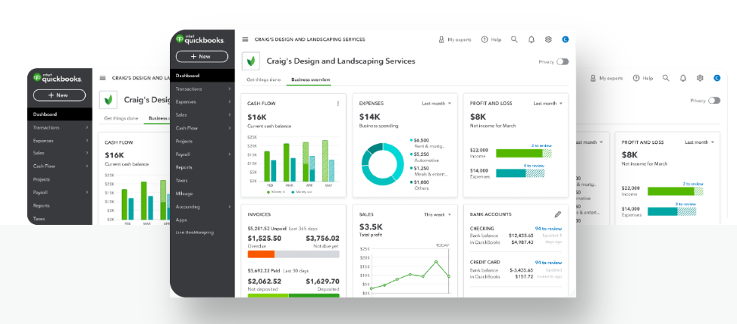  Get Started
Div 2. | 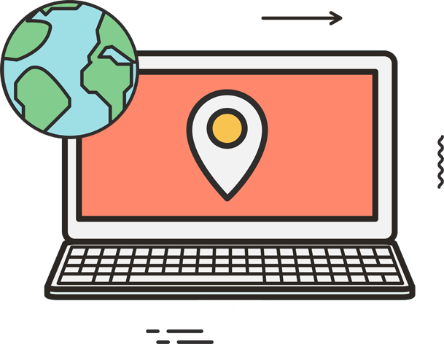  Quick Books  Automatically sync customers, invoices, and payment data between PnaPna and QuickBooks online.  Request a Free Quote
Div 3. | 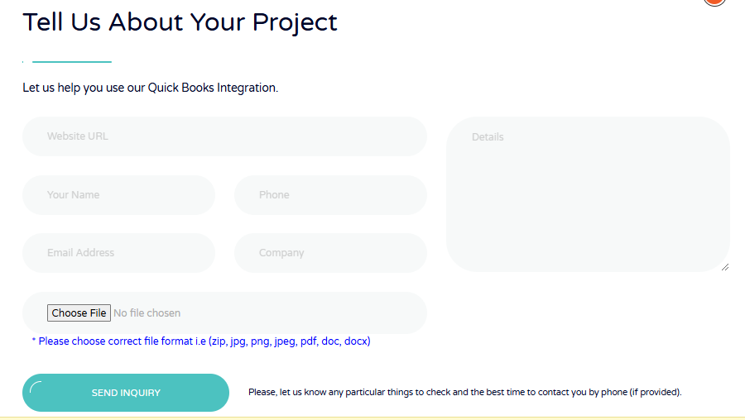

- Whatsapp

https://old0.pnapna.com/en/page/whatsapp
S.NO | Content | Change Content
Div 1. | WhatsApp is an instant messaging and voice-over-ip that can integrate with PnaPna.  WhatsApp runs on mobile devices and can be accessed from computers too. It allows users to send text and voice messages, make voice and video calls, and share images, documents, user locations, and other content.  Get Started  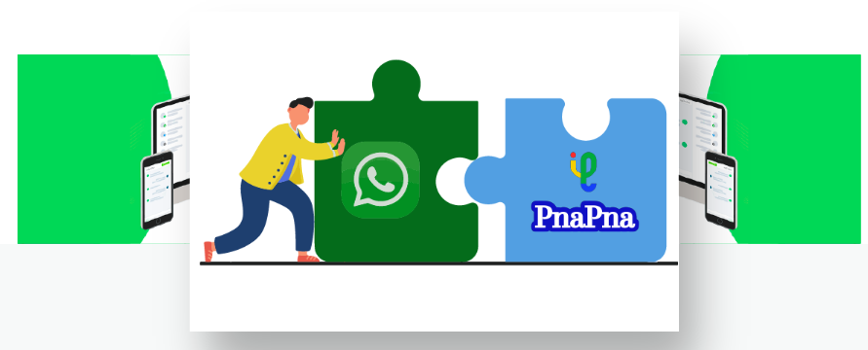

- Zoom meeting

https://old0.pnapna.com/en/page/zoom-meeting

S.NO | Content | Change Content
Div 1. | Zoom videotelephony and online chat can be integrated into PnaPna  Zoom is a cloud-based peer-to-peer software platform used for video communications, messaging, voice calls, conference rooms for video meetings, virtual events, and contact centers.  Get Started  
Div 2. | Zoom Meeting  PnaPna has introduced its clients to a new way of running a business: Video Meetings. Now communicate with your clients and employees via Zoom Meeting.  Request a Free Quote

- Tech-life-time-pricing-plans

https://old0.pnapna.com/en/page/tech-life-time-pricing-plans

S.NO | Content | Change Content
Div 1. |   Use Lifetime Deal Promo Code LTDT0124 at the Check Out.  Limited subscriptions on first come first served basis for limited time only  Promo Code LTDT0124Limited  Life Time  $2,999 $49  Installment payments available**  Everything in Life Time Deal  - Lead  - Estimate  - Proposal  - Live Chat  - Help Desk  - Work Order  - Internal Email  - Change Order  - One Click Estimate  - Qucik Flow  - Daily Log  - Activity Log  - Inspection  - Client Portal  Promo Code LTDT0124  Start 14 day money back Guarantee  Use Lifetime Deal Promo Code LTDT0124 at the Check Out.  Limited subscriptions on first come first served basis for limited time only

- privacy-policy

https://old0.pnapna.com/en/page/privacy-policy
S.NO | Content | Change Content
Privacy policy for all digital properties of Accutech Services LLC and PnaPna SAAS

Introduction
1. Thank you for taking the time to review our Privacy Policy. At times, PnaPna will collect certain personal information about customers and visitors to websites hosted by us. Such information will include both identifiable personal data, as well as non-identifiable personal information. Identifiable personal information will be collected when you sign a contract for service with us, or use our website for a transaction or subscription service. Non-identifiable information is gathered automatically when you visit our website or those websites hosted by us, and stored for use in our system.
2. The purpose of this privacy policy is to explain to customers what types of information we will collect and how that information is used. In most cases, we collect this information to ensure network integrity and that we continue to provide you with the most relevant content and best possible service that suits your needs. In some cases, we are required by law to collect personal information about customers. Except where the law requires otherwise, we undertake to protect the confidentiality of such data.

Confidentiality
3. PnaPna respects customer privacy and the privacy of those accessing our website, or those websites hosted by us. We undertake to protect the confidentiality of our customers and users including all personal information supplied in the course of contracting with us for services. We undertake not to sell your personal information to third parties for commercial or marketing purposes.

Collection of Personal Data
4. PnaPna collects personal data about our users when you visit a website hosted by us; apply for a service subscription; respond to a customer questionnaire; [add what’s relevant for your company- competitions and sweepstakes for example] and through the use of cookie technology. We may also combine information about you that we have with information we obtain from our business partners or affiliates. [ A cookie is a data file that sits on your computer hard disk. The cookie is placed there by a remote web server that you have visited using a browser like Chrome, Firefox, Safari and or Internet Explorer. It is used to uniquely identify you during web interactions with a website and contains data parameters that allow the remote HTML server to keep a record of who you are, and what actions you take at the remote web site. You have the option to disable the cookie function in your browser, but will be restricted from accessing many sites as a result.]

Use of Personal Data
If you upload images to the website, you should avoid uploading images with embedded location data (EXIF GPS) included. Visitors to the website can download and extract any location data from images on the website.
5. PnaPna may on occasion use your personal information to contact you about promotional offers; advise you of matters relevant to service provision and in some cases, solicit your feedback. However, PnaPna will provide you with an option within every communication to opt out of receiving any communications of this nature or you can contact our customer services representatives to ensure that you do not receive such promotional information, at email: info@pnapna.online.
6. PnaPna collects and shares aggregated user data with business partners, sponsors or other third parties for the purposes of developing content and ensuring relevant advertising and content, such user data will never be used to identify individual users. These business partners and affiliated companies do not have any independent right to share this information.
7. PnaPna may log the websites you visit; collect IP addresses and information about your operating system and the type of browser you use for the purposes of network/system administration; to report aggregate information to our advertisers, and to audit the use of our site. This data however will not be used to identify individual users who will at all times remain anonymous.
8. Any information PnaPna collects from you through correspondence with us, whether via e-mail, telephonically or by written letter, will only be used to address the matters within that correspondence. If this requires referring such correspondence within PnaPna or to a third party to ensure customer service, your personal information will only be disclosed to the point necessary to address your query or concerns, and will otherwise be kept confidential.

Public Space (Bulletin Boards, Chat Rooms and Third-Party Sites)
9. Any information that customers disclose in a public space, including on any bulletin board, chat room or any site PnaPna may host for you, is available to anyone else who visits that space. PnaPna cannot safeguard any information you disclose there.

Site Linking
10. PnaPna’s websites contain many links to sites that belong to third parties unrelated to us. PnaPna cannot be held responsible for any use of your personal information arising from you disclosing personal such information on third party sites. PnaPna cannot protect any information you may disclose on these sites and recommends that you review the privacy policy statements of those sites you visit.

Minors
11. PnaPna will not enter into a service subscription contract with a minor unless such minor has explicit written consent from a parent or guardian to do so. PnaPna undertakes not to contact minors about promotional offers or for marketing purposes without a parental consent .
12. PnaPna reserves the right to disclose information about customers where required in good faith, to do so by law or to exercise our legal rights or defend ourselves against legal claims.
13. PnaPna further reserves the right to share information with law enforcement to investigate or prevent illegal activities being committed over our network.
14. PnaPna reserves our rights to disclose your personal information where you have given us explicit legal written consent to do so.
15. PnaPna reserves the right to monitor user and network traffic for site security purposes and prevent any unauthorized attempts to tamper with our site or cause damage to our property.
16. PnaPna reserves the right to make changes to this privacy policy or update it. Where a major change is made, customers will be informed by e-mail notification or through a notice on our website. Customers and site visitors bear the responsibility to ensure that they have read the changes or updates as the case may be.
Version 01.01.02 dated July 06th 2021. Email to: info@pnapna.online

- Terms-conditions

https://old0.pnapna.com/en/page/terms-conditions
S.NO | Content | Change Content
Div 1. | Terms and Conditions for all digital properties of Accutech Services LLC and PnaPna SAAS  1. Scope of Application  This, “Terms and Conditions” (“TAC”) document, governs the contractual framework / conditions between Incuber Services LLP, and or Accutech Services LLC, and or the lawful owners / operators, who own / operate several domains (URL), also known by its brand name “PNAPNA” (PNP) and all websites owned collectively by PNP and referred to as “PNP” hereinafter, and the contractual partner of PNP (“Customer”) in connection with the provision of the Software for its use via the Internet (SAAS - “Software-as-a-Service”). The Customer accepts the version of a digital property (URL) owned by PNP, in, as is condition offered; and this TAC is an integral part of all existing and / or future contractual arrangements between the Customer and PNP in connection with the provision of Software / Service for use via the Internet / world-wide-web (WWW). This TAC shall also apply, irrespective of, whether it is, or is not expressly referred to, in the description of for any Self-Service Plan (“User Plan”) offered by PNP. Any addition to TAC / agreement, needs PNP’s written approval. Such an additional provision cannot have any prejudicial effect on TAC, between contractual parties. Additional provision, contrary to TAC, is expressly rejected / excluded. TAC will prevail over all other additional provisions, if and when in enforce.  2. Services Provided by PnaPna  2.1 Right of use  PNP shall provide the digital property / Software product, named / described in PNP’s Self Service User Plan (“Software”) to the Customer for its use via the internet (“Service”) to operate on their personal computer. The Customer has no other rights, such as ownership, copyright, patent, trademark, royalty, or usage etc. PNP’s Software shall be deployed / operated from / on computers / server centers that are owned / operated by third parties and or leased by PNP. For the duration of this Agreement, the Customer is given a non-exclusive / non-transferable right to access / use this Software through a browser and an internet connection, exclusively for their commercial or professional activity. The customer provides an internet connection between PNP’s computer center and hardware and Software required for this purpose (e.g., PC, Network connection, ISP, Browser, OS etc.). PNP does not provide Services via other means / channel like for Mobile Apps, etc. or meant for mobile hardware / instruments. The right of use is limited to the number of usage units booked by the Customer under the respective User Plan. Any sub-licensing or further licensing of the Software is prohibited. The Customer has no right to a copy or a backup of the Software. All rights of the Software or the Service over and above the right of use as defined in these TAC remain fully with PNP. PNP may not offer Service to anyone, and may terminate / cancel it, without prior notice.  2.2 Restrictions  Customer will not, directly or indirectly, reverse engineer, DE-compile, disassemble or otherwise attempt to discover the source code, object code or underlying structure, ideas, logic, know-how or algorithms relevant to the Services or any Software, documentation or data related to the Services; modify, translate, or create derivative works based on the Services or any Software (except to the extent expressly permitted by PNP or authorized within the Services); or remove any proprietary notices or labels.  2.3 Operation  PNP cannot guarantee the availability of the Service at all times and the absence of any other disruptions and interruptions to the functioning. PNP shall attempt to provide the Services to the Customer, as interruption-free as possible. The Customer shall notify PNP of any disruptions to the Service without delay and provide information regarding the details of the circumstances of the issue. PNP shall remedy the disruption to the Service within an appropriate period. PNP is entitled to circumvent the disruption to the Service utilizing a workaround solution if the cause of the disruption itself is only to be remedied with the appropriate expense and the usability of the Service is not significantly negatively affected.  2.4 Support  The Software is provided as a DIY (Do it yourself) Service. PNP may provide some limited ad hoc support on a case by case, basis. The support shall not include general know-how, transferring, training, configuration implementation of Customer-specific documentation, or modification of the Software. Self-service support for the Customer is to be carried out by the Customer from forums, Help documents, tutorials, etc. on the website, and or possibly by an email to info@pnapna.online. PNP may provide the support Services during working hours from Monday to Friday between 10.00 AM and 4.00 PM USA EDT. Legal holidays are excluded. Inquiries received outside of these support times shall be regarded as received on the following working day. Paid support Services are available for an additional fees as per PNP support/maintenance plans.  2.5 Changes to services  PNP may modify the Software (Services, including system requirements) for adapting to new technical or commercial market conditions and for a good cause. Such Services shall be deemed to be valid, if the modification is required due to:  a) A necessary adaptation to a new civil / legal challenge or a case law;  b) Changed technical framework conditions (new browser versions or technical standards);  c) Protection of the system’s security, or;  d) Further development of the Software (disabling old functions, replaced by new).  2.6 Defining, words, used herein  Word “Lifetime”, shall mean, the life of a particular version of the Software or Services sold, leased, or rented (as in SAAS) and is, not of, any person, nor any entity. Each version of the software has a life of its own. PNP agrees to maintain that version of Software or Service (including an updated version, if any, for the remainder part of that term) for at least one year from the date of original sale or renewal. However, after one year of existence of that version of the Software or Service; or when the original version is deprecated, PNP may not maintain that version of Software / Service, and the lifetime period of that version of the Software / Service, sold / leased / rented will be deemed to have been concluded / fulfilled upon completion of one year or deprecation, whichever comes later. Payment for additional / ancillary Services such as, for extra disk space / usage etc. later, does not extend the lifetime Service period. Word “Meaningful”, shall mean that the Customer shall use the Service substantially for the purposes it is intended for, by themselves and not employ an automation Software, or by bots used to replace the Customer’s human involvement.  2.7 Involvement of Third Parties  PNP is entitled to involve third parties in its operations. This shall, in particular, apply to hosting Services, maintenance contractors, affiliates and other Service providers etc. PNP shall not accept any liability for the Services of third parties involved to the extent legally permissible.  2.8 Software or Operation Issues  Customer reported defects would be delivered via upgrades to major product releases and service packs per the SAAS upgrade schedule published here.  3 Remuneration and Payment Terms  3.1 Fee structure  For the use of the Software during the contractual term, the Customer shall owe PNP for (the license, Service and maintenance) according to the respective User Plan, when ordered.  3.2 Payment, upgrading and downgrading  A valid Credit card / Payment method is required from Customers of paying accounts. Customers of trial accounts may not be required to do so. Trial accounts are not full featured plans. An upgrade from the free trial plan to any payment plan will end the free trial. The Customer will be billed for it, immediately upon upgrading. The Service for the Basic Period is billed in advance. If the Customer’s agreement is not terminated by an ordinary or extraordinary means, the Service will be billed for the Extension Period in advance at the end of the invoice cycle and is not refundable. There will be no refunds or credits for partial periods of unused Service. The Customer can upgrade or downgrade anytime. For the upgraded or downgraded plans, the Customers Credit card / Payment method will automatically be charged at the new rate on the next billing cycle. Downgrading of the Service may cause the loss of content, features, or capacity.  3.3 Net prices  All prices exclude applicable taxes such as sales tax, etc. The Customer is responsible for all taxes.  3.4 Measures in the event of default by Customer  If the Customer defaults on the payment of fees, PNP is entitled to block access to the Service or extraordinarily terminate the contractual relationship. The Customer shall have no access to their data, during the blocked period. PNP may delete all data after 5 days of non-payment.  3.5 Revenue from PNP Services  Customer agrees that PNP may use a mix of proprietary, leased and or open source codes / Software / content / materials. The fees paid by Customer to PNP are for the expenses, such as manpower to develop and maintain its proprietary Software, equipment/servers, overhead and operating expenses, etc. and are not for any benefit / Software / Services received from / of free sources or open source codes etc used in PNP bundles / Services.  4 Customer Data, Data Protection and References  4.1 Customer data (Intellectual Property Rights)  The Customer is exclusively entitled to the data input, generated thereby and allocated to the Customer and the end-users of the Customer in the context of the use of the Software (“Customer Data”). The Customer shall own all rights, title, and interest in and to the Customer Data, as well as any data that is based on or derived from the Customer Data and provided to Customer as part of the Services. PNP shall own and retain all right, title and interest in and to (a) The Services and Software, all improvements, enhancements or modifications thereto, (b) Any Software, applications, inventions, or other technology developed in connection with implementation Services or support, and (c) All intellectual property rights related to any of the foregoing. The provisions of this Section shall survive any termination of this Agreement.  4.2 Data protection  The Customer is aware that the use and processing of personal data within the meaning of the applicable domestic and / or foreign data protection legislation, in particular, and as far as applicable the EU General Data Protection Regulation (“EU-GDPR”) may require the prior consent of the affected persons and / or the registration of the relevant database with a domestic or foreign authority. PNP is, as far as applicable, fully compliant with the regulations of the EU-GDPR (PNP.com/en/gdpr) and the DSG. If PNP acts as the data processor, PNP shall process the Customer data solely on behalf of and/or according to the instructions of the Customer. The processed data is used to provide the Software and is handled under PNP Privacy Policy (PNP.com/en/privacy). The Customer remains responsible for the lawfulness of the collection, processing, and use of the Customer Data under the applicable legal regulations, in particular, under EU-GDPR and DSG. Therefore, PNP and the Customer agree to the terms of Data Processing Addendum (“DPA”), which is an integral part of the contractual relationship between PNP and the Customer. The DPA can be downloaded here. If PNP acts as the data controller, PNP shall process the Customer data to provide the Software and the processed data is handled under PNP Privacy Policy (PNP.com/en/privacy).  4.3 References  In the context of PNP’s marketing activities and in the preparation of its offers for projects of other Customers, PNP is entitled to refer to the projects realized by it for the Customers and to document same, subject to the justified confidentiality interests of the Customers. PNP is entitled to publish in the context of marketing activities, in reference to the business relationship on PNP’s website with the name and corporate logo of the Customer.  5 Release, Liability, Warranties, Terms and Terminations, and Confidentiality  5.1 Liability  The Customer shall release PNP and involved third parties of all third-party claims that may arise from: (a) Unlawful use of the Software by the Customer and / or, by third parties, with or without the consent of the Customer  (b) Disputes arising from data protection laws, copyright laws or other legal disputes associated with the use of the Software. Customer hereby agrees to indemnify and hold harmless PNP against any damages, losses, liabilities, settlements, and expenses (including without limitation costs and attorney fees) in connection with any claim or action that arises from an alleged violation of the foregoing or otherwise from Customer’s use of Services. In the assertion of relevant claims, the Customer is obligated to notify PNP thereof in writing without delay. In this case, PNP may block the Service to the Customer without providing a grace period. Compensation claims by the Customer for blocking of the Service is denied.  PNP shall not accept any liability whatsoever to the extent legally permissible, in particular for  1) Damages  a) Arising from the Customer’s violation of the contractual obligations  b) Caused by PNP ’s involved third parties or support persons  c) Due to viruses  d) As a result of malicious code;  e) After a hacker attack  f) After a Software error  g) After an error in the operating system, disruptions to operations as a result of fault remedy, maintenance, infrastructure modifications, the introduction of new technologies  h) After a faulty Service pack from another manufacturer  i) As a result of data losses.  2) Indirect or subsequent damages such as profits foregone, savings not realized, or third-party claims.  5.2 No Warranties  Except as represented in this agreement, the Software and or the Services of PNP are provided “as is” and is only a DIY Service. Other than as provided in this agreement, PNP makes no other warranties, express or implied, and hereby disclaims all implied warranties, including any warranty of merchant-ability and warranty of fitness for a particular purpose.  5.3 Term  The User Plan is concluded for a particular term (monthly or yearly etc.) depending on the Customer’s order (“Basic Period”) and shall thereafter extend automatically by the same period (“Extension Period”) if the contractual relationship is not ordinarily or extraordinarily terminated by one of the contractual parties. The provisions of termination shall apply as aforesaid concerning a reduction in usage units during the term.  5.4 Termination  a) Ordinary termination: The contractual relationship may be terminated by any of the contractual parties at the end of the Basic or an Extension Period.  b) Extraordinary termination: PNP may extraordinarily terminate the contractual relationship for good cause at any time and with immediate effect. Good cause entitling PNP to extraordinary termination shall include, in particular: if the Customer violates its contractual obligations insofar as the defect was not remedied by the Customer within 5 days if the Customer defaults on the payment of fees; and or if insolvency proceedings are instituted against the Customer.  5.5 Customer’s data after termination  At the end of the contractual relationship and upon written request by the Customer, PNP may provide a copy of the Customer’s data saved on its servers as of the date of the end of the contractual relationship on a customary data carrier or by electronic transfer and in a customary format. At the end of the 5 days from the end of the contractual relationship or upon request by the Customer already before this period, PNP shall delete the data of the Customer saved on its servers finally and in full. This action may be subject to mandatory legal retention obligations. PNP is not obligated to surrender its data to the Customer in deviation to these provisions (in particular relating to time, format, or migration). Any surrender of the Customer’s data shall require a separate remuneration to be paid by the Customer to PNP for this Service.  5.6 Termination of Customer’s Subscription  Free Accounts: Unless operated meaningfully, at least once, in every 30 days duration, the free account and all its data stored therein, shall be deemed to have been abandoned and shall be deleted entirely, without any notice, or recourse for recovery of data. Excessive requests or its abuse, as we deem to be inappropriate, shall result in account termination without any warning.  Paid Accounts: Unless renewal fee is paid, before, the expiration of the current subscription date, even when the fee is not received on account of the Customer’s payment gateway, is deemed to be a “Closed Account”. PNP does not store the Customer’s data beyond the date of the expiration of the subscription and all data is automatically deleted without any recourse for recovery.  5.7 Excessive use of bandwidth or storage size limits  All accounts, including but not limited to; free, lifetime, trial, and or paid accounts, etc. are subject to a disk storage size and or usage of server’s bandwidth, data transmission limits, etc. as provided in their accounts. The Subscriber must pre-pay in advance for additional fee, as provided in their agreement or the current price structure when the subscriber is about to exceed their limits on data storage and or its transmission limits beyond about 80% of their limit size or about two work days before the end of its limits. To enjoy uninterrupted Service, the subscriber must have prepaid, or have provided for advanced billing options, and this billing must materialize promptly.  If no such arrangements have been made, the Service may be interrupted until such time that the additional charges are paid. The account shall be deemed closed and the data shall be deleted that are unpaid accounts for this reason, beyond 5 days of the interruption of Service.  5.8 Life span of the prepaid amount or deposits  The Customer agrees that PNP incurs a fixed cost, regardless of the Customer’s usage. Parked or dormant accounts, not in use, in excess of 30 days, are not permitted by PNP. All Customers including prepaid accounts / deposits agree to use the service meaningfully, at least once, in every 30 days cycle period. If the account that has prepaid / deposited for the service but is not used meaningfully for 30 consecutive days, shall be deemed to have been abandoned and the account’s data shall be deleted on the 61st day of the last meaningful use. No refunds are due to the Customer in such condition. PNP does not hold any data and all customers data is purged / deleted from our servers.  5.9 Confidentiality  The contractual partners obligate themselves and their employees and involved support persons reciprocally to maintain the confidentiality of all agreements between the parties.  6 Other Provisions  6.1 Amendments to these TAC  PNP shall publish amendments in TAC on PNP websites. Customer’s entry into or use of the Service after the amendment is published, shall constitute Customer’s consent to such new amendment. Any amendment to the TAC shall come into force, upon publication, unless the Customer objects to it, within 5 days in writing after publication. PNP can terminate the contract due to disagreement on TAC amendment.  6.2 Offsetting and assignment of claims  The offsetting of any claims of PNP against counterclaims of the Customer shall require the prior written consent of PNP. The Customer can not assign any claims from the contractual relationship with PNP to third parties, in whole or in part, including, to any sub-Group or subsidiary.  6.3 Place of performance, method of communications  The place of performance shall be the registered offices of PNP and written / electronic mail shall the method of communications between parties. Phone / text messages are not a legal mode.  6.4 Sever-ability clause  Should any individual provision of TAC, be deemed invalid, incomplete, or should its performance be difficult, it shall not negatively affect the validity of the remaining provisions of TAC. Invalid provisions may be replaced by an admissible, valid provision that is as close as possible to the content of the original in terms of its intent by PNP.  6.5 Date of contract conclusion  The contract is deemed to be in-force, when PNP receives payment / initiates acknowledgement.  6.6 Applicable Law, Jurisdiction, Limits of liability and duration for taking action  The parties agree to resolve disagreement, if any, in good faith. If not, then the jurisdiction for the settlement of disputes shall be at any location of PNP’s operations under that location’s laws, upon PNP’s choosing. Irrespective thereof, PNP is entitled to take action against the Customer, at the Customer’s place of jurisdiction. Customer agrees that (i) Liability of PNP, if any, will end on the date, when the Service ends, (ii) Time to take a legal action by Customer for any recourse against PNP, ends 180 days after the Service ends and (iii) Maximum liability amount, of PNP, is equal to the payment by the Customer to PNP for that last period.  6.7 Languages of other countries  In the event of a possible discrepancy in the translation of TAC to other languages, which may not be exactly the same in intent or meanings, then, English words from a USA dictionary, shall prevail.  6.8 Trademarks and IP rights of others  Customer agrees that PNP recognizes, all Trade marks and IP rights of others, used in PNP Services, to be the sole property of their owners only, and PNP does not claim any inference from them.  6.9 Return and or Refund Policy  Except for the free-trial-period-Customers, if the paying Customer waives the money back guarantee / trial period, if any, before the end of 3 continuous days, after its first initiation; paying Customer will still have three (3) days (Cooling off period) to cancel this contract of Service after initiation and the Customer be not responsible for fulfilling their obligation for the duration. However, in all cases, regardless of when the paying Customer cancels the Service, the paying Customer, shall be entitled to a refund, only after the deduction of PNP’s expenses incurred, in their account setup as follows:  PNP, incurs certain costs in creating a full featured account, availability of man power, Software setup, handling and or shipping and or finance / transaction charges deducted by PAYPAL / bank / service, etc. or paid to other agents like affiliates, etc. opportunity or other losses suffered that are deemed necessary before the Service was initiated / provided, which are not returnable / non-refundable. The minimum fee for handling an account is $35.00 which is not returnable / non refundable.  Customers / Users / subscribers understand that PNP is not the sole or the original provider of its Services and goods. PNP relies on third-party Service providers, including but not limited to; such as hosting servers and or technology providers which may, still be in the testing process and may be far from being considered as usable. Technology and or our Services and its purveyance have their restrictions and limitations. PNP shall not be responsible for providing any higher level of Service. No refunds are provided or returns are accepted for this limitation.  Subscription paid for the Services of less than 33 days are not returnable / refundable. Part of the subscription fee paid for periods longer than 32 days may be refunded provided the minimum handling fee of $35.00 and standard tariff for Service provided for the server time used by the subscriber and other expenses are to be deducted in full. Balance amount, if any, is refunded to the subscriber after 30 days to the same account / currency / channel used when paid originally.  Version 01.01.02 dated July 06th 2021. Email to: info@pnapna.online

