S.NO | Image | Content | Change Content

Main Cleaning Webpage

https://old0.pnapna.com/en/page/maid-cleaning
Div 1. | 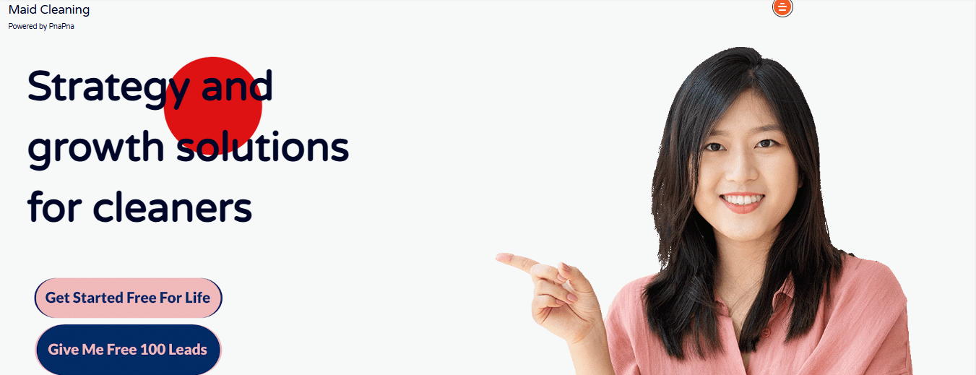 | Maid Cleaning  Powered by PnaPna  Strategy and growth solutions for cleaners  Get Started Free For Life  Give Me Free 100 Leads
Div 2. | 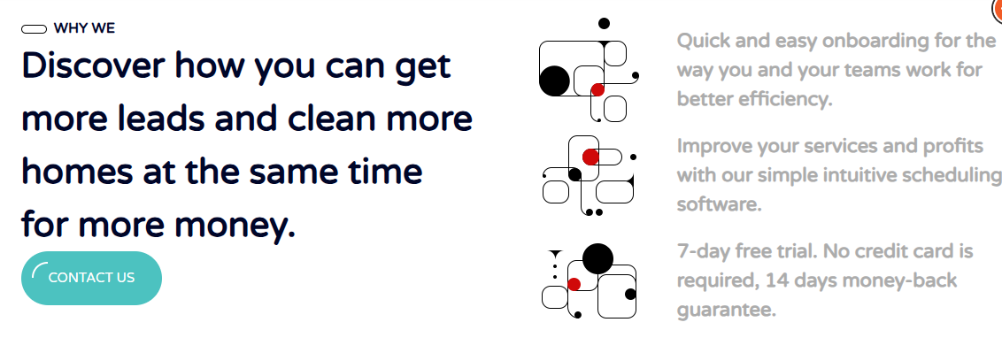 | WHY WE  Discover how you can get more leads and clean more homes at the same time for more money.  Contact us  Quick and easy onboarding for the way you and your teams work for better efficiency.  cleaning scheduling  Improve your services and profits with our simple intuitive scheduling software.  automatic scheduling  7-day free trial. No credit card is required, 14 days money-back guarantee.
Div 3. | 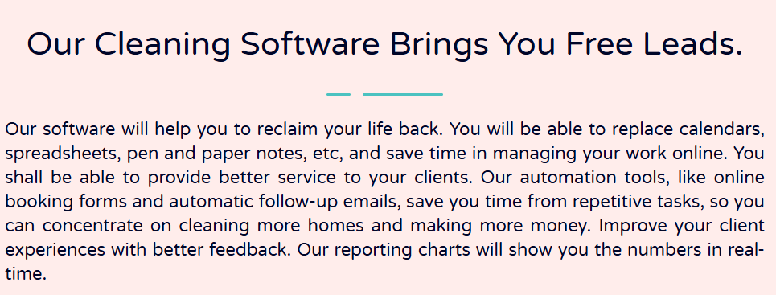 | Our Cleaning Software Brings You Free Leads.  Our software will help you to reclaim your life back. You will be able to replace calendars, spreadsheets, pen and paper notes, etc, and save time in managing your work online. You shall be able to provide better service to your clients. Our automation tools, like online booking forms and automatic follow-up emails, save you time from repetitive tasks, so you can concentrate on cleaning more homes and making more money. Improve your client experiences with better feedback. Our reporting charts will show you the numbers in real-time.
Div 4. | 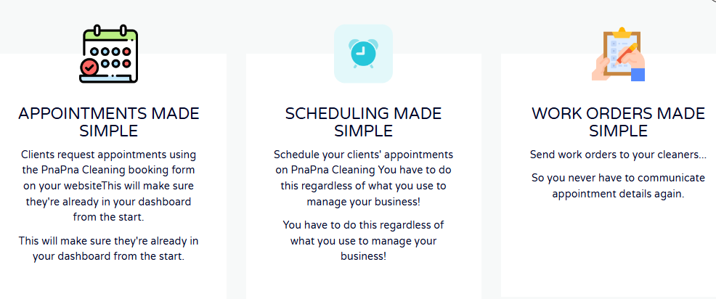  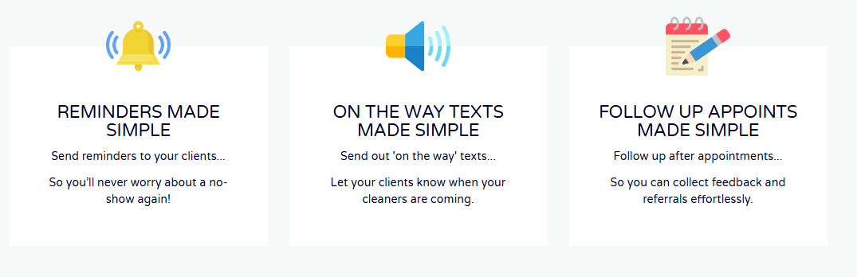 | Appointments Made Simple  Clients request appointments using the PnaPna Cleaning booking form on your websiteThis will make sure they're already in your dashboard from the start.  This will make sure they're already in your dashboard from the start.  Scheduling Made Simple  Schedule your clients' appointments on PnaPna Cleaning You have to do this regardless of what you use to manage your business!  You have to do this regardless of what you use to manage your business!  Work Orders Made Simple  Send work orders to your cleaners…  So you never have to communicate appointment details again.  Reminders Made Simple  Send reminders to your clients...  So you’ll never worry about a no-show again!  On the way texts Made Simple  Send out 'on the way' texts...  Let your clients know when your cleaners are coming.  Follow up Appoints Made Simple  Follow up after appointments...  So you can collect feedback and referrals effortlessly.
Div 5. | 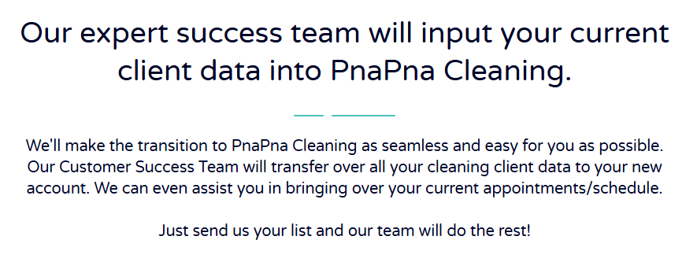 | Our expert success team will input your current client data into PnaPna Cleaning.  We'll make the transition to PnaPna Cleaning as seamless and easy for you as possible. Our Customer Success Team will transfer over all your cleaning client data to your new account. We can even assist you in bringing over your current appointments/schedule.  Just send us your list and our team will do the rest!
Div 6. | 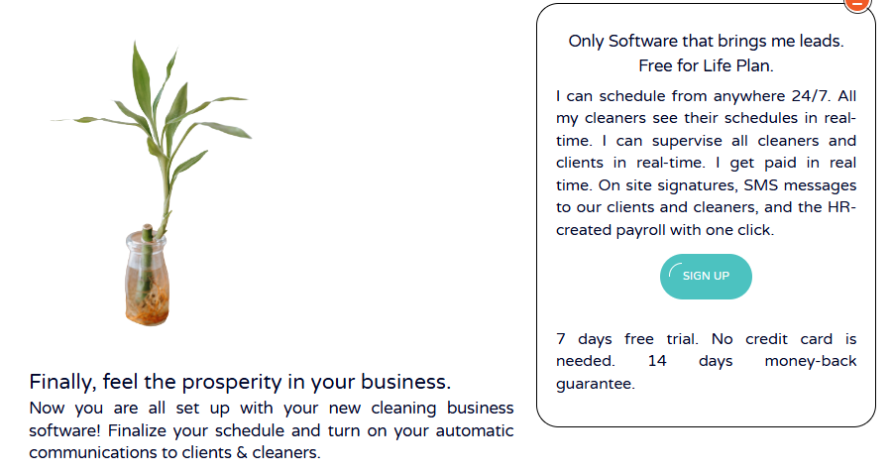 | Finally, feel the prosperity in your business.  Now you are all set up with your new cleaning business software! Finalize your schedule and turn on your automatic communications to clients & cleaners.  Only Software that brings me leads. Free for Life Plan.  I can schedule from anywhere 24/7. All my cleaners see their schedules in real-time. I can supervise all cleaners and clients in real-time. I get paid in real time. On site signatures, SMS messages to our clients and cleaners, and the HR-created payroll with one click.  Sign Up  7 days free trial. No credit card is needed. 14 days money-back guarantee.
Div 7. | 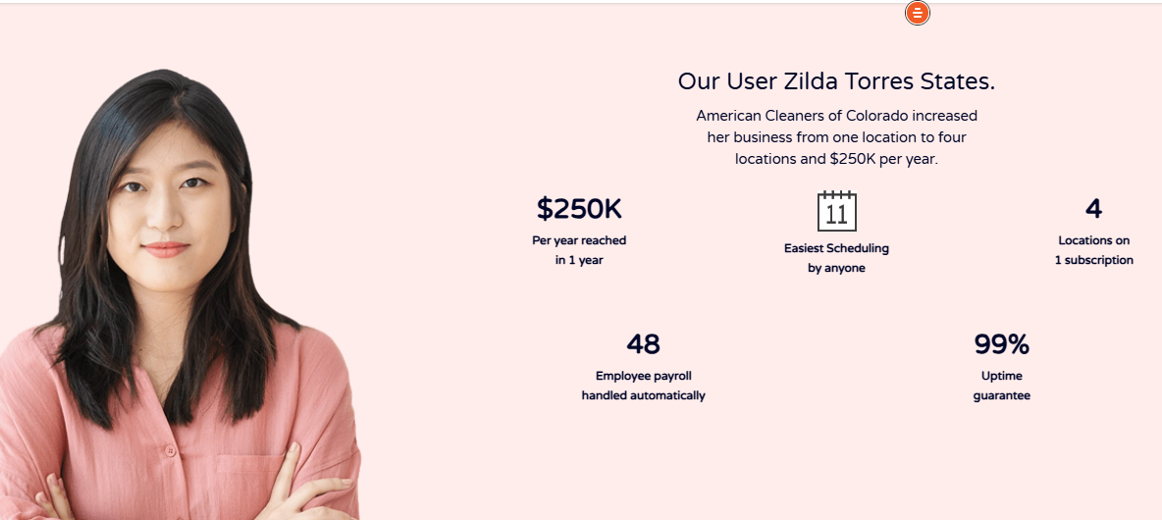 | Our User Zilda Torres States.  American Cleaners of Colorado increased  her business from one location to four  locations and $250K per year.  $250K  Per year reached  in 1 year  Easiest Scheduling  by anyone  4  Locations on  1 subscription  48  Employee payroll  handled automatically  99%  Uptime  guarantee
Div 8. | 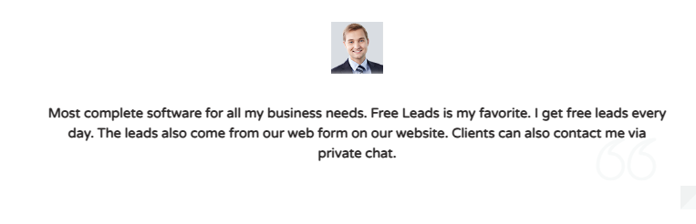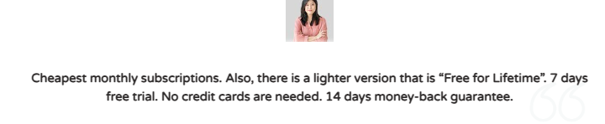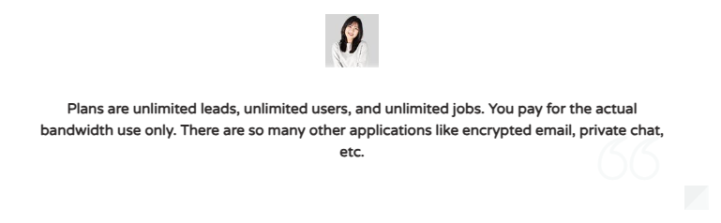 | Most complete software for all my business needs. Free Leads is my favorite. I get free leads every day. The leads also come from our web form on our website. Clients can also contact me via private chat.  Cheapest monthly subscriptions. Also, there is a lighter version  that is “Free for Lifetime”. 7 days free trial. No credit cards  are needed. 14 days money-back guarantee.  Plans are unlimited leads, unlimited users, and unlimited jobs.  You pay for the actual bandwidth use only. There are so many  other applications like encrypted email, private chat, etc.
Div 9 |  | Get new Leads  This is the only  software that brings  me new client leads.
Div 10. | 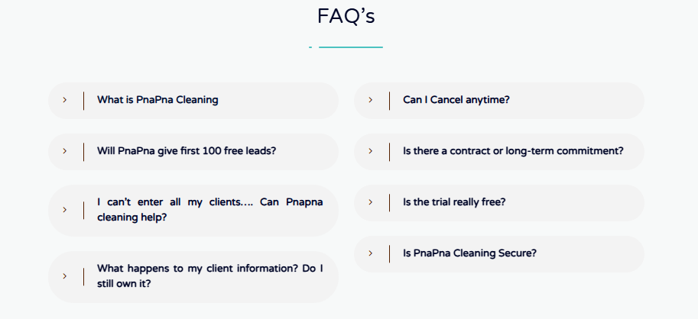 | 1. What is PnaPna Cleaning  PnaPna service software is software that caters specifically to residential home cleaning businesses. Your maid service should use software designed for maid services like yours by maid service owners like you. Your scheduling solution should improve your team's efficiency and help you provide your customer with an even better customer experience.  - Will PnaPna give first 100 free leads?  Yes, up to the first 100 leads are free from our market place.  - I can’t enter all my clients…. Can Pnapna cleaning help?  You bet we can! Just send us over your current client information however you have it, and the PnaPna team will format and upload it to your new account. FREE!  - What happens to my client information? Do I still own it?  Yes, PnaPna Cleaning's terms of service state that the only right we have to your clients information is to assist you with your account. You own any data you keep in PnaPna Cleaning.  - Can I Cancel anytime?  Yes.  - Is there a contract or long-term commitment?  No, you can try any of PnaPna Cleaning plans on a month-to-month agreement, with no signature necessary. If PnaPna Cleaning isn’t for you can cancel anytime.  - Is the trial really free?  Yes, when you sign up today, you’ll have days of free access to the best software on the market for PnaPna services. No hidden fees or surprise bills.  - Is PnaPna Cleaning Secure?  Yes, your payment information and customer information are safe with us.

Div 11. | 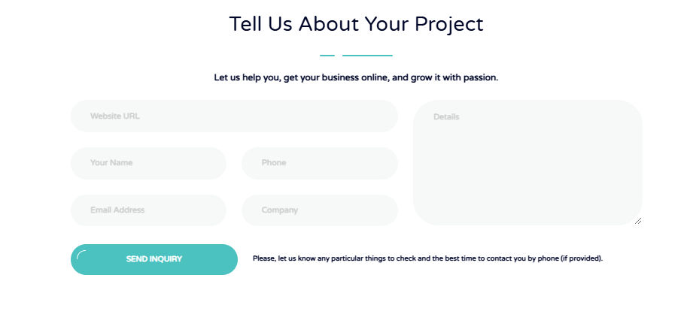 | Tell Us About Your Project  Let us help you, get your business online, and grow it with passion.  Website url :  Your name:  Phone:  Email Address:  Company:  Details:  Send inquery  Please, let us know any particular things to check and the best time to contact you by phone (if provided).

Contractor-business-software

https://old0.pnapna.com/en/page/contractor-business-software

