S.NO | Test | PnaPnaTech | Copilot
 | Link | https://demo.pnapna.us/tech/authentication/login | https://www.copilotcrm.com/  https://secure.copilotcrm.com/
 | Password | Username: incubers.gauravpatel@gmail.com  Password: kennedy63 | Username: incuber.sanjana@gmail.com  Password: incubers@jaipur123
 | Pricing | 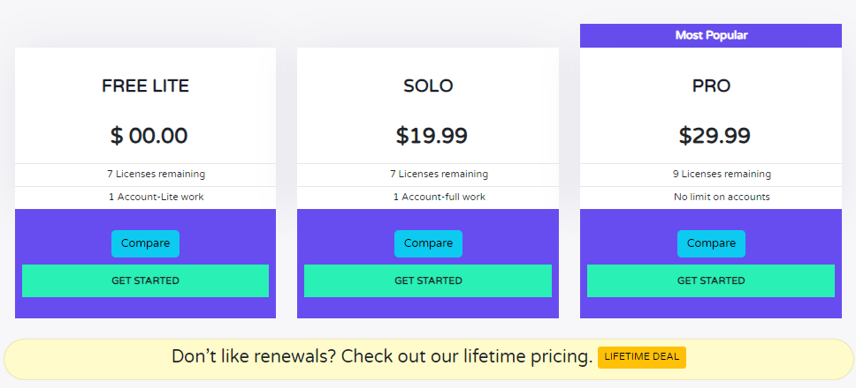   | 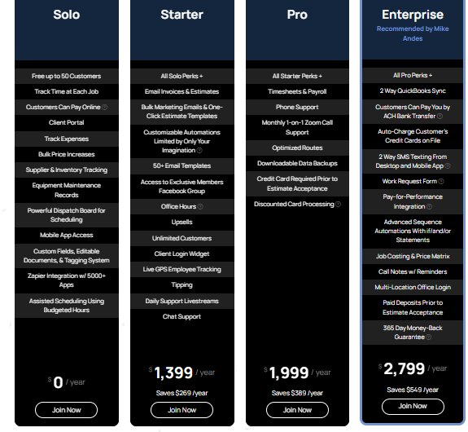  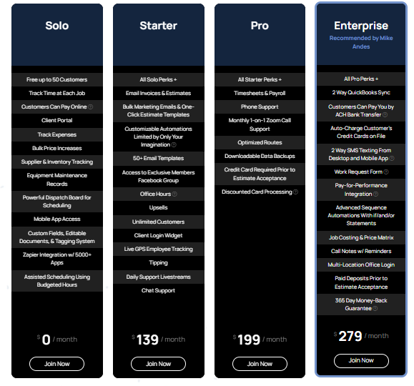
 | Speed | 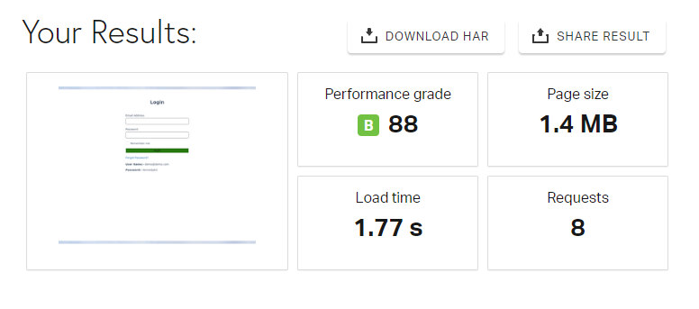 | 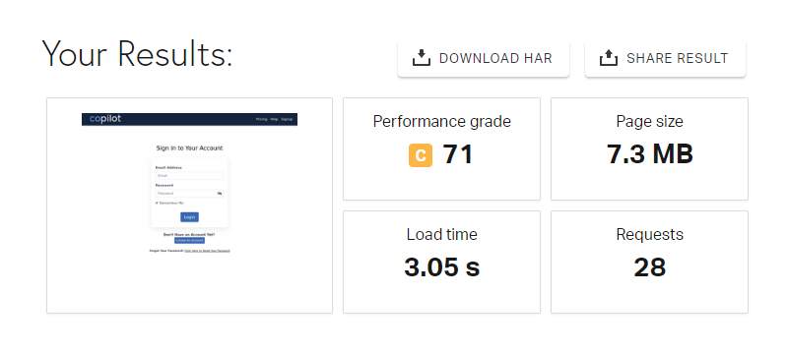
 | Key Features | - CRM functionalities  - Task and project management  - Financial management  - HR management  - Well Appointed Dashboard  - Reporting and analytics  - Best Value Priced Contractor Business Software  - One Click Quick Proposal Maker  - Professionally Designed Proposals  - Online Agreement And Signatures Process  - Knowledge Base Videos  - One Click Quick Invoicing  - One Click Quick Estimate Sheets  - Encrypted Emails  - Real-time Statements  - Online payment  - Document Maker Tool  - Geo-location Onsite Image  - On Site Manager For Incidents, Inspections, Visits  - One Click Quick Project Task Creator | - Contact management  - Sales pipeline management  - Task and activity tracking  - Email integration  - Reporting and analytics  - Customizable workflows  - Online paymen  - Get Paid Faster  - Hassle-Free Auto Pay from Client Portal  - Never Lose Money on a Big Project Again  - Never Worry About Invoicing Again  - Run Your Business From Anywhere in the World  - Built for Multi-Location Companies  - Know Your Numbers
 | Trial  or Demo | Often provides a free trial or demo version to explore features. | Often provides a free trial or demo version to explore features.
 | Description on Homepage | PnaPna is a business productivity software for SMEs, that needs to upgrade from spreadsheets and docs. Get all applications in one subscription. | Home Service Business CRM, Scheduling & Invoicing Software  Home Services CRM for scheduling, estimating, invoicing, marketing & more.This is a CRM for all home service based businesses such as landscaping, plumbing, electrician, garage door repair companies, HVAC, construction, pest control, locksmith, pool cleaning, janitorial, painting, restoration lawn care, & more.
 | Client side Programming language | Java-script | Java-script
 | Libraries | jQuery is a JavaScript library  Bootstrap is an open source HTML, CSS, and JavaScript framework. | jQuery is a JavaScript library  Bootstrap is an open source HTML, CSS, and JavaScript framework.
 | Top level domain | .us | .com
 | Operating system | Linux  Window | Linux
 | Web hosting provider | SSD Node | Duda  Amazon
 | Data center provider | SSD Node | Amazon
 | Server location | United States | United States  Germany
 | Content language | English | English
 | Image file formate | PNG  SVG  JPEG | PNG  SVG
 | Email server provider | SiteGround | Gmail is the email service provided by Google.
 | Web server | Ngnix 1.18.0 | Ngnix 1.22.1
 | Server-side programming language | PHP | Java
 | Content management | Perfex | Duda
 | CSS Framework | Bootstrap is an open source HTML, CSS, and JavaScript framework. | Bootstrap is an open source HTML, CSS, and JavaScript framework.  Animate is a CSS library focusing on animations.
 | DNS Provider | us.cloud | Amazon
 | Markup language | HTML5 | HTML5
 | Character encoding | UTF-8 | UTF-8
 | SSL Certificate Authorities | Certbot SSL | Let’s Encrypt is a free, automated, and open certificate authority provided by the Internet Security Research Group.  Starfield Technologies is an SSL certificate authority owned by Go Daddy.
 | Site Elements | External CSS  Embedded CSS  Inline CSS  Session Cookies  Gzip Compression  Cookies expiring in hours  HttpOnly Cookies  Secure Cookies  Default protocol https | External CSS  Embedded CSS  Inline CSS  Session Cookies  Gzip Compression  Non-Secure Cookies  HTTP Strict Transport Security  HTTP/2  Cookies expiring in hours  Default subdomain www  Default protocol https

