S.No | Links | Works | Images
1. | https://pnapna  /en/page/contractor-leads | Backend work form | 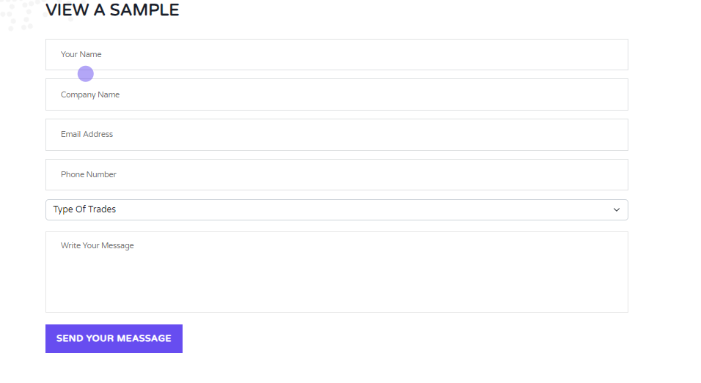
2. | https://pnapna.com/en/page/contacts | Backend work form | 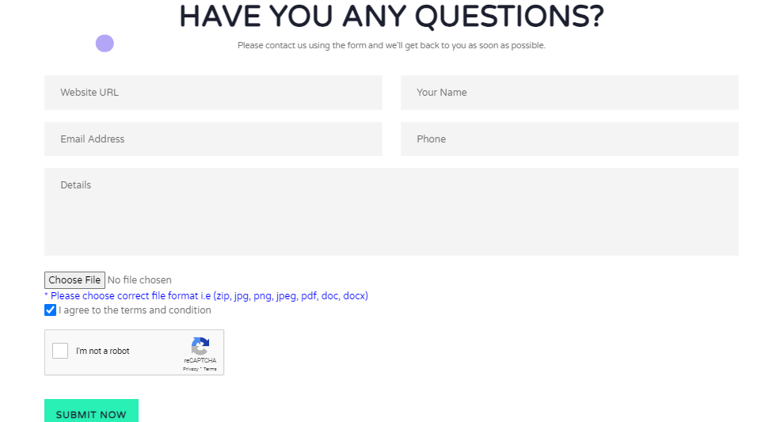
3. | https://pnapna.com/en/page/contractor-lead-pricing | Backend work form | 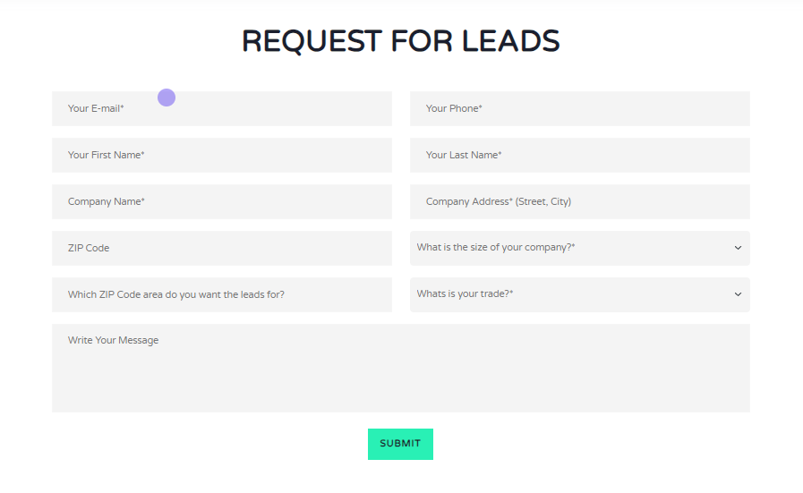
4. | https://pnapna.com/en/page/contractor-lead-pricing | Add More button | 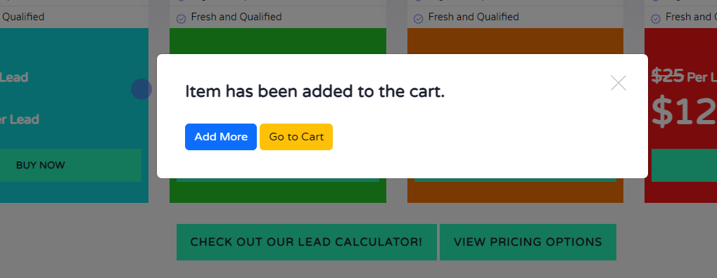
5. | https://pnapna.com/en/page/contractor-leads-generation-agreement | Backend work form | 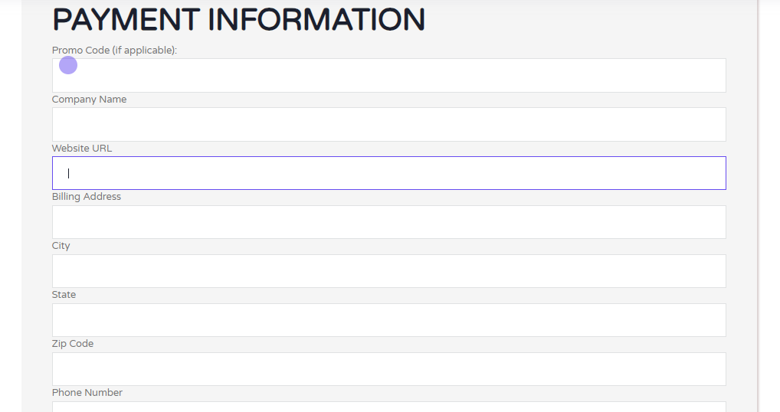
6. | https://pnapna.com/en/page/launch-page | Backend work form | 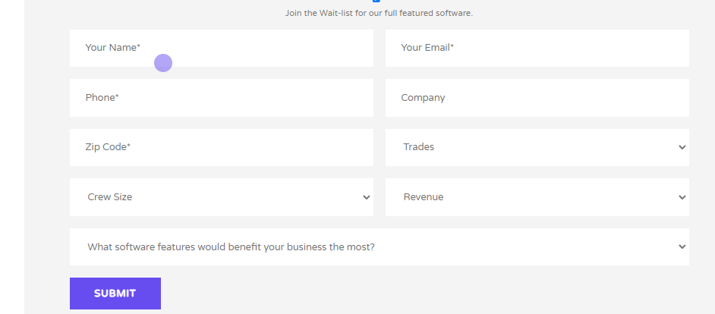
7. | https://pnapna.com/en/page/millionairecontractor | Backend work form | 
8. | https://pnapna.com/en/page/help-desk | Backend work form | 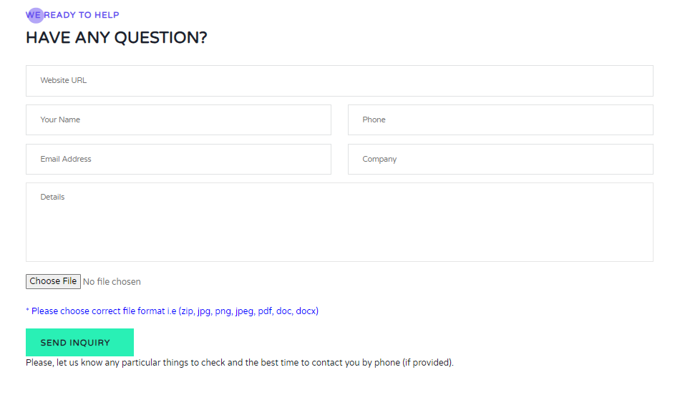
9. | https://pnapna.com/en/page/app-product-page | Backend work form | 
10. | https://pnapna.com/en/page/pnapna-features | PnaPna features content and images change. | 