S.NO | Test | PnaPnaTech | Copilot
 | Link | https://demo.pnapna.us/tech/authentication/login | https://www.copilotcrm.com/  https://secure.copilotcrm.com/
 | Password | Username: incubers.gauravpatel@gmail.com  Password: kennedy63 | Username: incuber.sanjana@gmail.com  Password: incubers@jaipur123
 | Pricing | 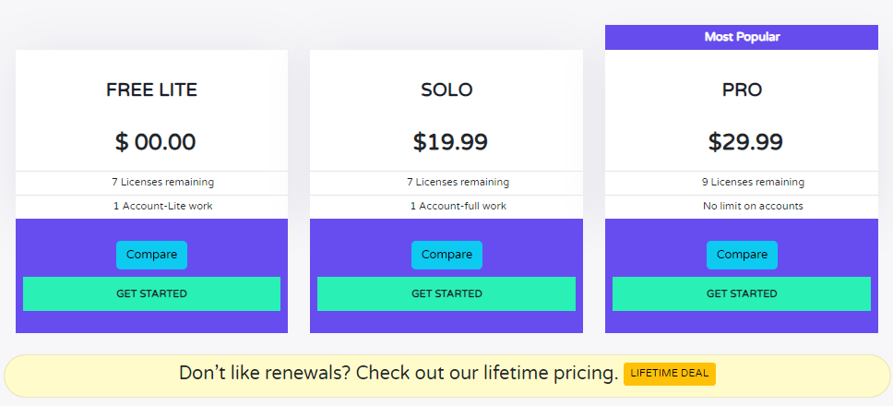  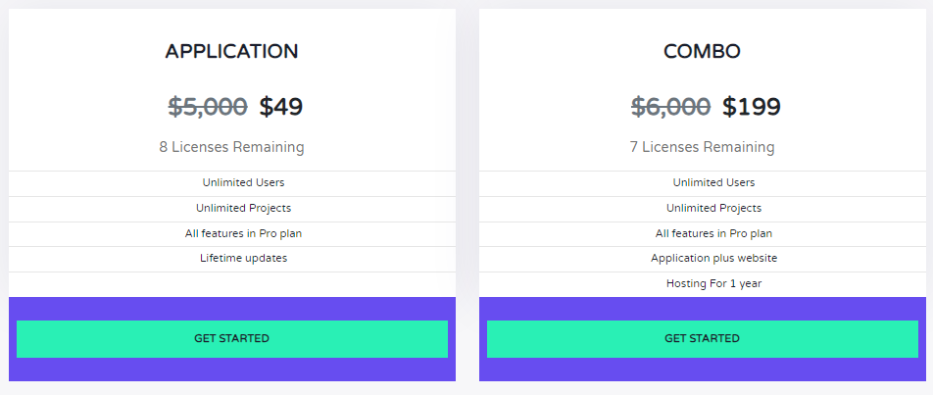 | 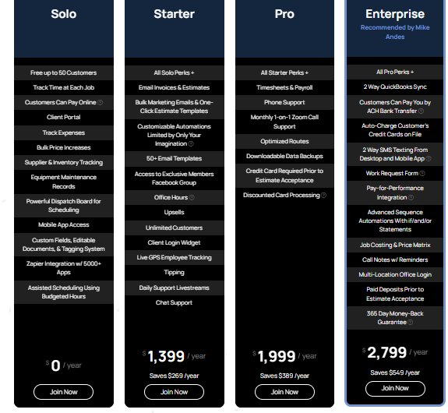  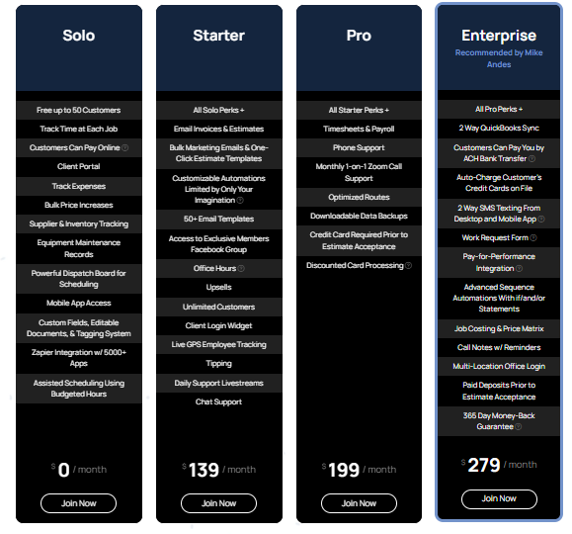
 | Speed | 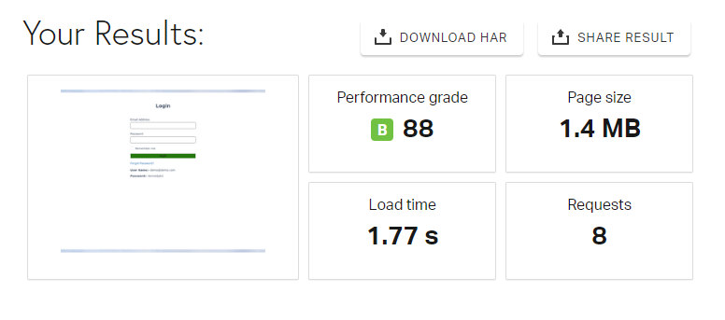 | 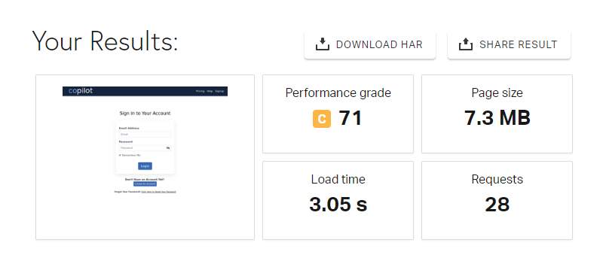
 | Features

