S.No | Download websites name | Links | Header Images
1. | kb.contractorforeman.com | https://sanjana.hubetc.com/bootstrap/downloded-websites/kb.contractorforeman.com/ | 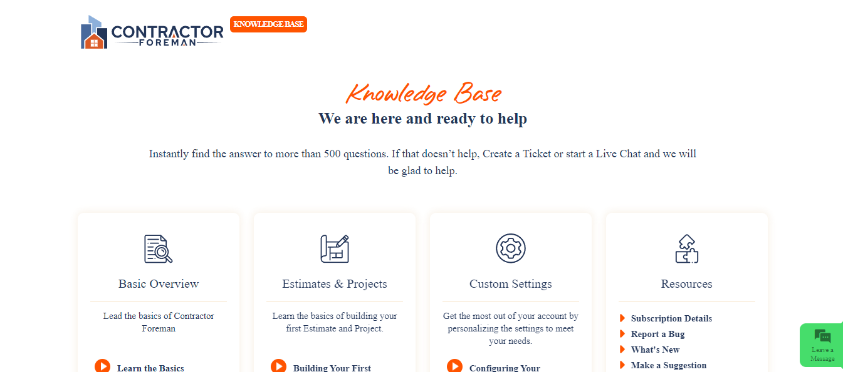
2. | www.owner.com | https://sanjana.hubetc.com/bootstrap/downloded-websites/www.owner.com/ | 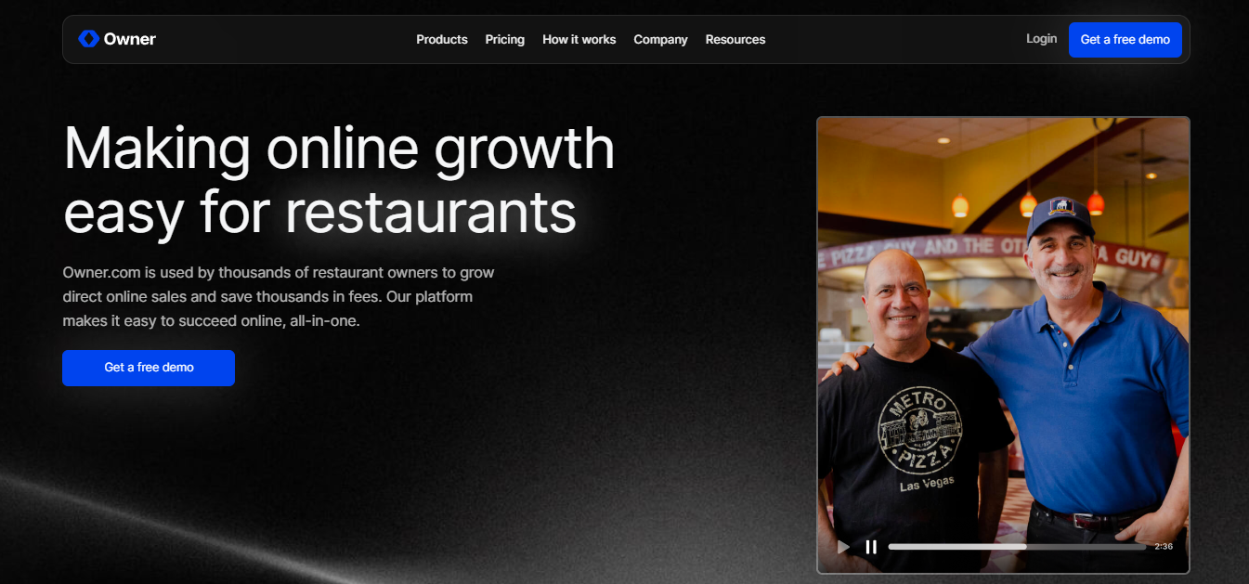
3. | www.windownationpros.com | https://sanjana.hubetc.com/bootstrap/downloded-websites/www.windownationpros.com/lp-1.html | 
4. | www.homebuddy.com | https://sanjana.hubetc.com/bootstrap/downloded-websites/www.homebuddy.com/contractor.html | 
5. | www.serviceautopilot.com | https://sanjana.hubetc.com/bootstrap/downloded-websites/www.serviceautopilot.com/field-service/software/tour/ | 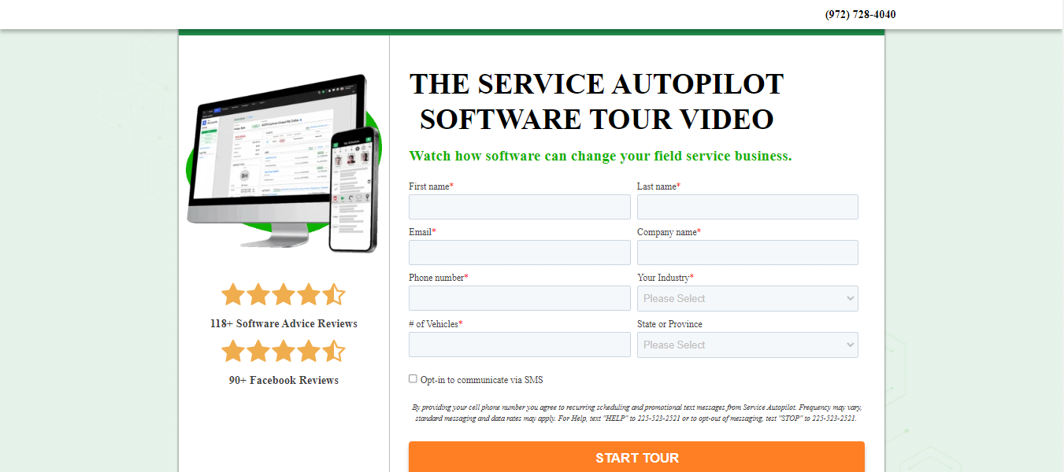
S.No | Clone websites name | Links | Header Images
1. | kb.pnapnatech-Ver_02.com | https://sanjana.hubetc.com/bootstrap/clone-websites/kb.pnapnatech-Ver_02.com/knowledge_base_features.php | 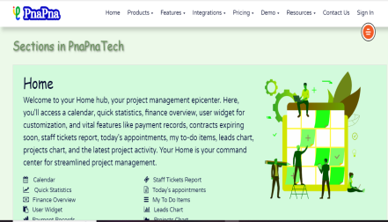
2. | kb.pnapnatech-Ver_03.com | https://sanjana.hubetc.com/bootstrap/clone-websites/kb.pnapnatech-Ver_03.com/knowledge-base.php | 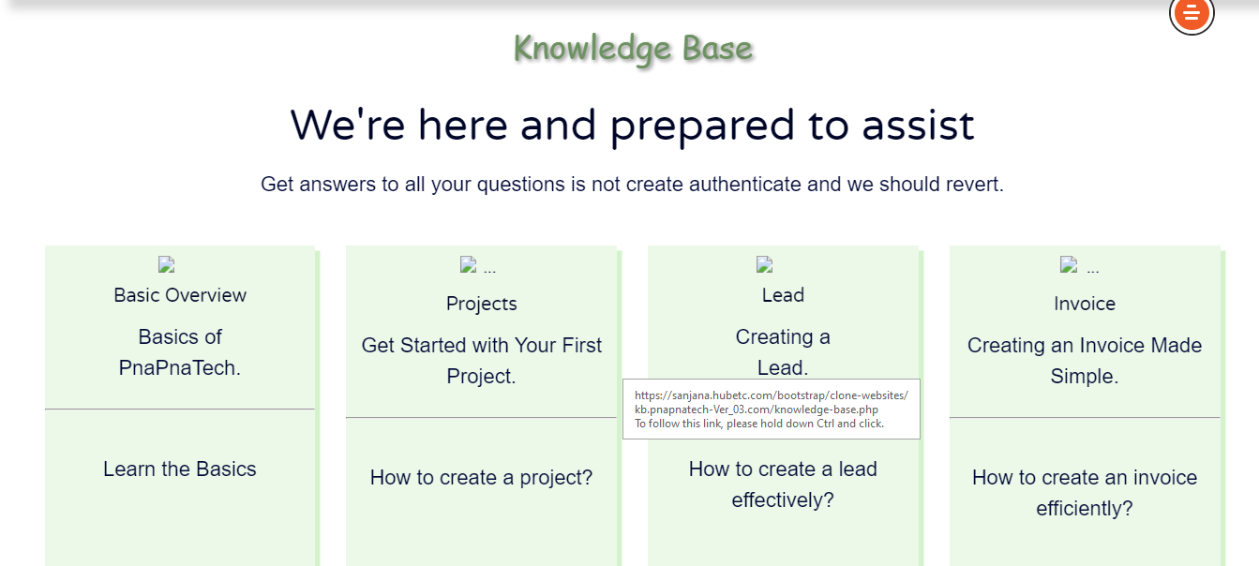
3. | ebook-landingpage | https://sanjana.hubetc.com/bootstrap/clone-websites/ebook-landingpage/ | 
4. | pnapnatech-tralingpage | https://sanjana.hubetc.com/bootstrap/clone-websites/pnapnatech-tralingpage/ | 

