S.No | Pricing-plan page dives
Div 1 | 
Pricing
Superior Marketing
Automation.
Simple Pricing.
All of our licenses include WP Fusion extensibility, scalability, reliability, and the best support around. Powering 28,337 sites and counting!

Div 2 | 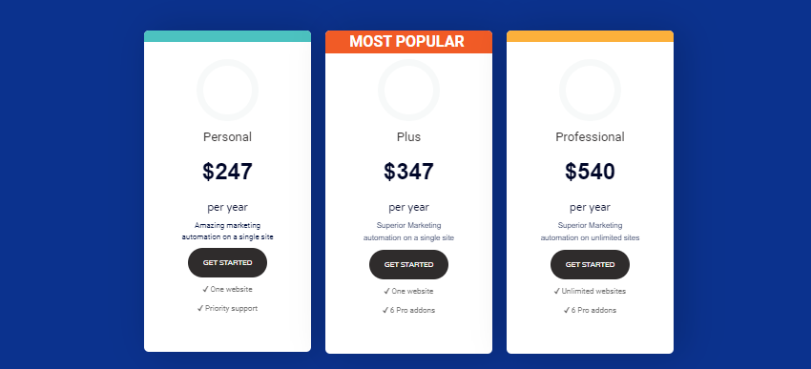
 | Personal $247 per year Amazing marketing automation on a single site GET STARTED ✓ One website ✓ Priority support Plus $347 per year Superior Marketing automation on a single site GET STARTED ✓ One website ✓ 6 Pro addons Professional $540 per year Superior Marketing automation on unlimited sites GET STARTED ✓ Unlimited websites ✓ 6 Pro addons
Div 3 | 
Not ready for the full version of WP Fusion? Download WP Fusion Lite for free.

Building a site for a client? Don’t like annual renewals? Check out our lifetime pricing.
Div 4 | 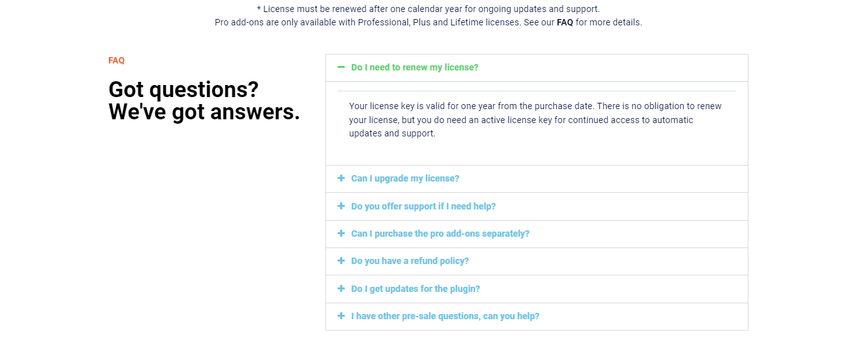
FAQ  Got questions? We've got answers. | Do I need to renew my license?  Your license key is valid for one year from the purchase date. There is no obligation to renew your license, but you do need an active license key for continued access to automatic updates and support.
Can I upgrade my license?
Yes, you can easily upgrade your license from your account page.
Do you offer support if I need help?
Yes! Top-notch customer support is key for a quality product, so we’ll do our very best to resolve any issues you encounter via our support page.
Can I purchase the pro add-ons separately?
The pro add-ons are only available to Plus or Professional license holders and cannot be purchased separately.
Do you have a refund policy?
Yes we do! We stand behind the quality of our product and will refund 100% of your money if you are unhappy with the plugin
Do I get updates for the plugin?
Yes! Automatic updates are available free of charge to all users with a valid license key.

I have other pre-sale questions, can you help?
Yes! You can ask us any questions through our support page.

Div 5 | 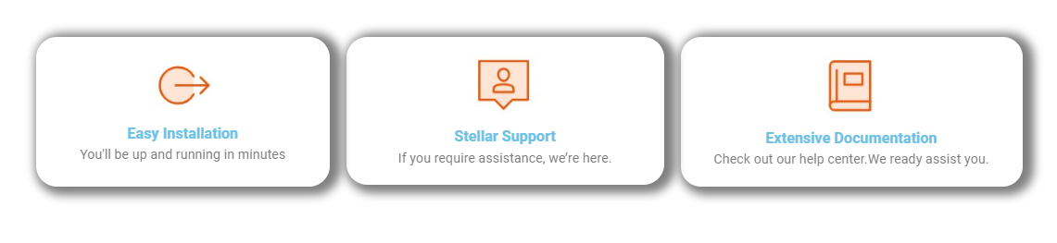

Easy Installation
You'll be up and running in minutes

Stellar Support
If you require assistance, we’re here.

Extensive Documentation
Check out our help center.We ready assist you.

Div 6 | 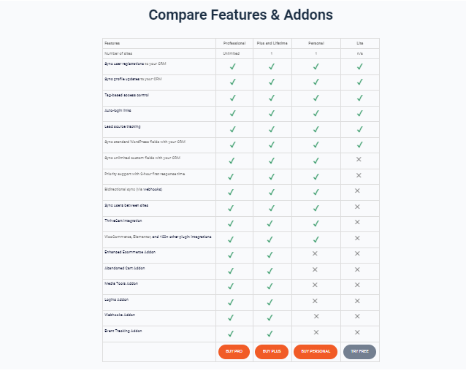
Features | Professional | Plus and Lifetime | Personal | Lite
Number of sites | Unlimited | 1 | 1 | n/a
Sync user registrations to your CRM | ✓ | ✓ | ✓ | ✓
Sync profile updates to your CRM | - ✓ | ✓ | ✓ | ✓
Tag-based access control | ✓ | ✓ | ✓ | ✓
Auto-login links | ✓ | ✓ | ✓ | ✓
Lead source tracking | ✓ | ✓ | ✓ | ✓
Sync standard WordPress fields with your CRM | ✓ | ✓ | ✓ | ✓
Sync unlimited custom fields with your CRM | ✓ | ✓ | ✓ | ✕
Priority support with 2-hour first response time | ✓ | ✓ | ✓ | ✕
Bidirectional sync (via webhooks) | ✓ | ✓ | ✓ | ✕
Sync users between sites | ✓ | ✓ | ✓ | ✕
ThriveCart integration | ✓ | ✓ | ✓ | ✕
WooCommerce, Elementor, and 100+ other plugin integrations | ✓ | ✓ | ✓ | ✕
Enhanced Ecommerce Addon | ✓ | ✓ | ✕ | ✕
Abandoned Cart Addon | ✓ | ✓ | ✕ | ✕
Media Tools Addon | ✓ | ✓ | ✕ | ✕
Logins Addon | ✓ | ✓ | ✕ | ✕
Webhooks Addon | ✓ | ✓ | ✕ | ✕
Event Tracking Addon | ✓ | ✓ | ✕ | ✕
 | BUY PRO | BUY PLUS | BUY PERSONAL | TRY FREE

Div 7 | 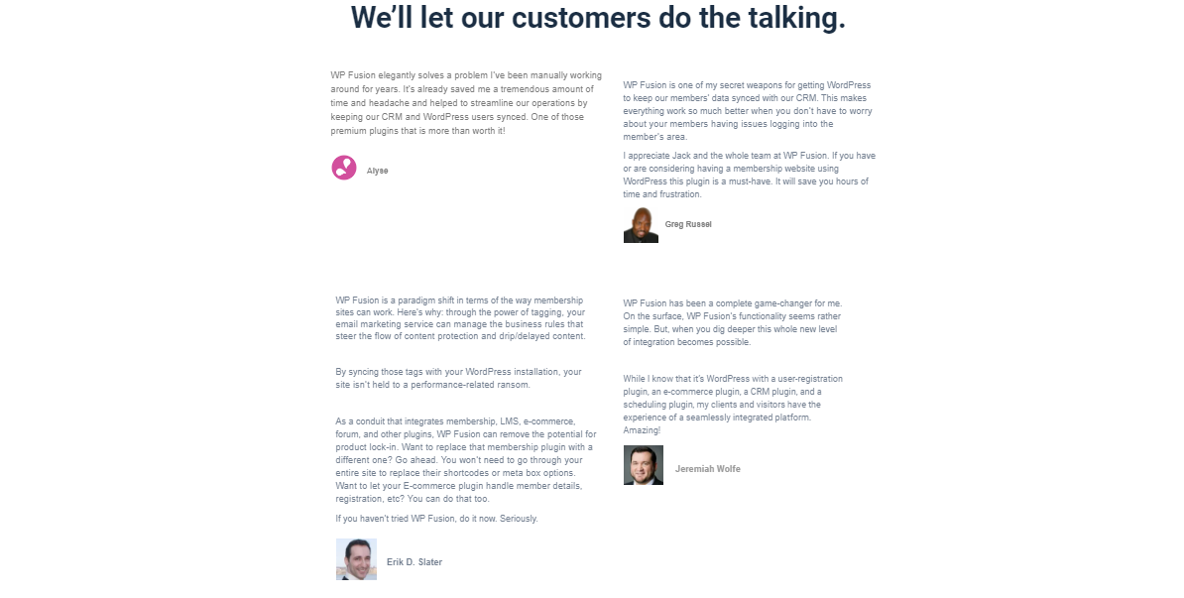

We’ll let our customers do the talking.

WP Fusion elegantly solves a problem I’ve been manually working around for years. It’s already saved me a tremendous amount of time and headache and helped to streamline our operations by keeping our CRM and WordPress users synced. One of those premium plugins that is more than worth it!  Alyse | WP Fusion is one of my secret weapons for getting WordPress to keep our members’ data synced with our CRM. This makes everything work so much better when you don’t have to worry about your members having issues logging into the member’s area.  I appreciate Jack and the whole team at WP Fusion. If you have or are considering having a membership website using WordPress this plugin is a must-have. It will save you hours of time and frustration.  Greg Russel
WP Fusion is a paradigm shift in terms of the way membership sites can work. Here’s why: through the power of tagging, your email marketing service can manage the business rules that steer the flow of content protection and drip/delayed content.  By syncing those tags with your WordPress installation, your site isn’t held to a performance-related ransom.  As a conduit that integrates membership, LMS, e-commerce, forum, and other plugins, WP Fusion can remove the potential for product lock-in. Want to replace that membership plugin with a different one? Go ahead. You won’t need to go through your entire site to replace their shortcodes or meta box options. Want to let your E-commerce plugin handle member details, registration, etc? You can do that too.  If you haven’t tried WP Fusion, do it now. Seriously.  Erik D. Slater | WP Fusion has been a complete game-changer for me. On the surface, WP Fusion’s functionality seems rather simple. But, when you dig deeper this whole new level of integration becomes possible.  While I know that it’s WordPress with a user-registration plugin, an e-commerce plugin, a CRM plugin, and a scheduling plugin, my clients and visitors have the experience of a seamlessly integrated platform. Amazing!  Jeremiah Wolfe

Div 8 | 
Div 9 | 