S.No | Pricing page dives
Div 1 | 
Pricing
Lifetime Pricing​
If you’re building a site for a client and don’t want to leave them on the hook for yearly renewals, or you just prefer buying things lifetime, we’ve got you covered with our Lifetime Updates packages.
Our lifetime pricing includes lifetime updates and three years of premium support.
Div 2 | 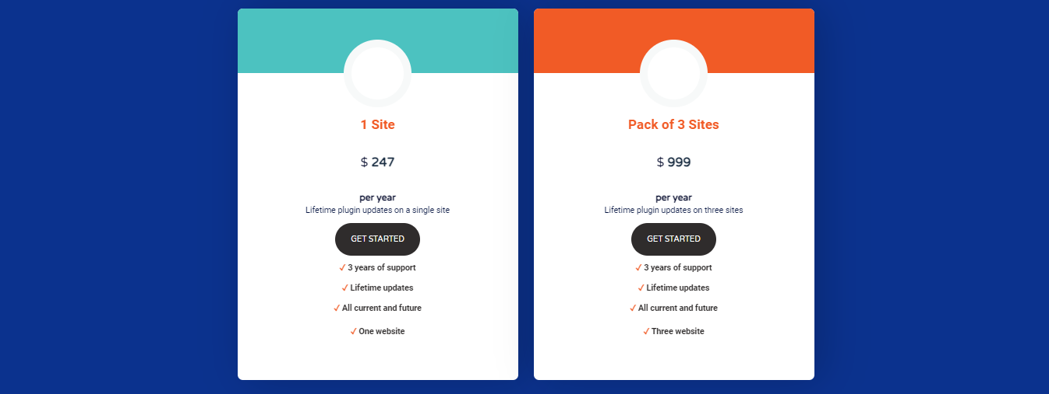
 | Personal $247 per year Amazing marketing automation on a single site GET STARTED ✓ One website ✓ Priority support Pack of 3 Sites $ 999 per year Lifetime plugin updates on three sites GET STARTED ✓ 3 years of support ✓ Lifetime updates ✓ All current and future ✓ Three website
Div 3 | 
FAQ  Lifetime Pricing | What's included?  Lifetime licenses are equivalent to a Plus license, except they don’t require an annual renewal. They include all current and future Pro addons.  Lifetime licenses include three years of premium support and automatic updates for as long as WP Fusion is being developed.
Who is this for?

Lifetime licenses are intended for agencies and individuals who are building sites for clients and don’t want to leave the client on the hook for yearly renewals.

By pre-paying for three years of support, we include lifetime automatic updates of the plugin as a bonus.
Can the licenses be moved?

Yes. Your license key(s) can be moved between sites simply by deactivating the license on one site and re-activating it on another
What if I need support after three years?

If you need premium support after the three year support period has ended you’ll be able to purchase an additional year of support for a one-time fee of $99.
What if I need support after three years?
If you need premium support after the three year support period has ended you’ll be able to purchase an additional year of support for a one-time fee of $99.
Can I get separate license keys?
Yes, if you want your clients to have their own license keys we’ll happily break your three-site license into three separate keys for you. Just contact our support.

Div 4 | 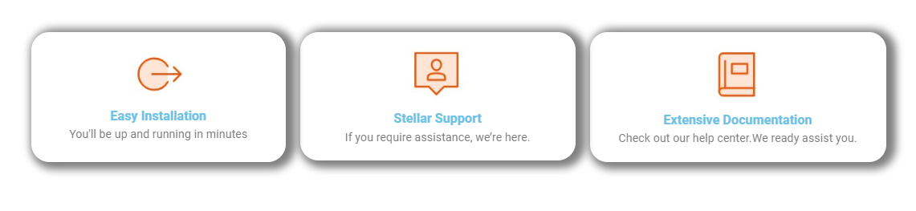

Easy Installation
You'll be up and running in minutes

Stellar Support
If you require assistance, we’re here.

Extensive Documentation
Check out our help center.We ready assist you.

Div 5 | 
Div 6 | 