Downloaded websites

S.No | Download websites name | Links | Header Images
1. | www.curamarketing.ca | https://archana.hubetc.com/bootstrap/downloded-websites/www.curamarketing.ca/ | 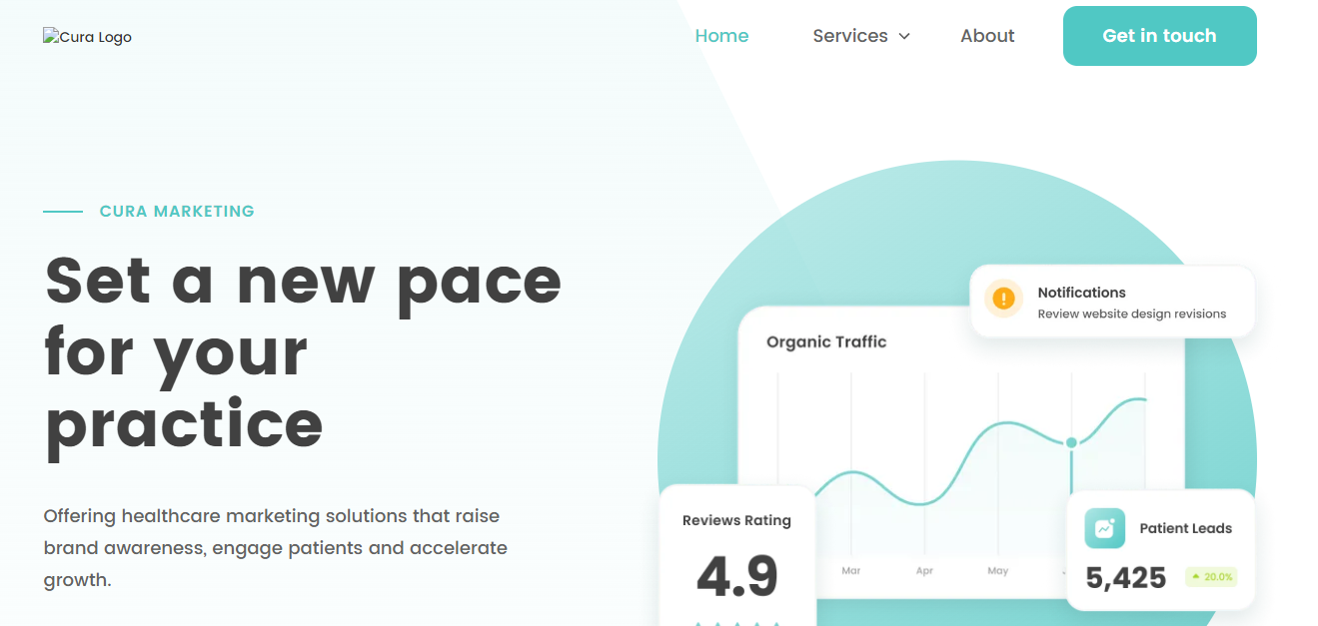
2. | kb.contractorforeman.com | https://archana.hubetc.com/bootstrap/downloded-websites/kb.contractorforeman.com/ | 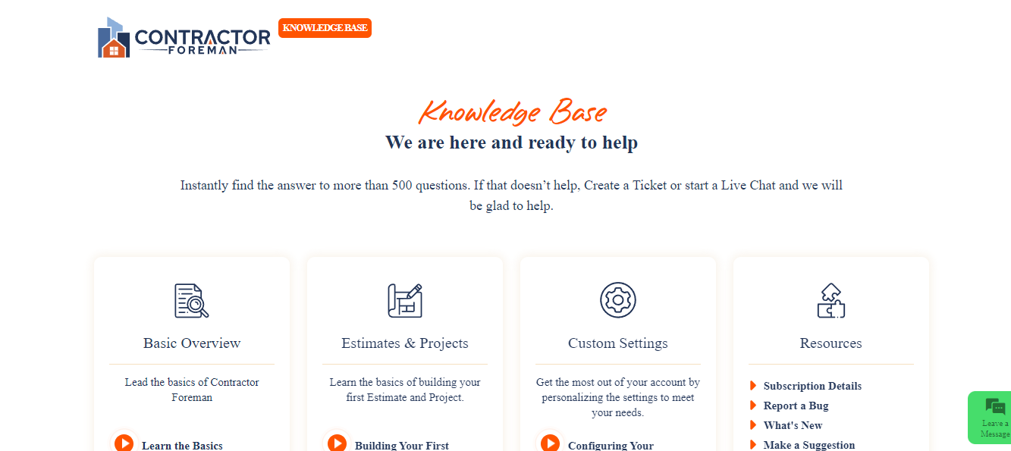
3. | donefor999 | https://archana.hubetc.com/bootstrap/downloded-websites/donefor999/ | 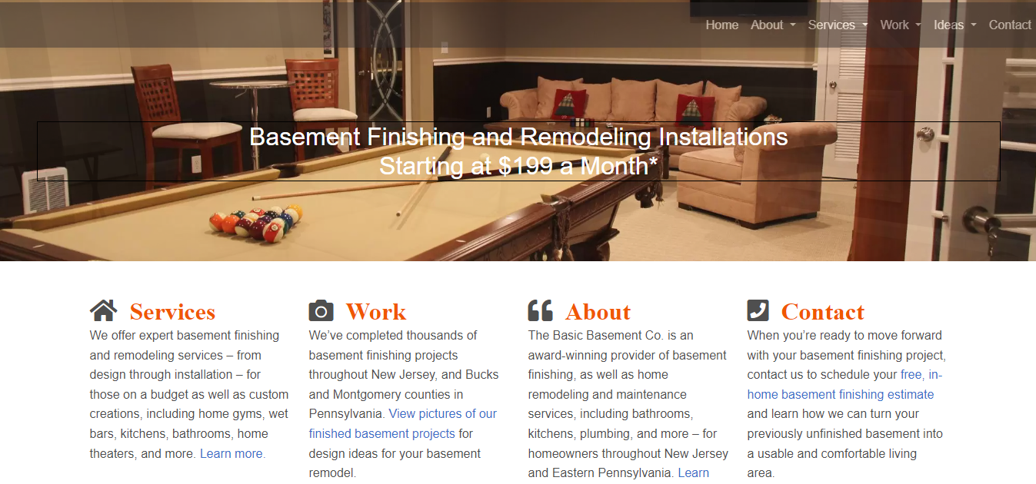
4. | www.doubleudigital.co.uk | https://archana.hubetc.com/bootstrap/downloded-websites/doubleudigital/www.doubleudigital.co.uk/index.html | 
5. | www.successware.com | https://archana.hubetc.com/bootstrap/downloded-websites/hvac-and-plumbing-glossaries/www.successware.com/glossary/index.html | 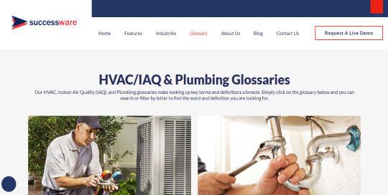

Clone websites

S.No | Clone websites name | Links | Header Images
1. | Affiliate-Program | https://archana.hubetc.com/bootstrap/Affiliate-Program/ | 
2. | Web.com | https://archana.hubetc.com/bootstrap/web/# | 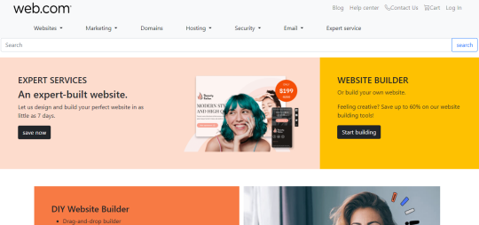
3. | hotjar | https://archana.hubetc.com/bootstrap/hotjar/# | 
4. | NRI.com | https://archana.hubetc.com/bootstrap/NRI.com/ | 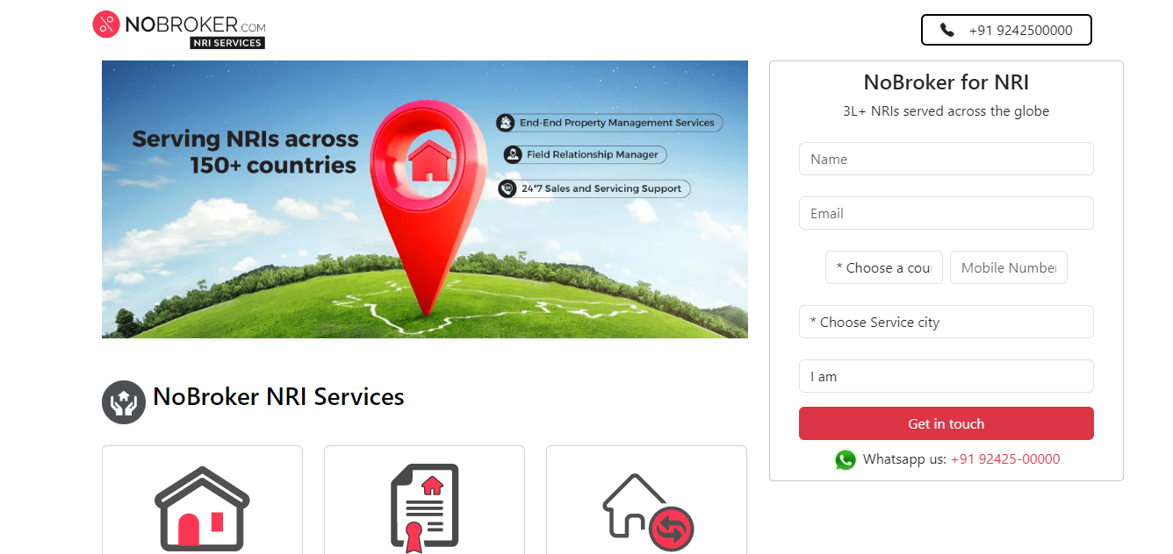
5. | Sera | https://archana.hubetc.com/bootstrap/sera/#! | 
6. | linqto | https://archana.hubetc.com/bootstrap/linqto/ | 
7. | kb.pnapnatech.com | https://archana.hubetc.com/bootstrap/kb.pnapnatech.com/features.html | 
8. | rural-sourcing | https://archana.hubetc.com/bootstrap/rural-sourcing/insights.html | 

