**How to Download & Use CamScanner on iPhone**

**Step 1: Download & Install CamScanner**

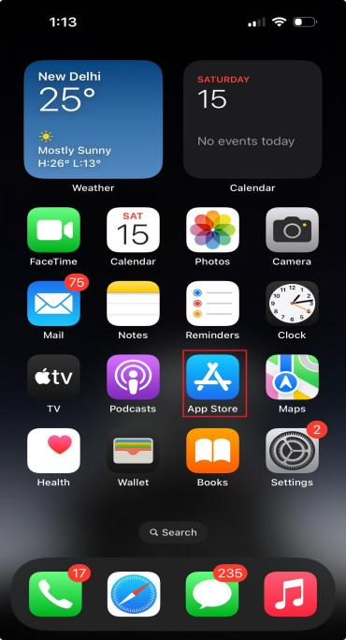First, open the **App Store** on your iPhone. In the search bar, type **CamScanner** and tap the get **button**. Once installed, open the app to start using it.

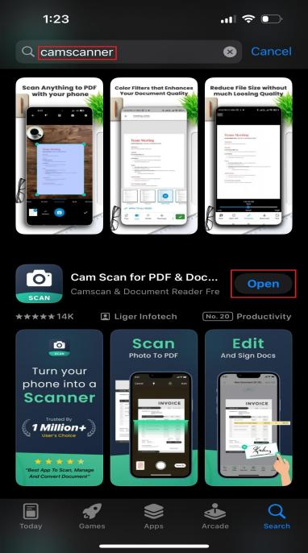

**Step 2: Setting Up Permissions**

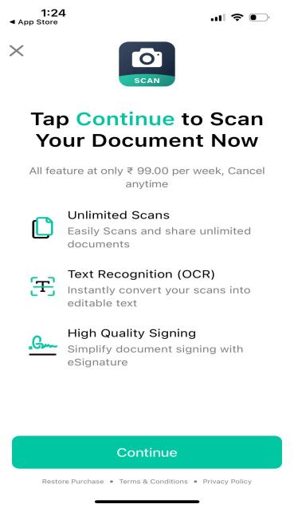When you open CamScanner for the first time, it will ask for **camera and storage access**. Tap **Allow** so you can scan do save them easily. You can either **sign up for a free account** or continue as a guest.

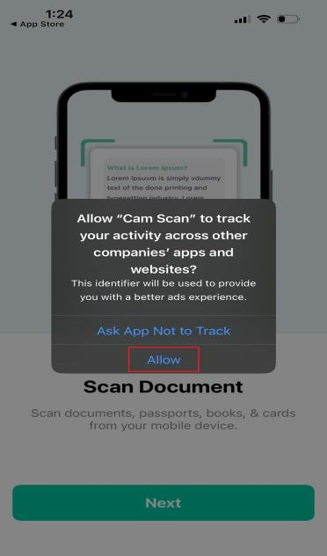

**Step 3: How to Scan a Document**

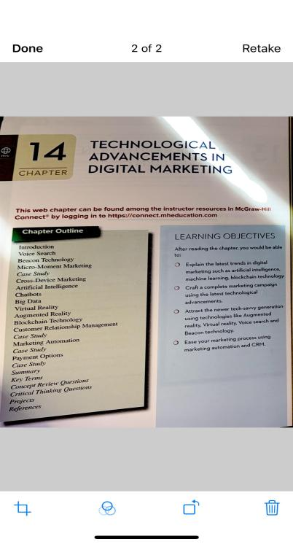To scan a document, tap the **camera icon**. Place your document on a flat surface and take a picture. CamScanner will **automatically detect the edges** and adjust the quality. You can also **manually crop or rotate** if needed.

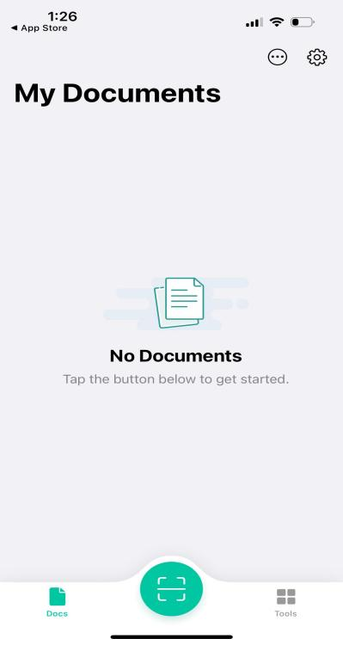

**Step 4: Editing & Enhancing the Scan**

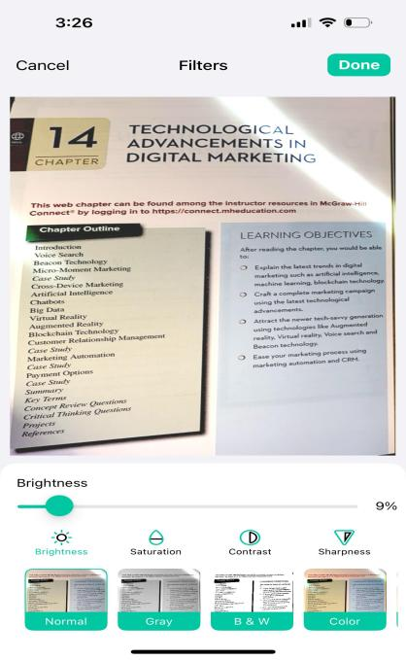After scanning, you can **edit the document** by adjusting brightness, applying filters, or improving clarity. This makes sure your scanned documents look professional and easy to read.

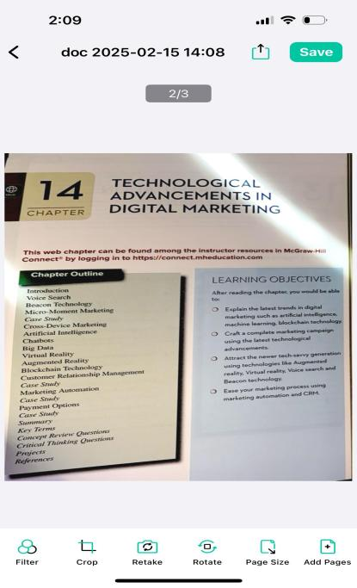

**Step 5: Saving & Sharing Scans**

Once you're happy with your scan, tap **Save** and choose **PDF or JPG format**. You can then share it via **email, WhatsApp, Google Drive, or other apps**.

