@Sanjana (CC Gaurav, Atul):

We are very close to launching phase 1 of ABT except for the following corrections.
Please do the Pricing Plans page first and then attempt to do the editing on the following items.

Screenshots of client admin panel
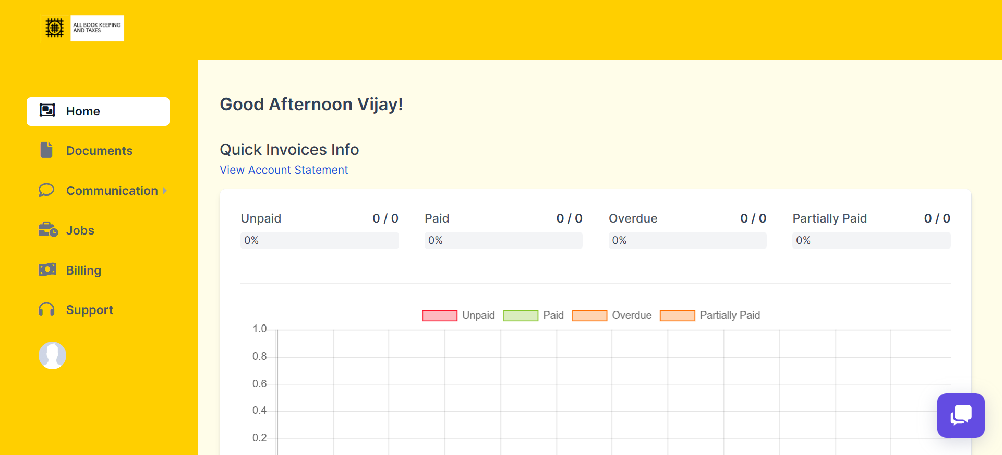
TBD in conference
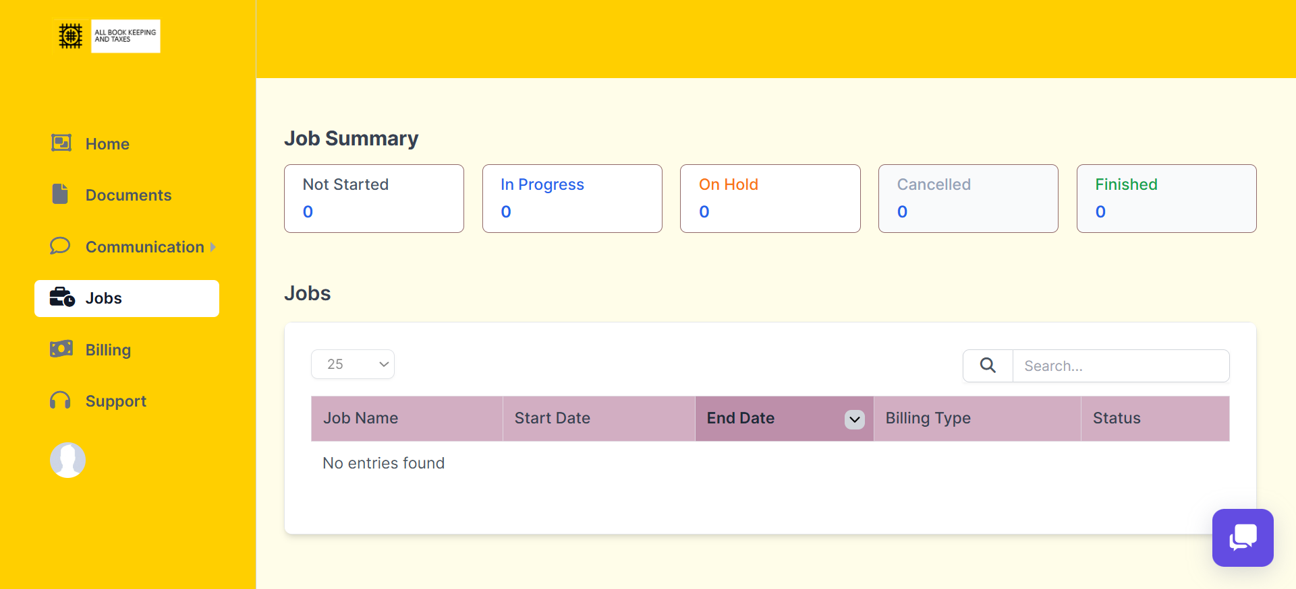
What jobs are these in client admin panel? I think remove this
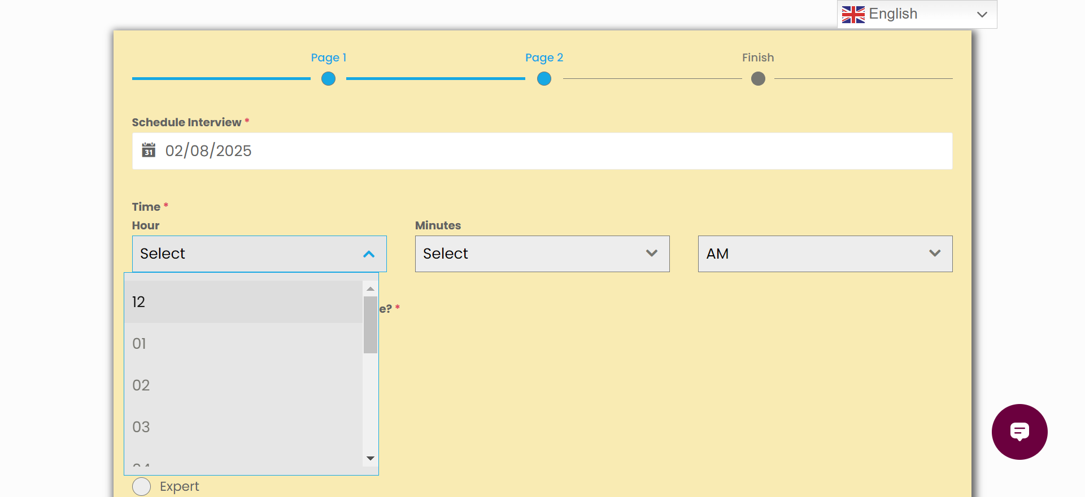
Sanjana:Time has to be Mon to Sat from 8AM to 6 PM Eastern standard time (NewYork)
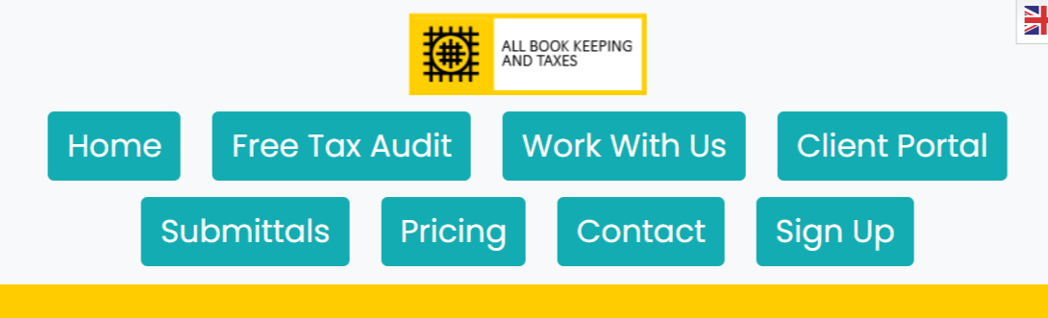
Why do these pages not open in another window, on mouse right click? Is this on purpose?
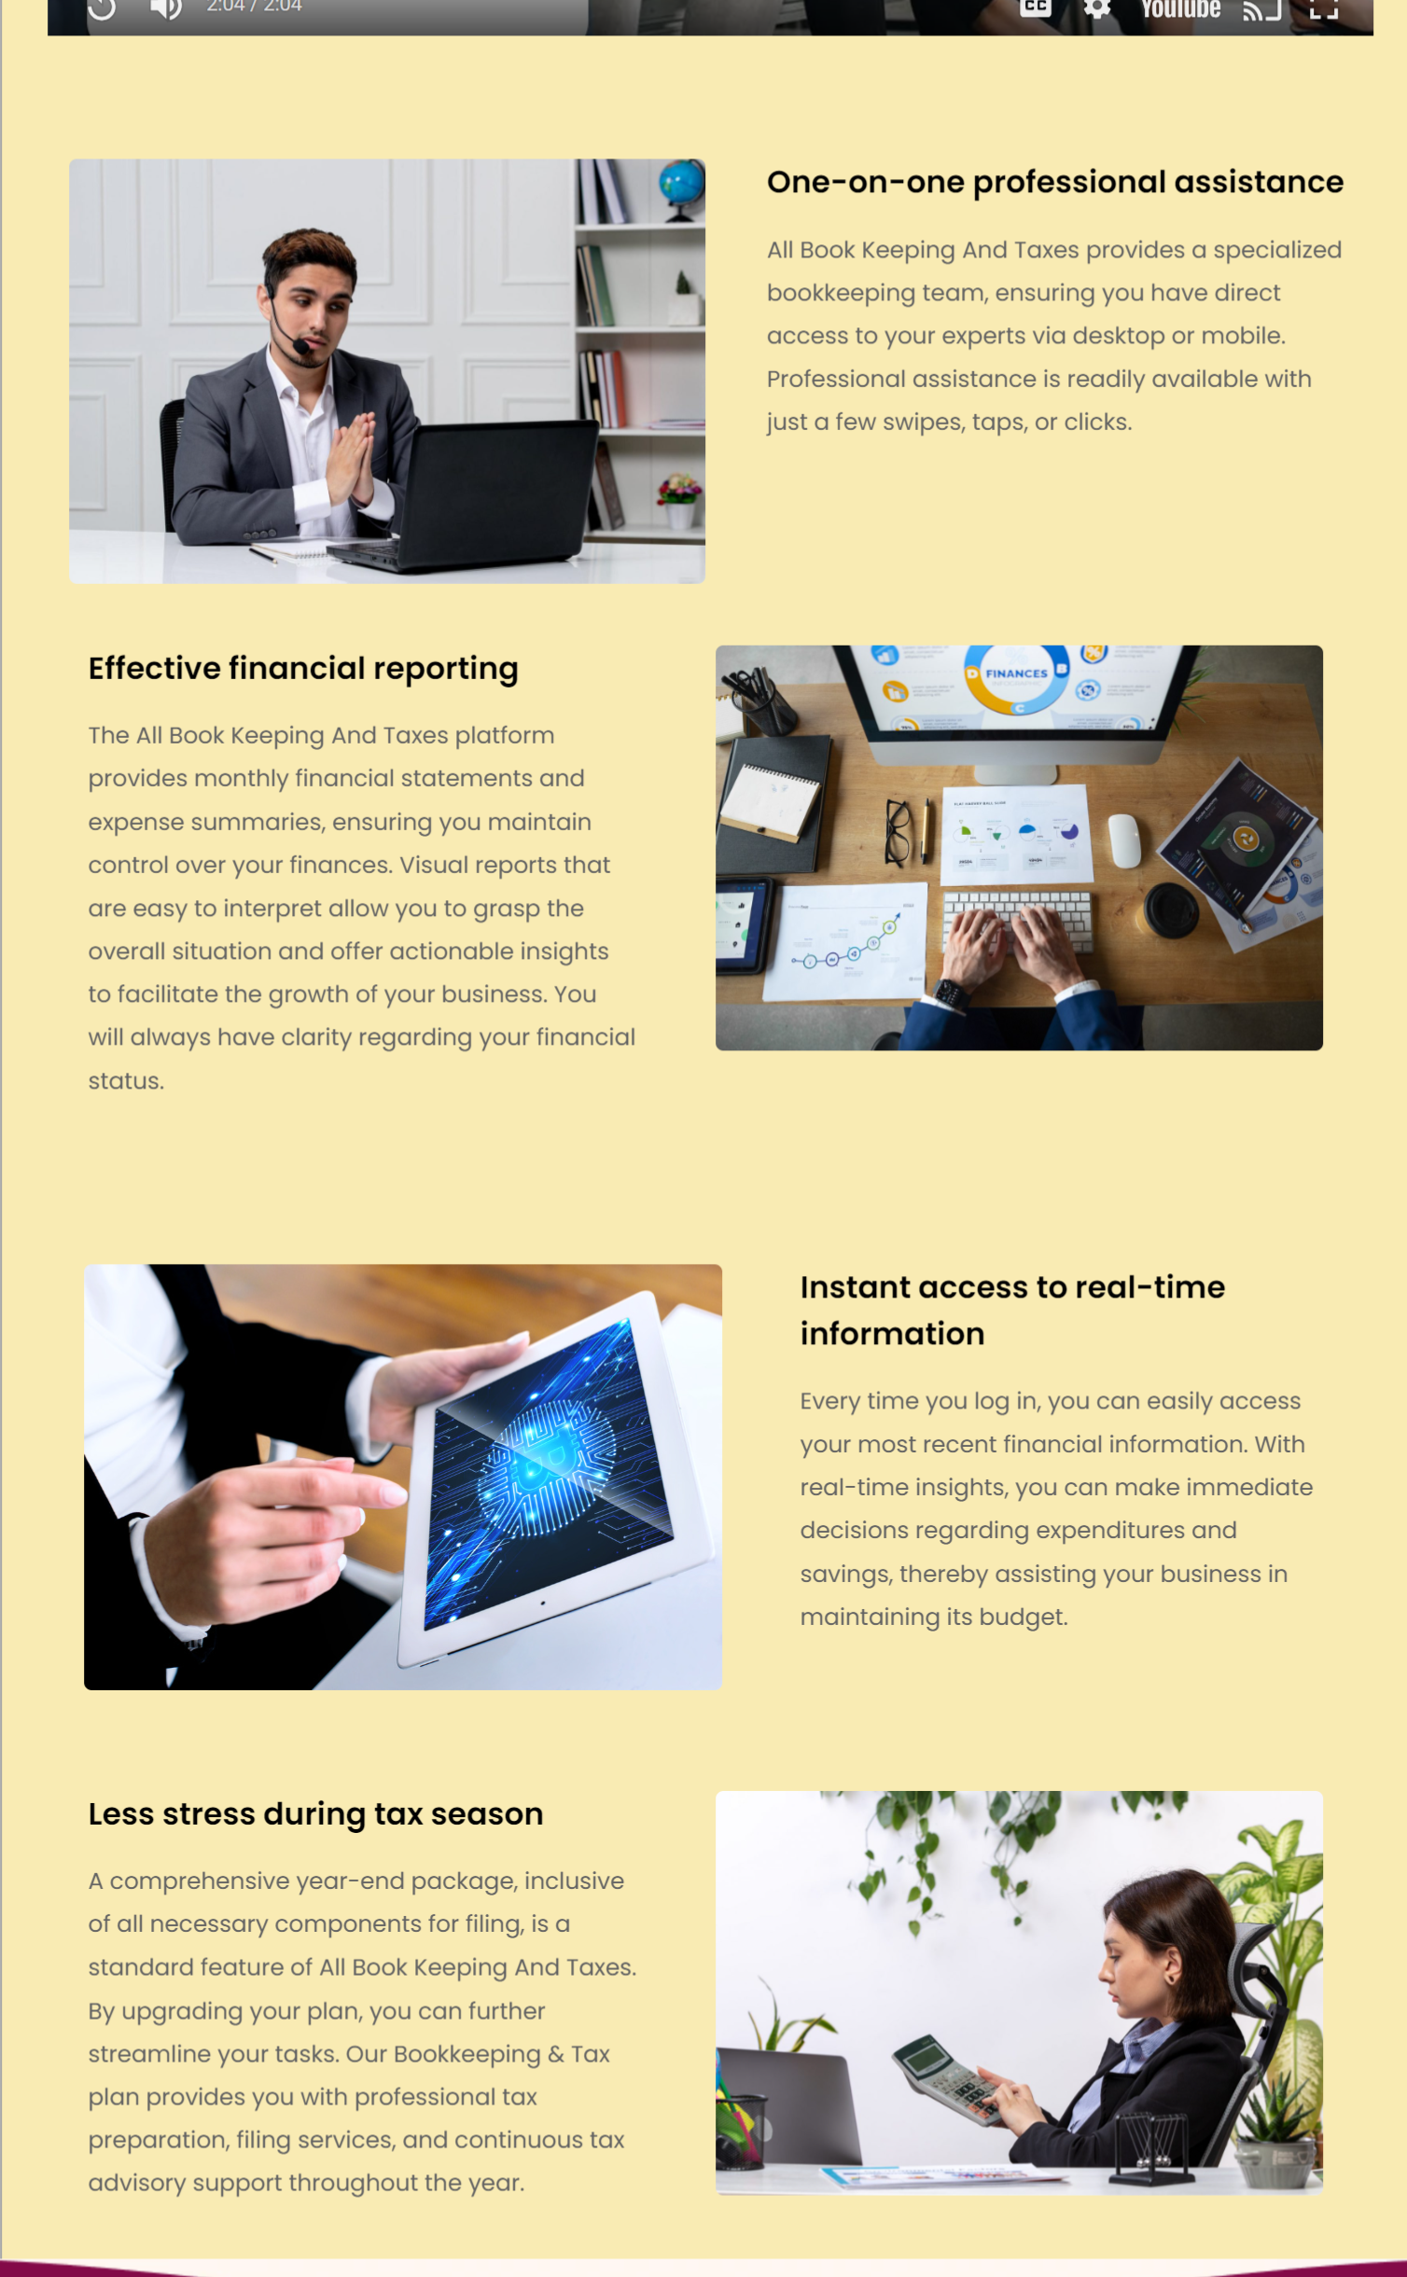
Uneven spaces between DIVs

Keep address as “Somerset, NJ 08873” (remove street address). Remove text only phone number. Keep email address.
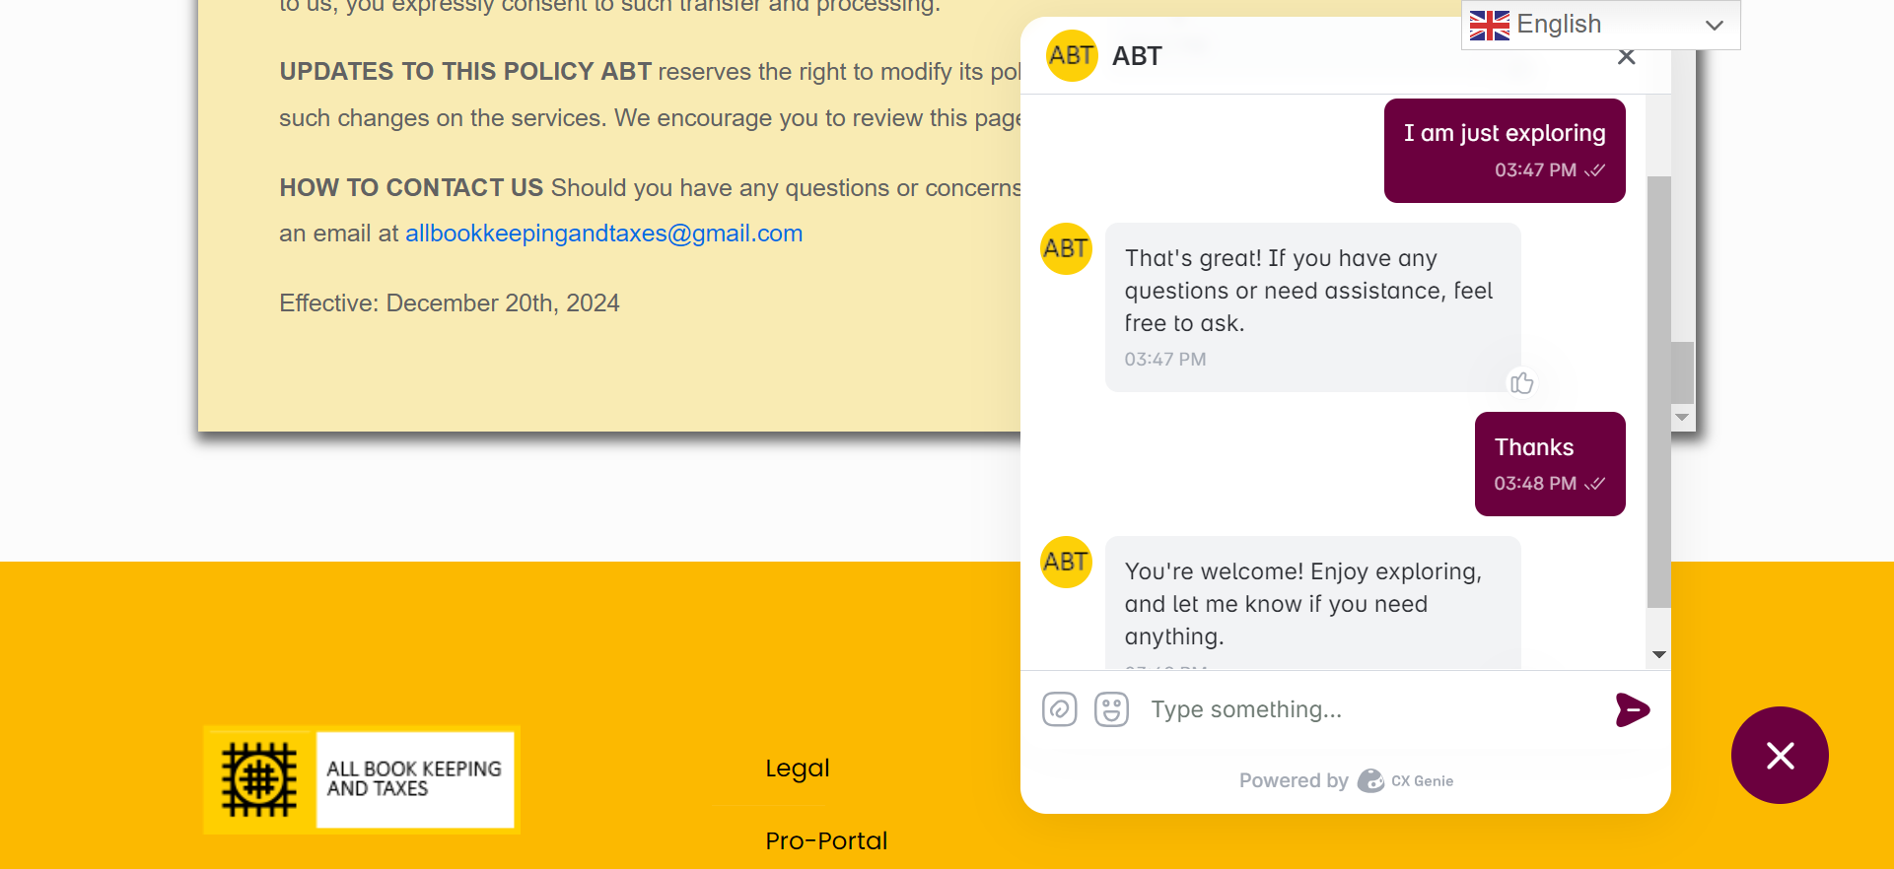
Is the chat box recorded some where for us in Email?
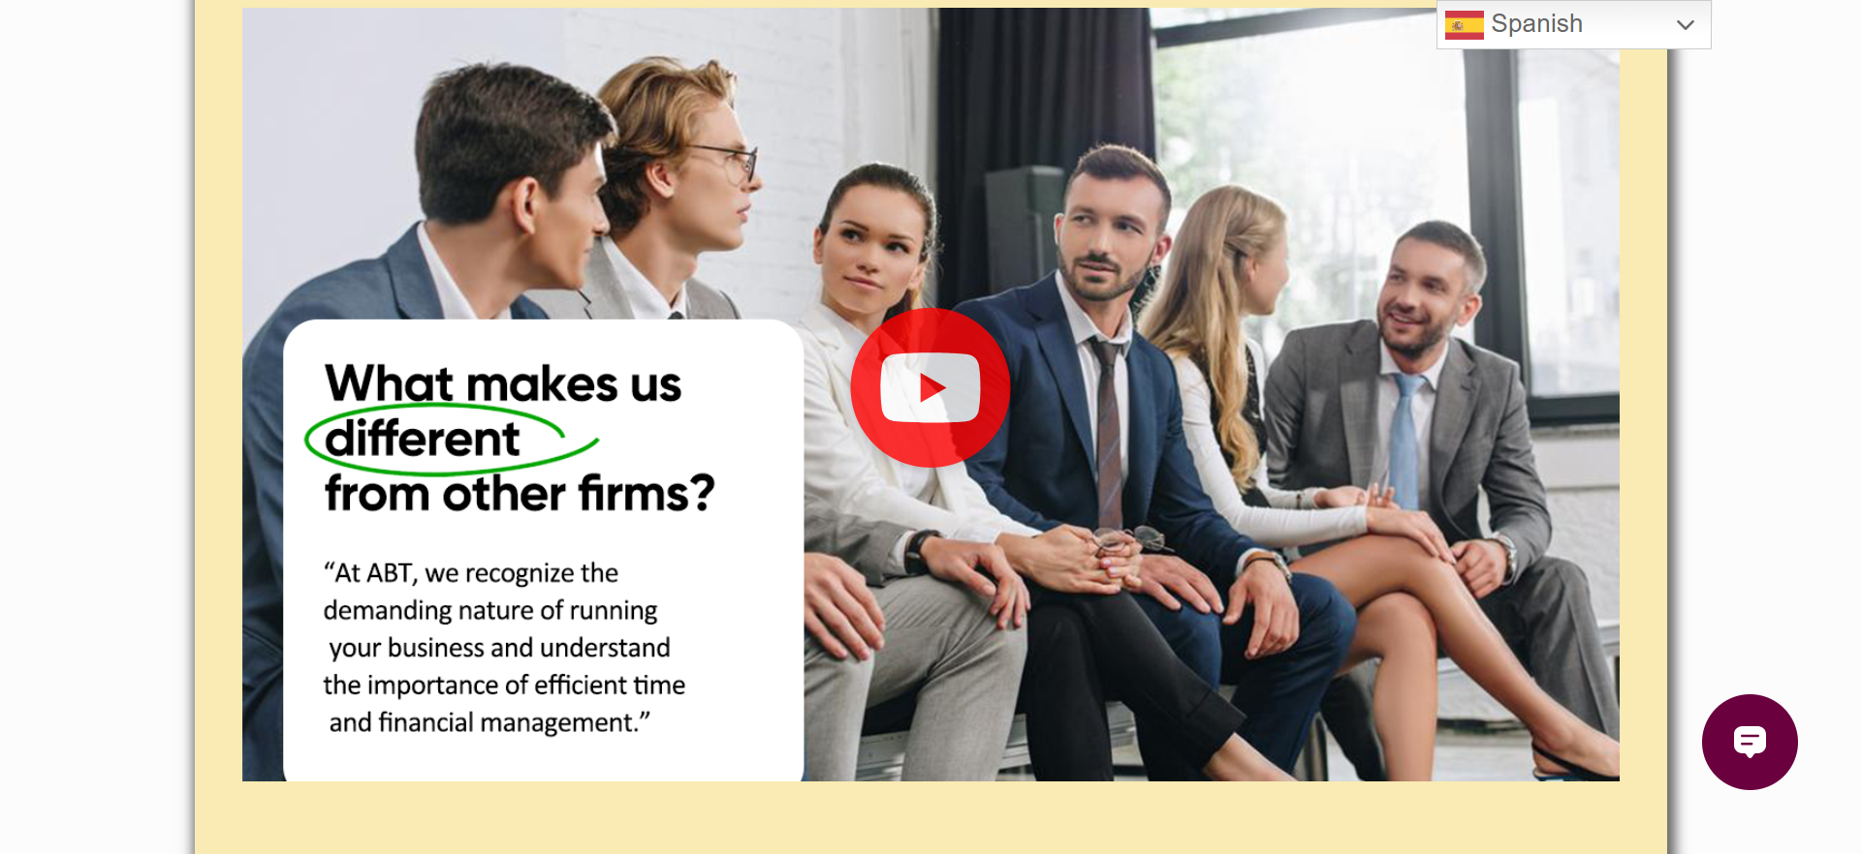
Can we get Spanish thumbnail and Spanish voice over for this and other videos in the website. Mark this task or Ankita and Tanishka for later
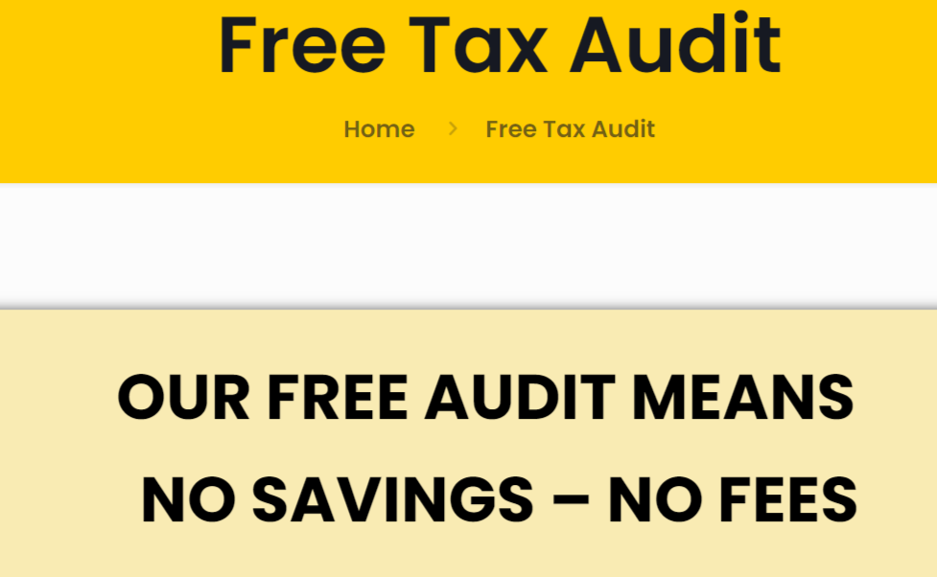
Change last (4th) line to read “NO FEES, IF WE DON’T SAVE YOU MONEY”
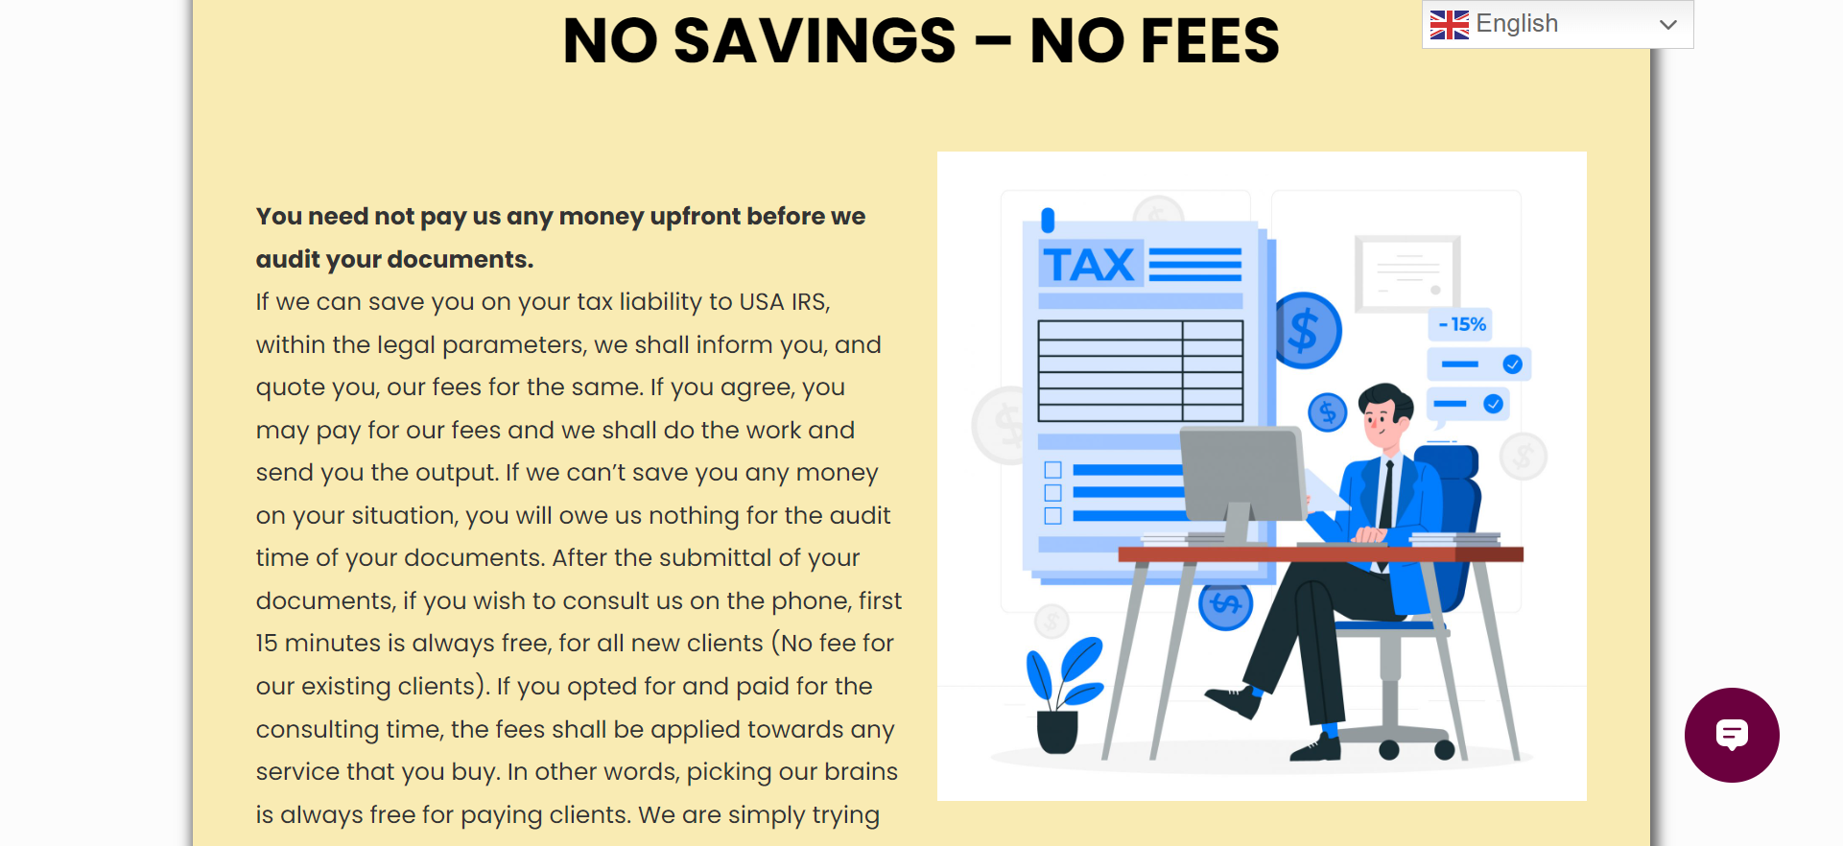
Text and image are not top aligned.
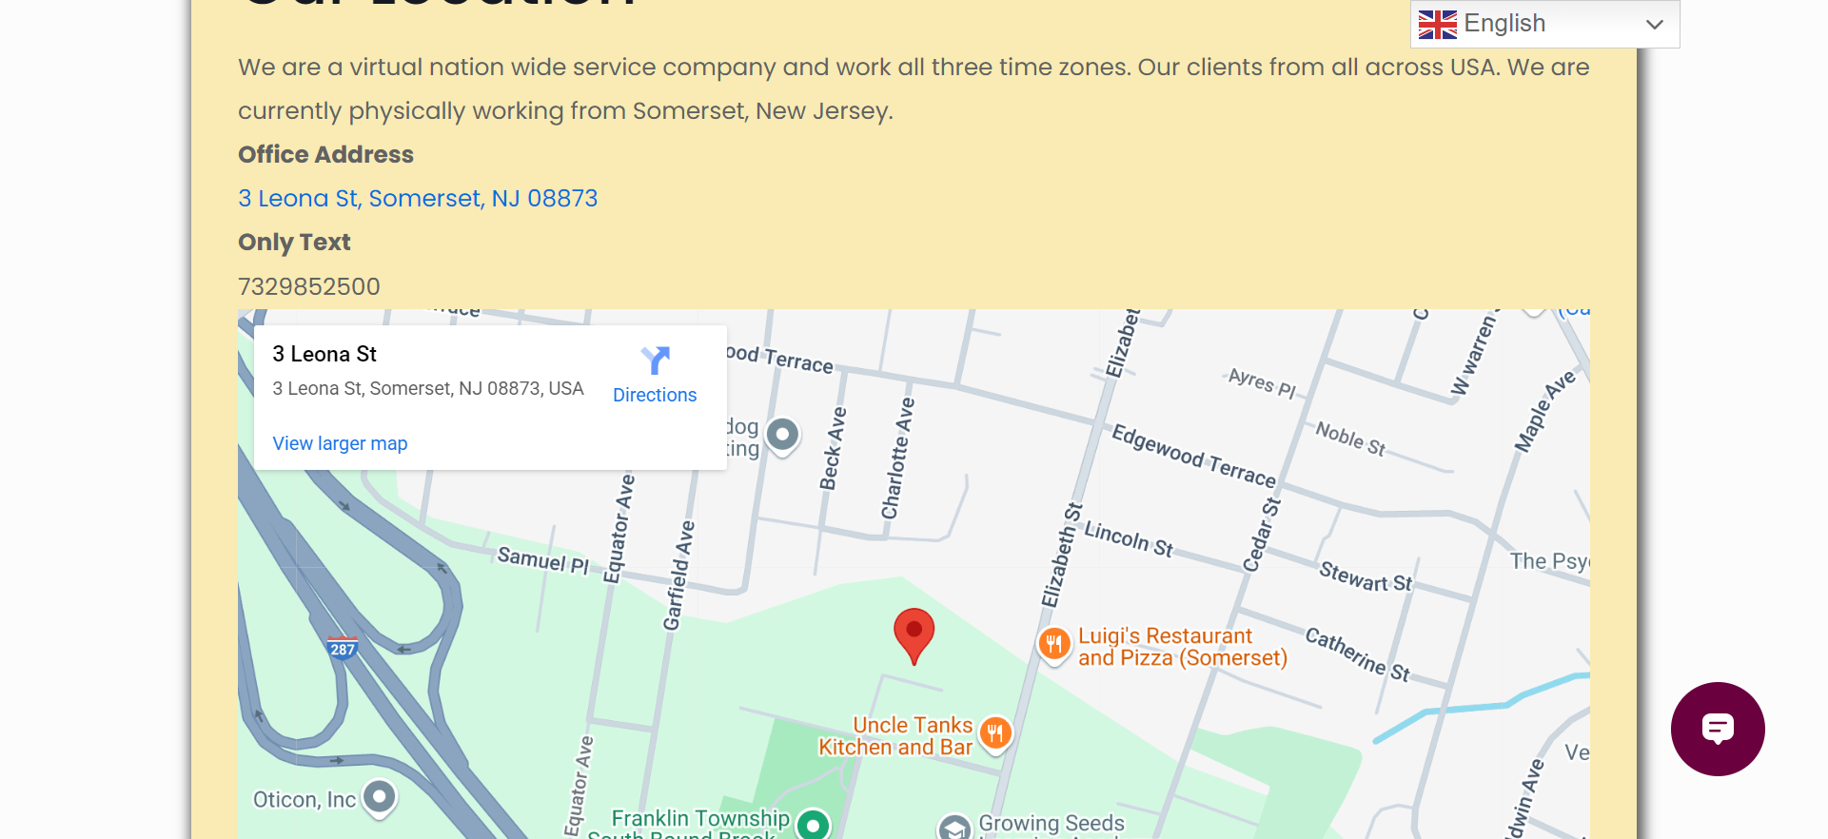
Our clients are from… Remove Sunday from the calendar.
Will explain conference. All email addresses have to be an image
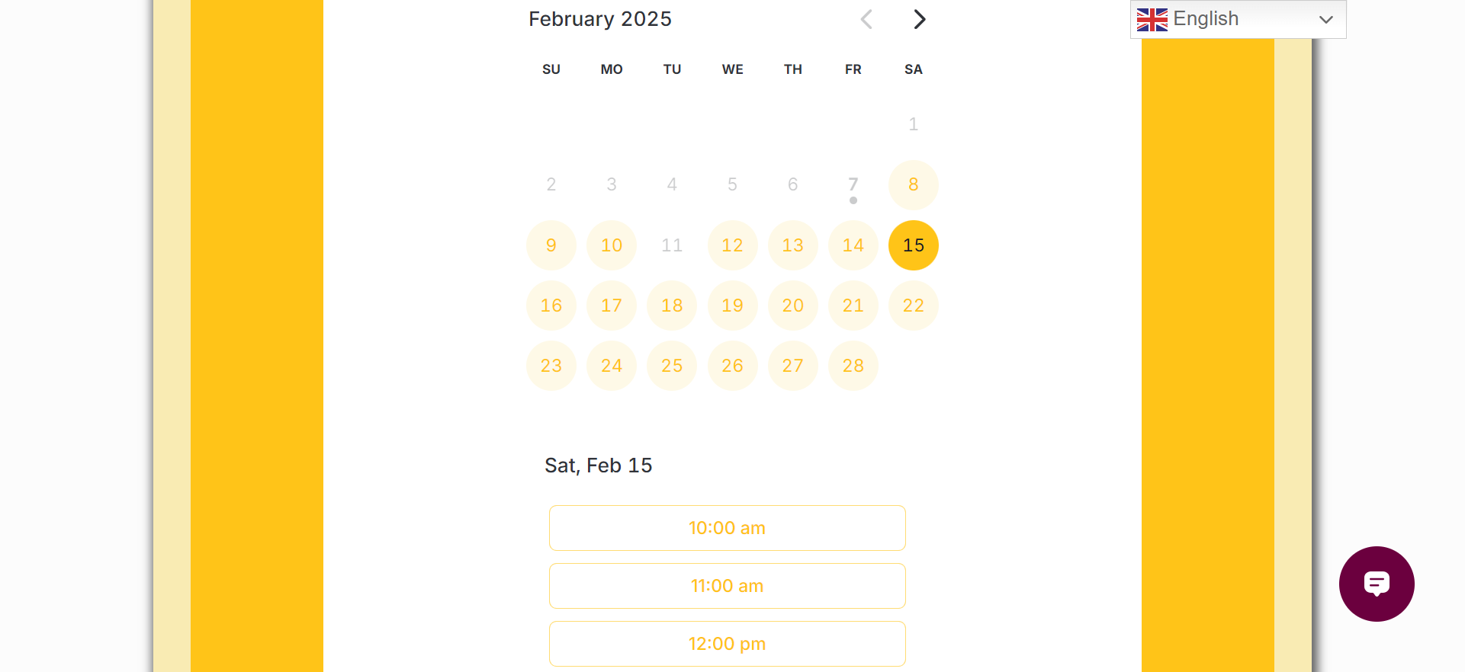
Why is 11th not seen. Also remove Sunday from bookings (Off)
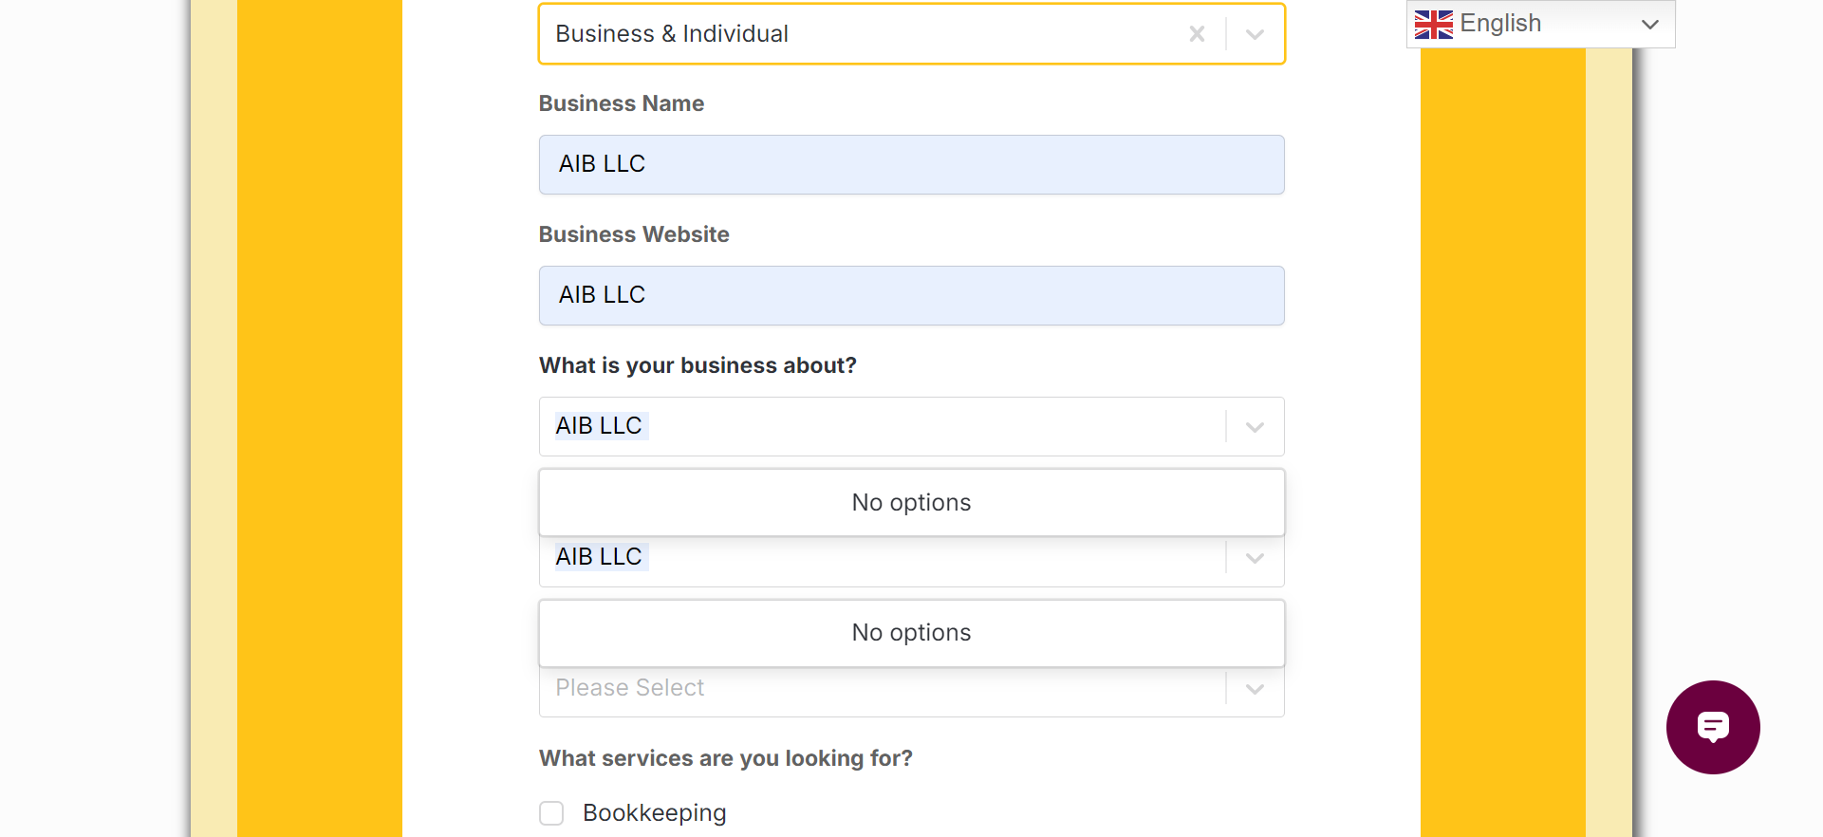
Why ?no options” text is showing?
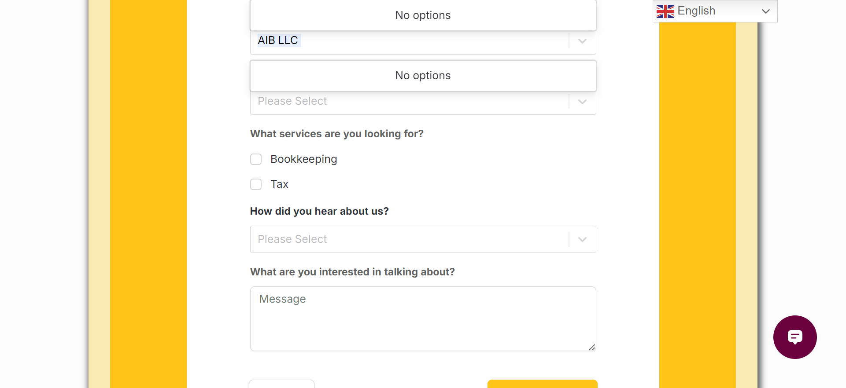
Show 3 sevices - Book keeping, Tax filings, Tax resolutions
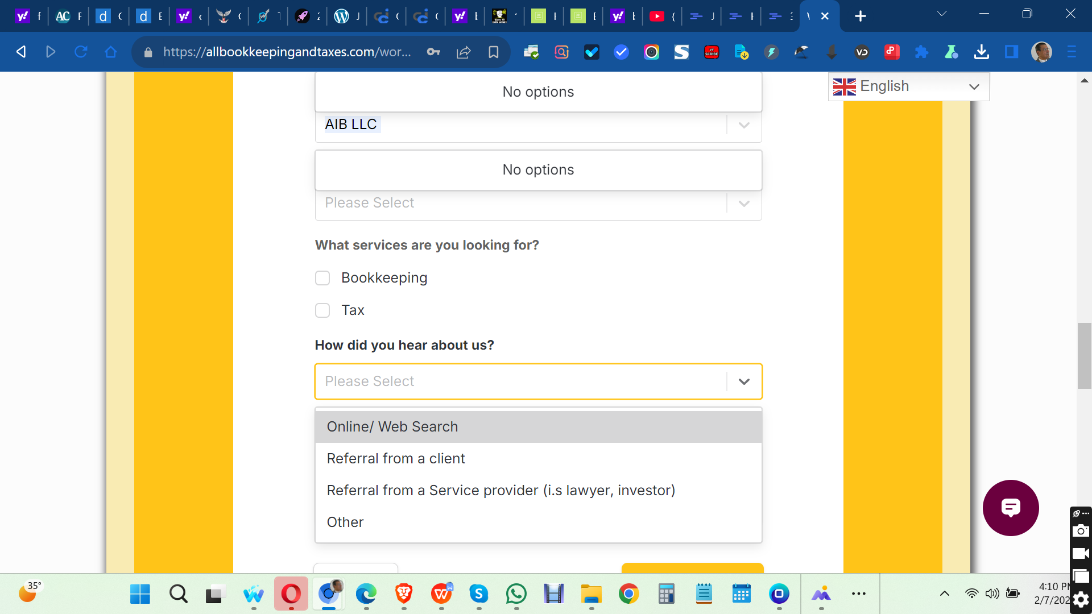
How did you hear from us should be “i.e.”
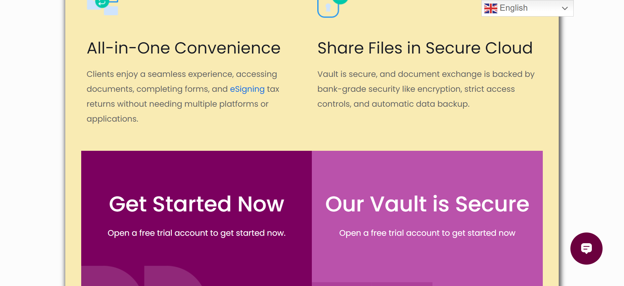
Remove “e-sign” hyperlink from here
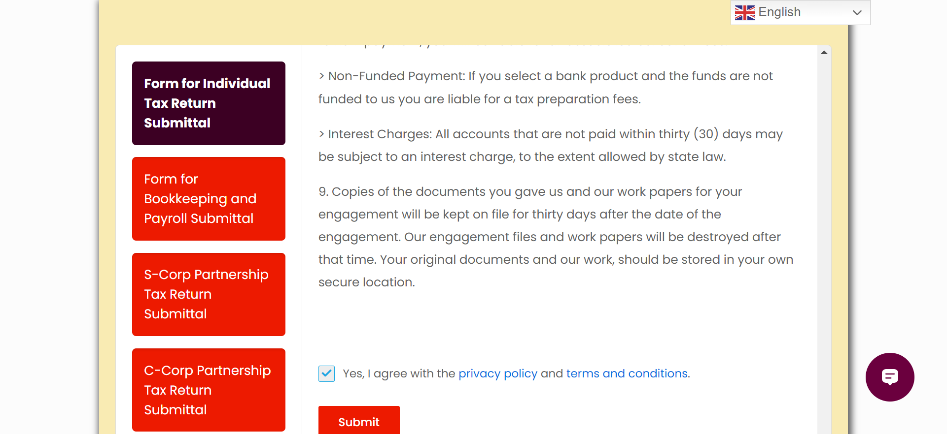
TAC and PP page links are not working
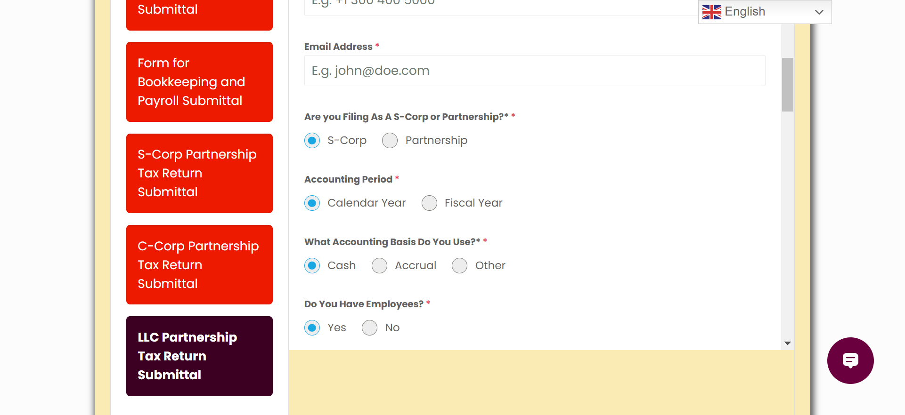
Remove this line “Are you filing as S Corp C corp etc
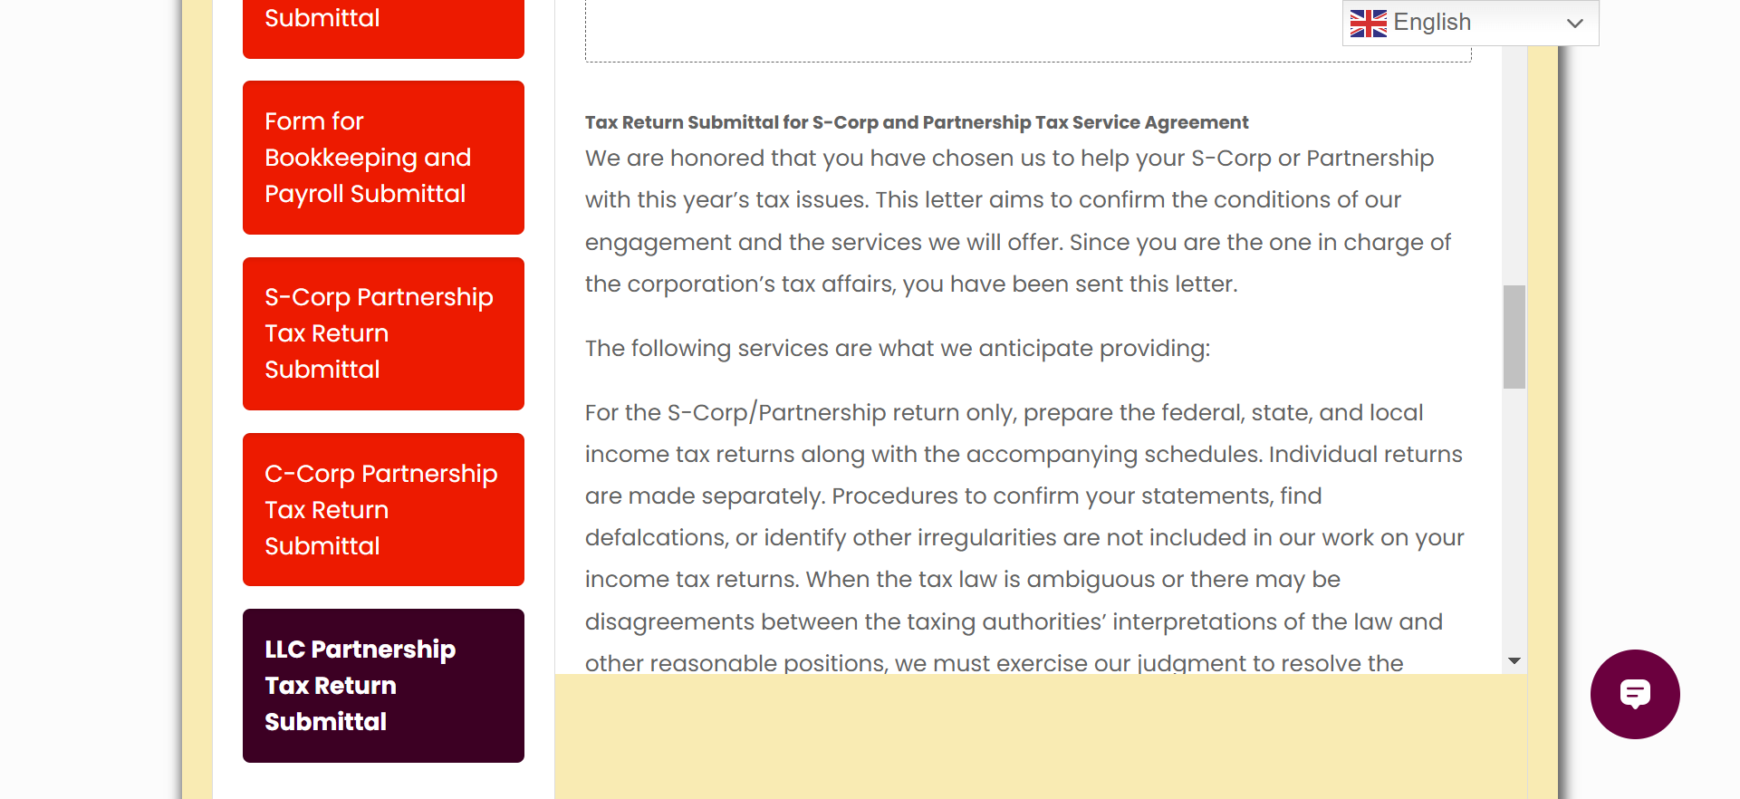
In the LLC submittalremove S Corp and C Corp
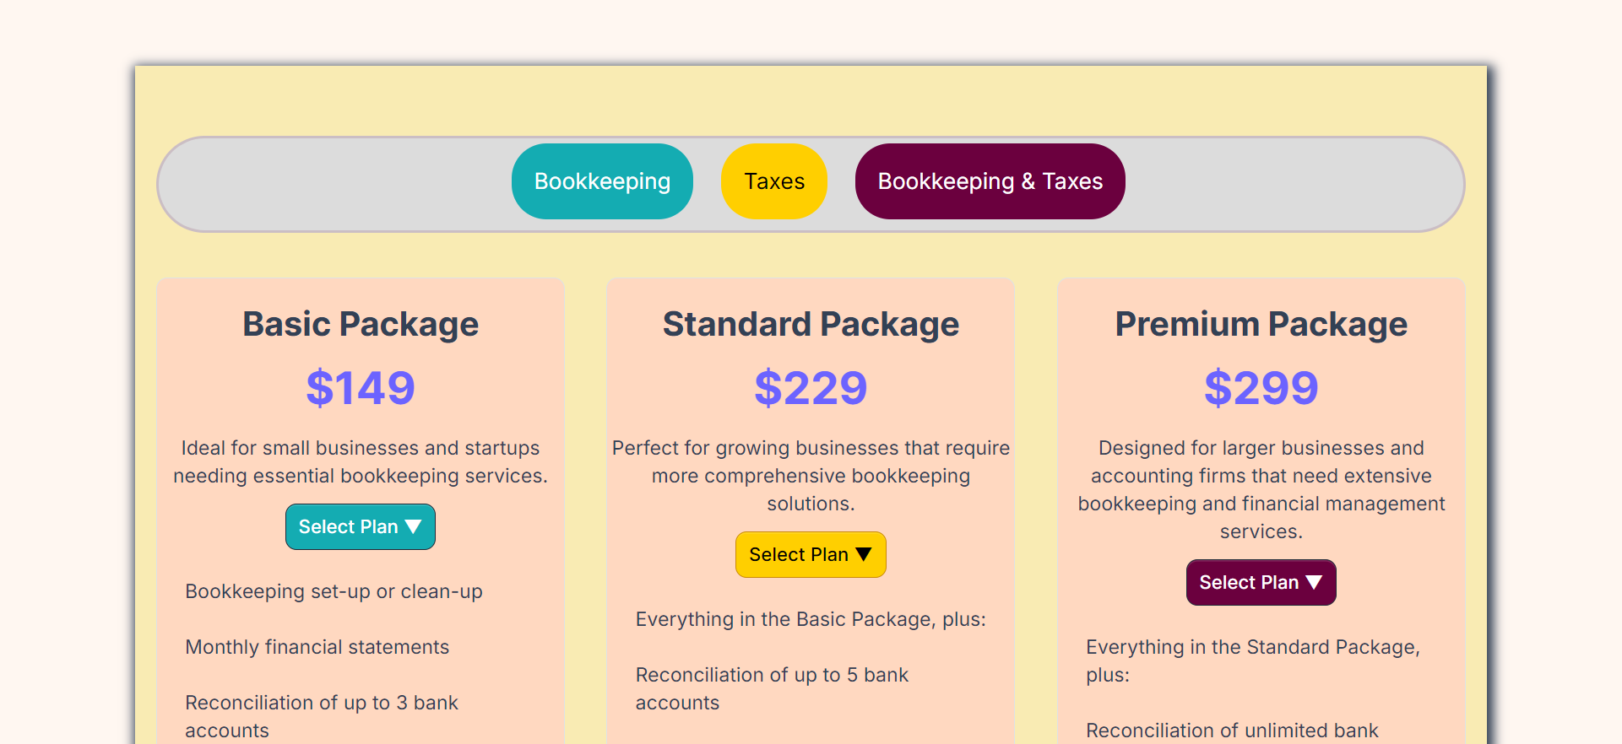
Need to discuss pricing page
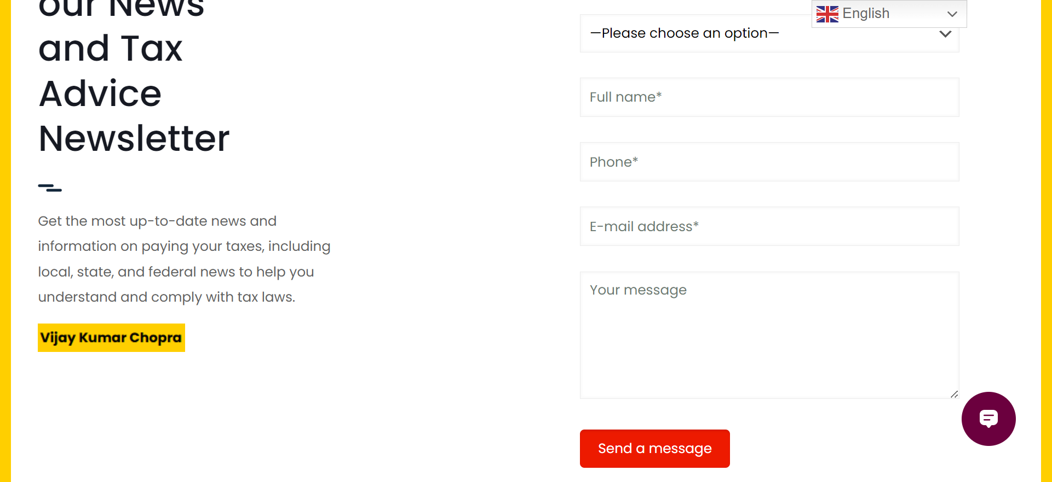
Remove my name
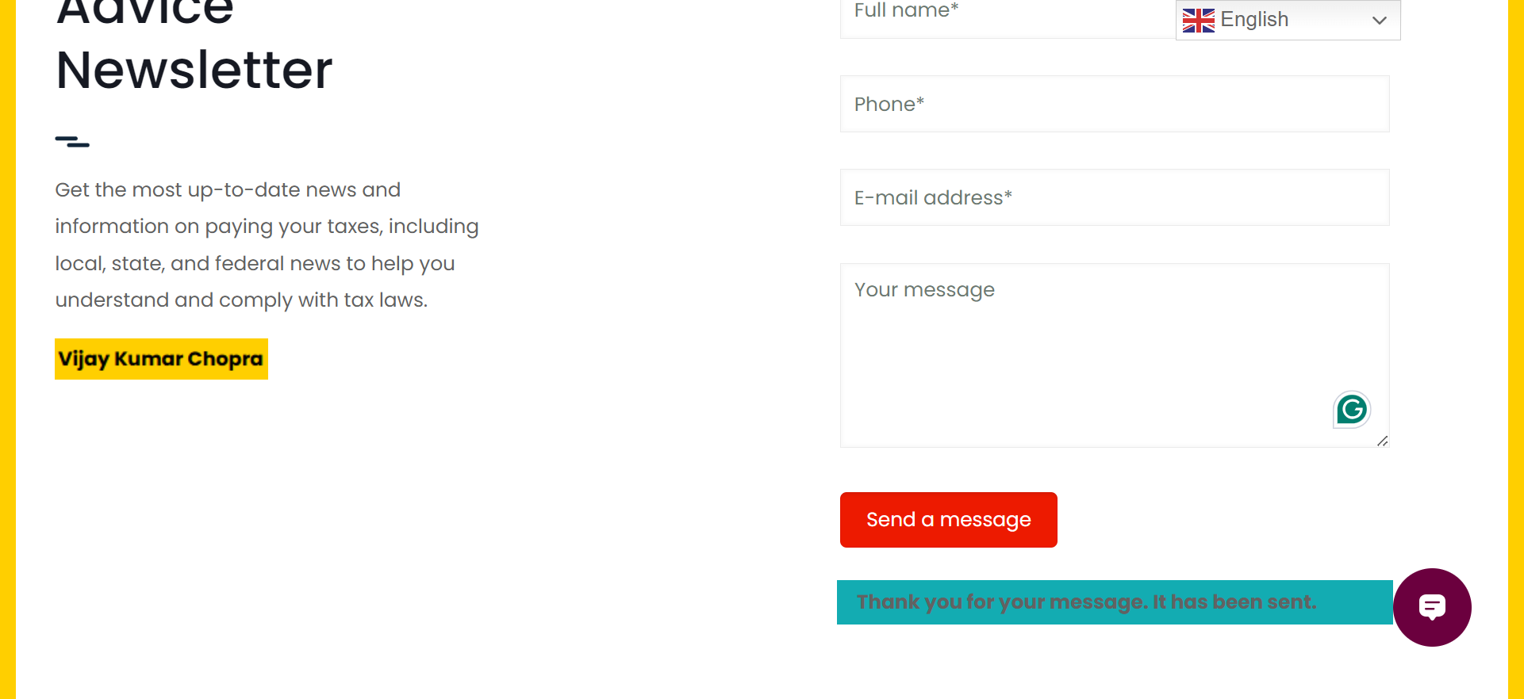
System response line contrast is not legible.
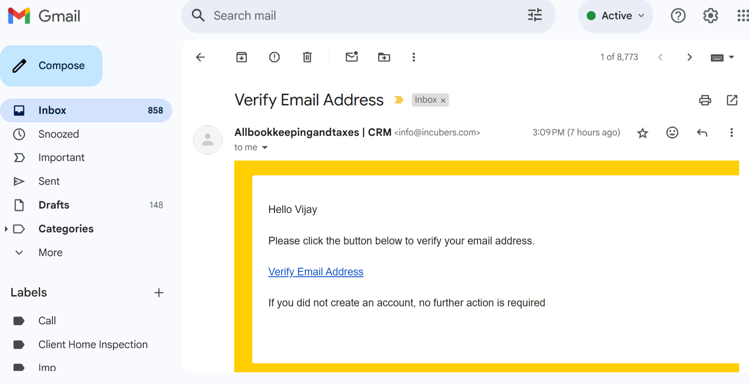
Email received
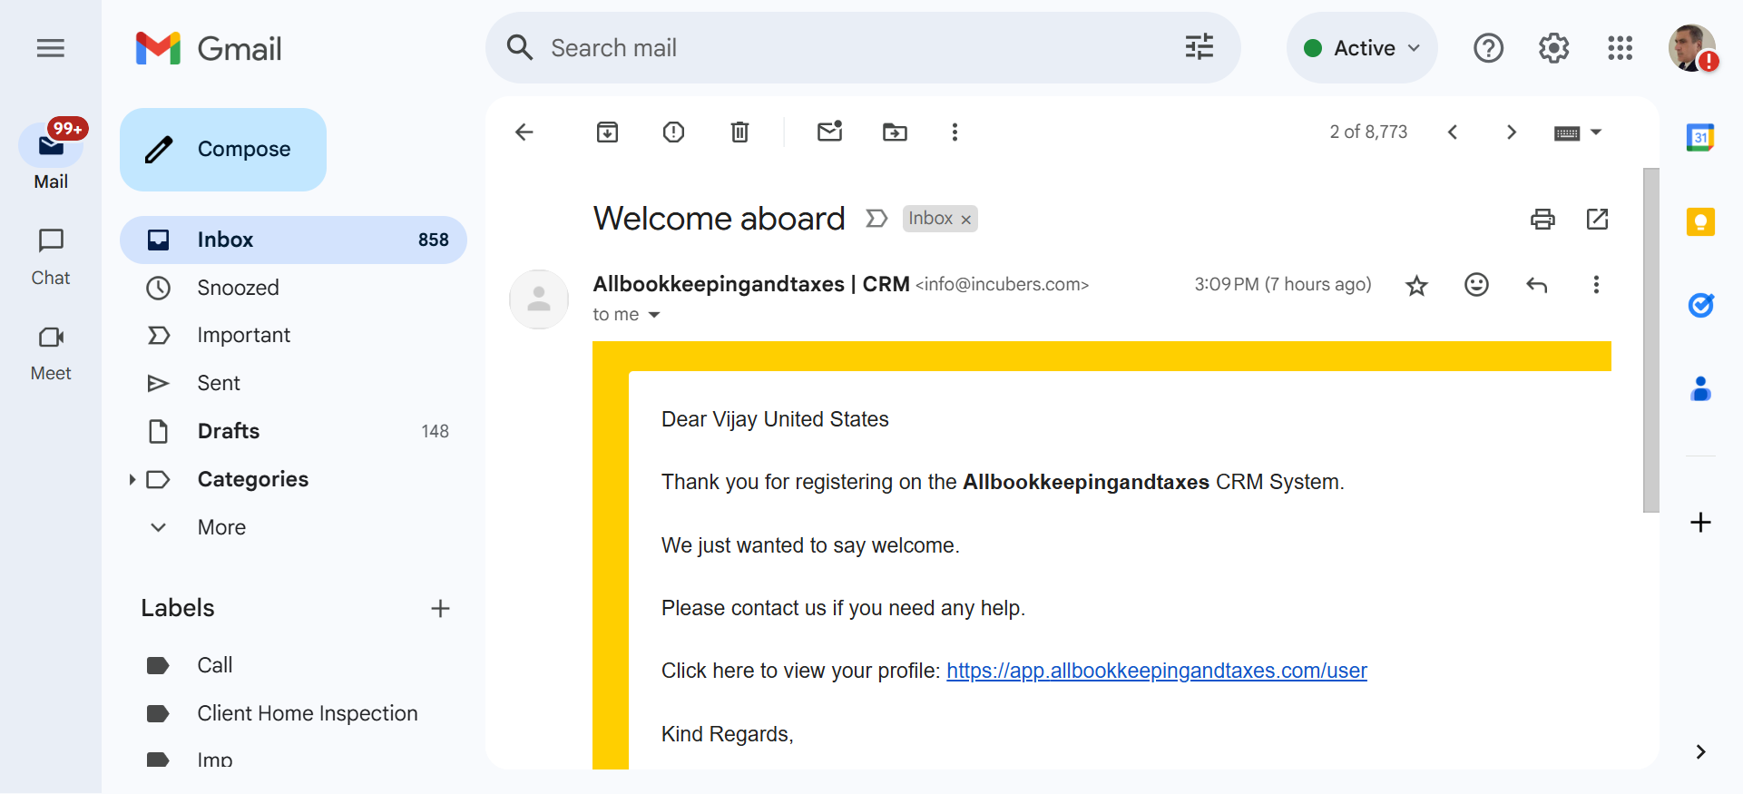
Email received
https://play.google.com/store/apps/details?id=com.cambyte.okenscan
Add a link in the let side Nav bar “How to Scan Docs”. We also need for iphone. And show this page and link in the body, Plus for iphone
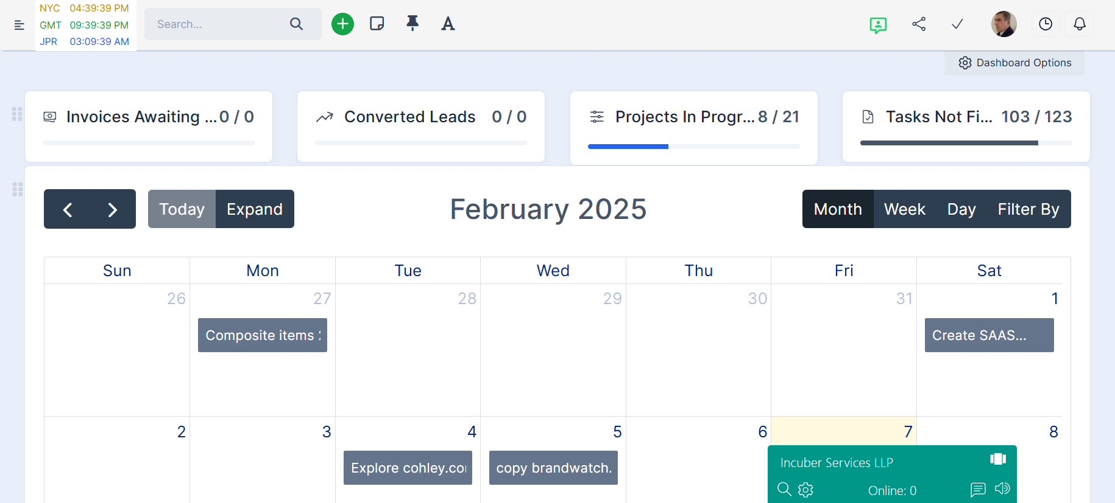
Can we get this look for default “HOME” for client portal and on top “Pending Message”, “Email received”, etc?

